Customizing an RC Truck for Towing and Racing

By: Joshua Danielowski, Brayden Fisher, and Andrew Vitale

April 4th, 2025

# Abstract

This report details the design and manufacturing of components for an existing RC truck chassis. This report and project were completed as a part of the lab portion of the Manufacturing Processes and Equipment (MAE 241) course at Trine University. The project presented several customer needs and requirements to the team that were used to generate and select concepts for several different subsystems that met those requirements. The subsystems for which designs were considered included body design, body material, Trine pride, racing tires, towing tires, headlights, taillights, bumper, hitch, trailer design, and trailer material. Those subsystems were combined and refined during the second and third iterations due to the manufacturing processes chosen to produce the prototypes. Chosen designs underwent three iterations, each with more manufacturing processes available to the team than the previous iteration. The first design iteration was completed, and a critical design review was completed prior to the second iteration. Designs were altered based on findings from the first iteration testing and feedback from the critical design review. The body of the truck was vacuum formed from clear thermoplastic around a PLA mold, and a PLA spoiler was attached to achieve the design chosen. The Power T was cast from aluminum and attached to the top of the truck body. The truck was fitted with LED lights that served as headlights. Two sets of tires were designed, one for the racing test and one for the towing test. An aluminum bumper was manufactured, complete with an integrated hitch loop to attach the trailer. The trailer was also manufactured with an integrated hitch hook to attach to the bumper of the truck. The final prototype performed well in the racing portion, but left some performance to be desired in the towing test. Overall, the team was satisfied with the performance of the final prototype.

Table of Contents

Abstract i

List of Figures iv

List of Tables vi

Customer Needs and Requirements 1

Justification for Requirements 1

Global, Economic, Social, and Environmental Impacts 2

Design Summary (Design Iteration 1) 3

Concept Generation (Design Iteration 1) 4

Polymer Body 4

Head and Taillights 4

Trine “Power T” 5

Tires 5

Aluminum Bumper and Hitch 7

Trailer 7

Concept Selection (Design Iteration 1) 8

Polymer Body 8

Head and Tail Lights 9

Tires 10

Aluminum Bumper 11

Trailer Hitch 12

Trailer 12

Detailed Design Discussion (Design Iteration 1) 13

Polymer Body 14

Tires 15

Trine “Power T” 16

Bumper 17

Trailer 20

Hitch 22

Bill of Materials 23

Manufacturing and Assembly Plan 24

Polymer Body 24

Tires 25

Trine “Power T” 26

Bumper 27

Trailer 28

Hitch 29

Testing and Validation 30

Design Summary (Design Iteration 2) 32

Concept Generation (Design Iteration 2) 32

Polymer Body 32

Tires 32

Trine “Power T” 32

Bumper 32

Trailer 33

Headlights and Taillights 33

Concept Selection (Design Iteration 2) 33

Polymer Body 33

Tires 34

Bumper 35

Trailer 36

Hitch 37

Detailed Design Discussion (Design Iteration 2) 38

Polymer Body 38

Tires 39

Bumper with Hitch 41

Trailer with Hitch 42

Head and Tail Lights 43

Bill of Materials 44

Manufacturing and Assembly Plan 44

Polymer Body 44

Tires 45

Bumper with Hitch 46

Trailer with Hitch 47

Headlights and Taillights 48

Testing and Validation 49

Design Summary (Design Iteration 3) 51

Concept Generation (Design Iteration 3) 51

Detailed Design Discussion (Design Iteration 3) 51

Polymer Body 51

Head and Taillights 53

Tires 54

Trine “Power T” 57

Bumper with Hitch 57

Trailer with Hitch 58

Bill of Materials 62

Manufacturing and Assembly Plan 62

Polymer Body 62

Head and Taillights 65

Tires 67

Trine “Power T” 67

Bumper with Hitch 69

Trailer with Hitch 69

Testing and Validation 73

Conclusion 73

References 75

Appendix A: Gantt Chart 76

# List of Figures

Figure 1: Polymer Body Subsystem Concept Sketches 4

Figure 2: Headlight Subsystem Concept Sketches 5

Figure 3: Taillight Subsystem Concept Sketches 5

Figure 4: Trine School Spirit Subsystem Concept Sketch 5

Figure 5: Racing Tire Subsystem Concept Sketches 6

Figure 6: Towing Tire Subsystem Concept Sketches 6

Figure 7: Bumper and Hitches subsystem concept sketches 7

Figure 8: Trailer Subsystem Concept Sketches 8

Figure 9: Engineering Drawings for Body Components 15

Figure 10: Body Prototype 1 15

Figure 11: Engineering Drawing for Wheel 16

Figure 12: Wheel Prototype 1 16

Figure 13: Engineering Drawing for Power T 17

Figure 14: Power T Prototype 1 17

Figure 15: Engineering Drawings for Bumper Components 19

Figure 16: Bumper Prototype 1 20

Figure 17: Engineering Drawing for Trailer Components 21

Figure 18: Trailer Prototype 1 22

Figure 19: Engineering Drawing for Hitch 23

Figure 20: Hitch Prototype 1 23

Figure 21: Manufacturing Flow Chart for Body 25

Figure 22: Manufacturing Flow Chart for Tire 26

Figure 23: Manufacturing Flow Chart for Power T 27

Figure 24: Manufacturing Flow Chart for Bumper 28

Figure 25: Manufacturing Flow Chart for Trailer 29

Figure 26: Manufacturing Flow Chart for Hitch 30

Figure 27: Engineering Drawing for Body Components 38

Figure 28: Body Prototype 2 39

Figure 29: Engineering Drawing for the Tire 40

Figure 30: Tire Prototype 2 40

Figure 31: Engineering Drawing for the Bumper with Hitch 41

Figure 32: Bumper Prototype 2 41

Figure 33: Engineering Drawing for the Trailer with Hitch 42

Figure 34: Trailer Prototype 2 42

Figure 35: Engineering Drawings for the Head and Tail Lights 43

Figure 36: Head and Tail Lights Prototype 1 43

Figure 37: Manufacturing Flow Chart for the Body 45

Figure 38: Manufacturing Flow Chart for the Tires 46

Figure 39: Manufacturing Flow Chart for the Bumper 47

Figure 40: Manufacturing Flow Chart for the Trailer 48

Figure 41: Manufacturing Flow Chart for the Head and Taillights 49

Figure 42: Engineering Drawing for Body Mold 52

Figure 43: Body Final Prototype 53

Figure 44: Head and Tail Lights 54

Figure 45: Illustration of a non-pneumatic tire structure showing the shear layer. (Image Credit: University of Illinois) 54

Figure 46: Engineering Drawing for the Towing Tires 55

Figure 47: Engineering Drawing for the Racing Tires 56

Figure 48: Racing Tires Final Prototype 56

Figure 49: Power T Final Prototype 57

Figure 50: Aluminum Bumper Final Prototype 57

Figure 51: Engineering Drawing for the Flat Trailer Geometry 58

Figure 52: Engineering Drawing for the Hitch Connection 59

Figure 53: Engineering Drawing for the Axle 59

Figure 54: Engineering Drawing for the Trailer Tires 60

Figure 55: Isometric, Side, and Bottom Views of the Trailer Final Prototype 61

Figure 56: Manufacturing Flow Chart for the Body 63

Figure 57: Mold for Vacuum Forming 64

Figure 58: Vacuum Forming the Body 65

Figure 59: Manufacturing Flow Chart for the Head and Tail Lights 66

Figure 60: Failed Vacuum Forming Molds 66

Figure 61: Manufacturing Flow Chart for the Tires 67

Figure 62: Manufacturing Flow Chart for the Power T 68

Figure 63: Milling Process on Power T 68

Figure 64: Manufacturing Flow Chart for the Bumper 69

Figure 65: Manufacturing Flow Chart for the Trailer 71

Figure 66: Welding the Trailer Components 72

Figure 67: Turning Operation on the Axle 72

Figure 68: Milestone 1 Gantt Chart 76

Figure 69: Milestone 2 Gantt Chart 76

Figure 70: Milestone 3 Gantt Chart 77

Figure 71: Final Report Gantt Chart 77

# List of Tables

Table 1: Requirements for RC Truck 1

Table 2: Concept Selection Matrix for Body Geometry 8

Table 3: Concept Selection Matrix for Body Material 9

Table 4: Concept Selection Matrix for Headlights 10

Table 5: Concept Selection Matrix for Taillights 10

Table 6: Concept Selection Matrix for Racing Tires 10

Table 7: Concept Selection Matrix for Towing Tires 11

Table 8: Concept Selection Matrix for Bumper Geometry Subsystem 12

Table 9: Concept Selection Matrix for Trailer Hitch Geometry Subsystem 12

Table 10: Concept Selection Matrix for Trailer Geometry Subsystem 13

Table 11: Concept Selection Matrix for Trailer Material Subsystem 13

Table 12: Bill of Materials for Prototype 1 24

Table 13: Legend for Manufacturing Flowcharts 24

Table 14: Testing and Validation for Prototype 1 31

Table 15: Concept Selection Matrix for Body Geometry Subsystem 34

Table 16: Concept Selection Matrix for Body Material Subsystem 34

Table 17: Concept Selection Matrix for Racing Tire Subsystem 35

Table 18: Concept Selection Matrix for Towing Tire Subsystem 35

Table 19: Concept Selection Matrix for Bumper Geometry Subsystem 36

Table 20: Concept Selection Matrix for Trailer Geometry Subsystem 36

Table 21: Concept Selection Matrix for Trailer Material 37

Table 22: Concept Selection Matrix for the Trailer Hitch 37

Table 23: Bill of Materials for Prototype 2 44

Table 24: Testing and Validation for Prototype 2 50

Table 25: Bill of Materials for the Final Prototype 62

Table 26: Testing and Validation for the Final Prototype 73

# Customer Needs and Requirements

A customer has requested that the team re-design and customize an RC truck that can excel in both racing and towing applications. The team has been asked to re-design many aspects of the RC truck which includes: a new polymer body with Trine school pride, two sets of rims and tires, one specialized for racing and the other for towing, a new aluminum bumper and hitch, a trailer which can attach to the hitch and carry a designated load, and new head and tail lights. The team is allowed $50 for purchasing materials but they must first obtain their materials from the Foundry and SDC if possible. All materials used must also be listed in the Bill of Materials. The team must make three design iterations for the product. Design Iteration 1 must be constructed using only laser-cut cardboard, cardstock, or foam board. It will be used to check dimensions, geometry, and tolerances. Design Iteration 2 can be made using both laser cutting and 3D printing to test the functionality of the prototype. Design Iteration 3 can use all manufacturing and assembly methods and will become the final product. All manufactured products must also be refined using secondary processing methods. All of these requirements can also be found in Table 1.

Table 1: Requirements for RC Truck

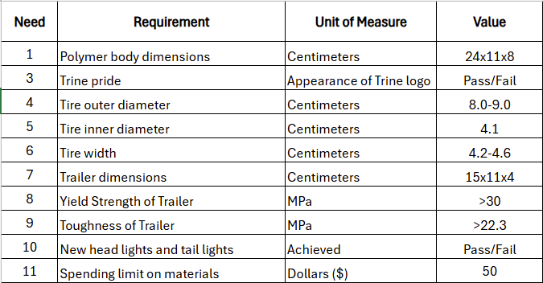

## Justification for Requirements

The RC truck must be given a new polymer body that will make it both aerodynamic and weighted evenly. It is important that the polymer body has dimensions that are compatible with the RC truck. The original body was 24 centimeters long, 11 centimeters wide, and 8 centimeters tall. The new body will have roughly these dimensions. The Trine school spirit is required because the team consists of proud Trine students. The dimensions of both sets of tires are also crucial. Based on measurements from the truck’s original tires, the new tires should have an inner diameter of about 4.1 centimeters, an outer diameter ranging from 8.0 to 9.0 centimeters, and a width ranging from 4.2 to 4.6 centimeters. The trailer should be about 15 centimeters long, 11 centimeters wide, and 4 centimeters deep. These dimensions were estimated based on the dimensions of the RC truck’s shell. Regarding the material the trailer will be composed of, it is important that it has a yield strength and toughness that will be able to support a designated load. The necessary values for each parameter were determined by comparing them to aluminum which is a suitable material for the trailer. It has also been required that the team design and manufacture new sets of headlights and taillights for the RC truck. Finally, a $50 limit for purchasing materials has been imposed on the team.

# Global, Economic, Social, and Environmental Impacts

The impacts of this project, while relatively insignificant at first glance, are quite significant when analyzed in depth. On a global scale, this project is the first step for the team in the manufacturing and engineering design process involved with the projects the team will eventually be a part of following graduation. The project helps to teach how to create concepts and select those that best fit the needs of the customer or the constraints of the project, which is one of the more difficult parts of engineering. In addition, it teaches different manufacturing processes such as casting, welding, forging, and others that we will encounter, most likely in more automated or streamlined forms, when working in industry. Furthermore, the RC industry is one that relies heavily on global supply chains, with many parts being manufactured outside of the United States and imported as a finished product or to be assembled. The trucks purchased for this project supports international trade and supply chains and provide some insight into how those processes play into our role as engineers.

The economic impact of this project will be relatively insignificant, as the entirety of the work will be done by the team, meaning that there will be no pay for anyone involved in the project. The only economic constraint provided for the project is a $50 budget, and most of the materials used will be provided by that school. The companies that produce the RC trucks used for the project will benefit from the sales, and companies that produce the raw materials used to produce the different replacement parts of the truck that the team fabricates will benefit from the sale of those raw materials. However, on a deeper look into the RC truck market, the economics are quite significant. According to Research and Markets, the RC car market grew by over USD 40 million, from USD 309.06 million in 2023 to USD 350.84 million in 2024, and is expected to reach USD 773.52 million by 2030 (Research and Markets, 2024). While this is a testament to the increase in the industry's popularity, it also spells an increase in jobs in the sectors that contribute to the RC truck industry.

The social impact of this project will be the most significant of the four categories in this section. This project will be a glimpse into the teamwork aspects that are integral to working in engineering, and it will allow the team to gain essential collaboration and teamwork skills that will allow us to thrive as engineers working in a team and collaborating with different groups within a company. The concepts of meeting deadlines, prioritizing tasks, executing them on time and with the highest quality, and delegating tasks to group members with the skills best suited for those tasks are all skills that are essential for success when working in industry as an engineer. In addition, this project could serve as the catalyst for some to further explore the RC industry, both as a hobby and as a career path. It could also awaken a preference for a larger-scale version, opening opportunities in the automotive industry for the team.

The environmental impact of this project will be relatively minimal. Most of the materials that will be used, such as aluminum for the trailer hitch or polymers and cardboard for the prototyping phases of the project, will be recycled from around The Foundry. However, there will be some trial and error throughout the prototyping process, which could lead to some plastic waste. In addition, the batteries and other electronic components of the trucks will contribute to the already prevalent issue of e-waste, where components that die often end up in landfills. One study exploring this issue defines e-waste as “a type of garbage generated by electronic in the industrial world, trash is one of the most difficult and rapidly expanding issues” (Jain et al., 2023). E-waste can harm the planet if not disposed of properly, so the electronics used during the project will need to be handled appropriately once at the end of their lifespan. There will also be a significant amount of electricity dedicated to this project, between the time spent collaborating on Teams to create the report and the time spent on school computers developing CAD files for the different components of the truck, along with the electricity required to run the machines used during the manufacturing processes. Aside from the transportation of the RC truck to The Foundry for pickup, and any other items that are ordered for the project, there will be minimal transportation costs.

# Design Summary (Design Iteration 1)

The overall design for the racing truck was divided into several subsystems, including the body geometry, body material, trailer hitch geometry, trailer hitch material, trailer geometry, trailer material, lighting components, racing wheels, and towing wheels. The team used selection matrices for each subsystem to choose the idea that best suits the customer needs from each subsystem. Each matrix utilized a 1-to-5 scale to score each concept, where 5 is the most practical and 1 is the least practical. The rows indicated the relevant qualities of each concept, and the columns contained the different design concepts. Each quality was given weight based on the team’s perceived importance to the success of the project, and the score was multiplied by the weight percentage to obtain a weighted score for each concept. The concept for each subsystem with the highest score was chosen for the team’s first design iteration. The team unanimously decided that the Trine “Power T” would be used to display school spirit. The use of subsystems allowed the team to carefully analyze each component of the truck and tailor it to fit the needs of the customer.

# Concept Generation (Design Iteration 1)

For the project, the team decided to break the product up into many different subsystems, which will be developed and produced separately and brought together to make the final product. The subsystems include the polymer body, an attachment with Trine school spirit, a set of tires for racing, a set of tires for towing, a bumper with a hitch, a trailer, and headlights and taillights. For each subsystem, the team created sketches of several possible designs, which allowed them to be easily visualized. These sketches are preliminary, meaning that they do not include dimensions or tolerances, but they aim to give a general idea of some of the concepts the team evaluated during the first design iteration.

## Polymer Body

For the RC Truck’s polymer body, the team came up with three distinct designs. The first is a sleek model with a compact build and sharp edges. The second is a curvier design with a more intricate rear. The final design is a more stereotypical racecar build with a spoiler to reduce drag. Sketches of these designs are shown in (Figure 1).

Back to the Future Concept Racecar Concept Spoiler Concept

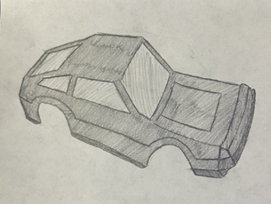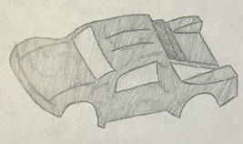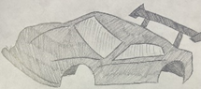

Figure 1: Polymer Body Subsystem Concept Sketches

## Head and Taillights

For the head and taillights, the team has entertained a few distinct ideas that aim to add some aesthetic features to the truck. Since the lights are mainly a cosmetic feature, with a slight effect on the aerodynamics of the truck, these designs were selected and sketched to improve the appearance of the truck while also taking into consideration their aerodynamic properties (Figure 2, Figure 3). The first design incorporates some school spirit into the design, as both the head and taillights include a section resembling a “T”. The second design resembles that of a traditional sports car, with round headlights and a sleek taillight. The third design is a more traditional truck headlight and taillight system, with a box-like appearance.

T Concept Eye Concept Boot Concept

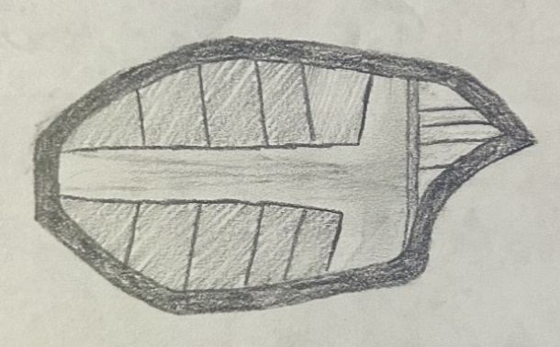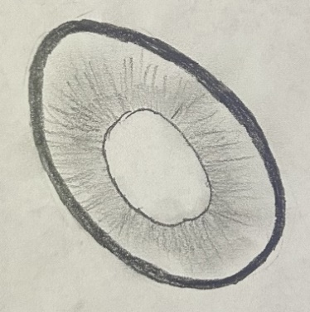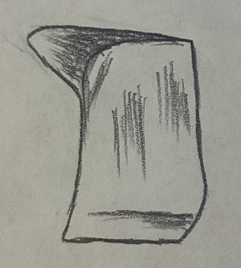

Figure 2: Headlight Subsystem Concept Sketches

L Concept Sleek Concept Lock Concept

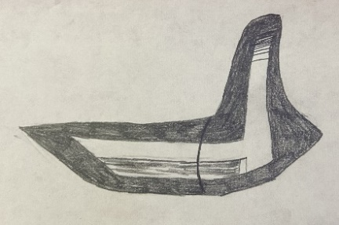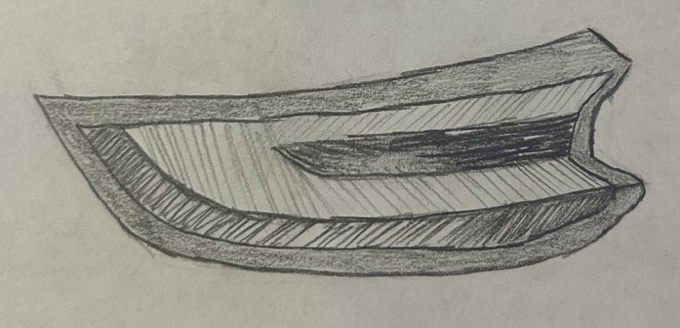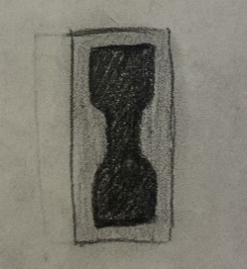

Figure 3: Taillight Subsystem Concept Sketches

## Trine “Power T”

To incorporate some Trine school spirit into the design, the team will 3D-print the Trine logo which will likely be placed somewhere on the rear end of the RC Truck to minimize the effect of the part on the truck’s speed. A sketch of the Trine T is shown in (Figure 4).

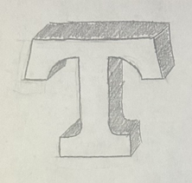

Figure 4: Trine School Spirit Subsystem Concept Sketch

## Tires

For the set of racing tires, the team has narrowed it down to three similar designs. All three are wide and have minimal tread to maximize surface contact. The first design consists of a single tread through the middle of the tire with further treads branching out on either side. The second design has a more intricate tread design with several curved lines of varying lengths and a V-shape pattern. The third design has the same single tread through the middle as the first and a four-like shape repeated on each side. Sketches of these designs are shown in (Figure 5).

Spiderweb Concept Antler Concept U Concept

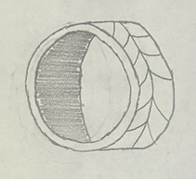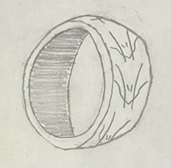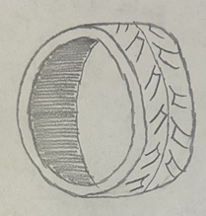

Figure 5: Racing Tire Subsystem Concept Sketches

For the set of towing tires, the team has selected three similar designs, each with some distinct different qualities that make them optimal for towing. They aim to increase friction to allow the truck to have better traction on the ground. The first design is an all-terrain style tire, which could allow for good traction and towing capabilities on the different surfaces that the truck will encounter. The second emulates a tire that would be found on a tractor or other pieces of heavy machinery, which are often designed to carry heavy objects. The third is a more traditional all-weather tire with a more aggressive tread pattern, which would allow the truck to have good traction while also not limiting its maneuverability. It is important to note that, for both the towing and racing tires, the amount of air in the tires, and the stiffness of the material used, will play a large role in the performance of the tire in both the towing and racing tasks.

Puzzle Concept Deep Concept Parallelogram Concept

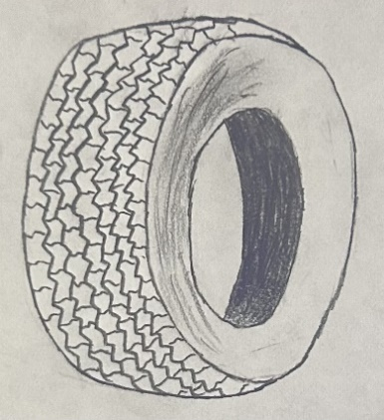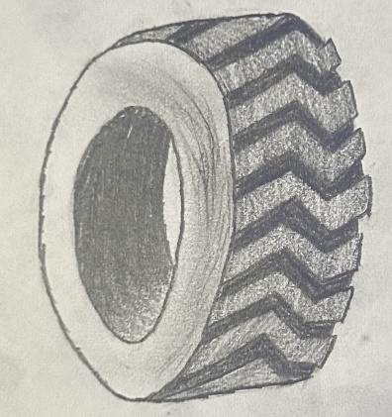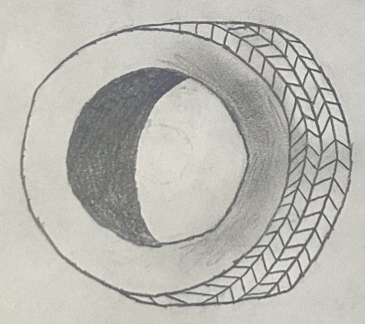

Figure 6: Towing Tire Subsystem Concept Sketches

## Aluminum Bumper and Hitch

For the set of bumpers, the team sketched three designs (Figure 7). The first design is a simple, flat aluminum bumper that is easy to manufacture. The second design is like the first but is curved to be slightly more aerodynamic and more aesthetically pleasing. The third design is a curved skeletonized bumper that trades energy absorption and protection for weight. For the hitches, the team selected three designs, the first being a standard ball hitch. The second design is a hook hitch that contains no moving parts and is simple to manufacture. The third design is simply a pin which is used to connect two identical appendages that would be present on both the bumper and the trailer.

Block Concept Curved Concept Open Gate Concept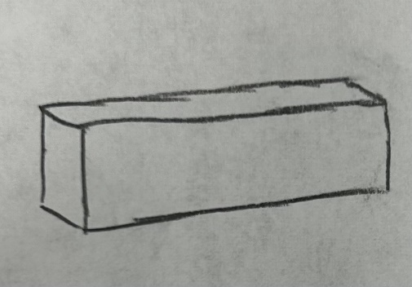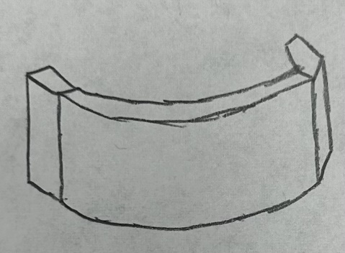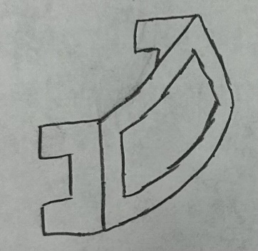

Ball Concept Hook Concept Penetration Concept

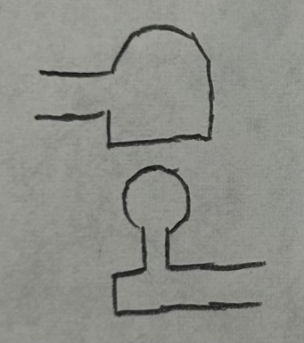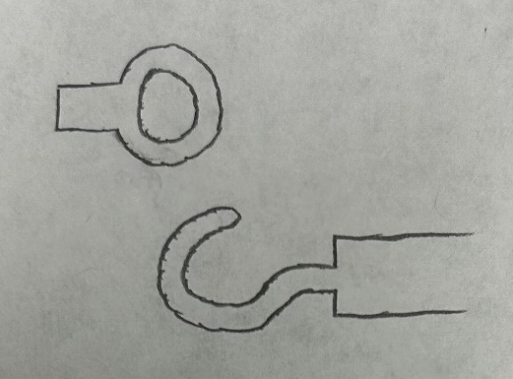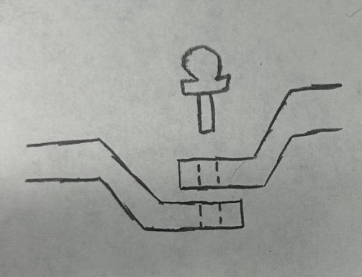

Figure 7: Bumper and Hitches subsystem concept sketches

## Trailer

For the set of trailers, the team sketched three similar designs (Figure 8). The flatbed trailer is long and has a low center of mass, lightweight, and able to transport varying loads. The pickup truck bed has the “trailer” integrated into the rear of the truck. This design is easy to implement into the existing shell, at the cost of bed space and load capacity. The third design is an enclosed trailer that is potentially more aerodynamic than the flatbed trailer and can protect and contain loads better. This is at the cost of potentially not being able to haul large loads due to space constraints.

Single Axle Concept Long Leg Concept Open Gate Concept

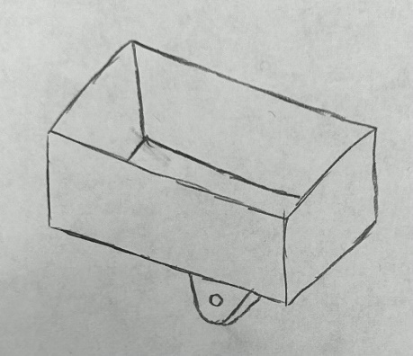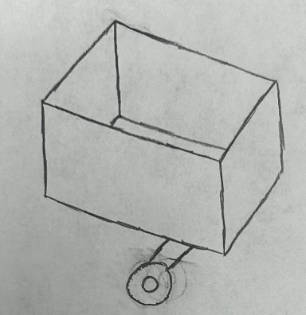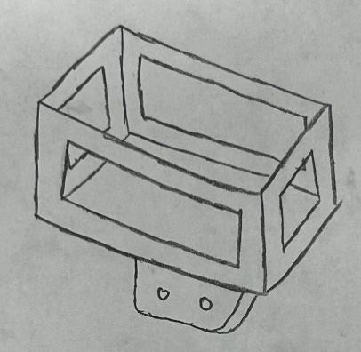

Figure 8: Trailer Subsystem Concept Sketches

# Concept Selection (Design Iteration 1)

## Polymer Body

For the body geometry subsystem, the team was tasked with deciding between three sleek designs, each of which with their own unique strengths. The team judged the models based on four categories, aerodynamics, racing, towing, and feasibility in (Table 2). The first, aerodynamics, is how aerodynamic each model is and how they reduce drag. The third concept was the most aerodynamic due to its racecar-like build and spoiler while the first design was the least aerodynamic due to its sharp edges. The next two categories, racing and towing, are how well each model will likely perform in the actions of racing and towing. The team decided that the third design would be best suited for racing while the second design would be best suited for towing. Finally, the team judged the feasibility of each concept, that is how realistic it is to produce each concept, which was judged to be about equal for all three. The team decided to weigh racing and towing equally at 25% each, with aerodynamics weighted at 35% and feasibility at 15%. Taking these weights into account, the team chose to pursue the third design.

Table 2: Concept Selection Matrix for Body Geometry

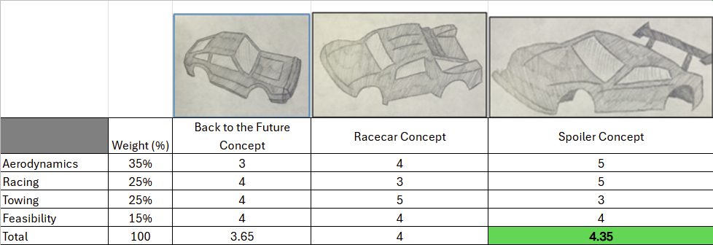

For the body material subsystem, the team decided to judge the body’s material based on durability, weight, price, and ease of production, as indicated in (Table 3). The durability was scored based on the material’s ability to remain functional with excessive maintenance. Density played a large role in deciding the material that will be used for the body as it is important that the truck isn’t slowed down by a heavy shell. The final categories considered were price and ease of production, or how easily the material can be changed into its final desired shape. The team decided to move forward with polycarbonate because of its good balance of all factors.

Table 3: Concept Selection Matrix for Body Material

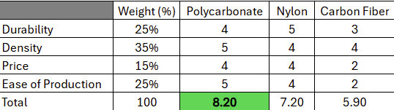

## Head and Tail Lights

For the head and taillights subsystem, the team developed three concepts for both the headlights and taillights. The criteria used for the lights were appearance and feasibility, meaning how good they look and how logical it is to manufacture them, as indicated in (Table 4, Table 5). For the headlights, the team preferred the first two concepts over the third, but the difference was made by feasibility as the first concept would be significantly more difficult to produce than the second concept. Regarding the taillights, the first two concepts certainly trump the third in terms of appearance but are far more difficult to produce than the third concept. As a result, the team decided to move forward with the third concept.

Table 4: Concept Selection Matrix for Headlights

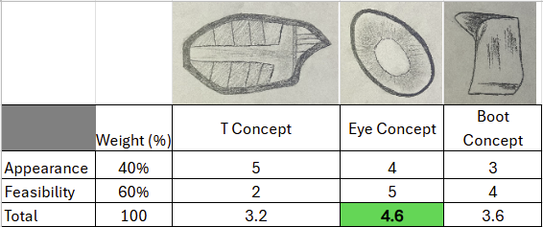

Table 5: Concept Selection Matrix for Taillights

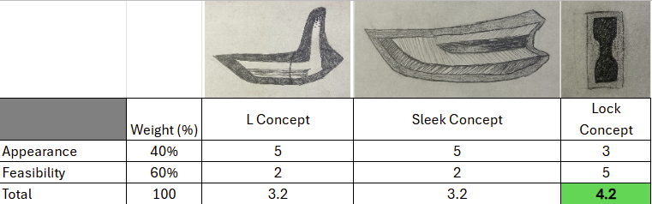

## Tires

For the racing tires subsystem, the team decided to judge the models on treads and feasibility, as indicated in (Table 6). The treads category is how much traction each tire will provide. For racing tires, it is ideal to have fewer and shallower treads to maximize surface contact. For this reason, along with the fact that it should be easier to produce, the first concept was chosen.

Table 6: Concept Selection Matrix for Racing Tires

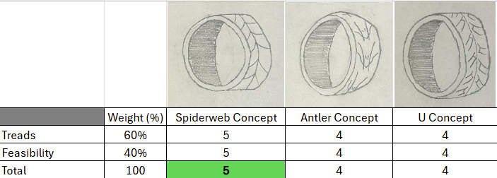

For the towing tires subsystem, the team used the same criteria as used for the racing tires subsystem. However, because the tires are designed for different applications, the treads category is slightly different. Ideal treads for towing a load are deep. The weights of each tire concept, while important, weren’t considered as a factor as these are simply concepts of a design which doesn’t consider material, size, etc. So, due to the vast depth of the treads on design two and its greater feasibility, the team decided to move forward with it (Table 7).

Table 7: Concept Selection Matrix for Towing Tires

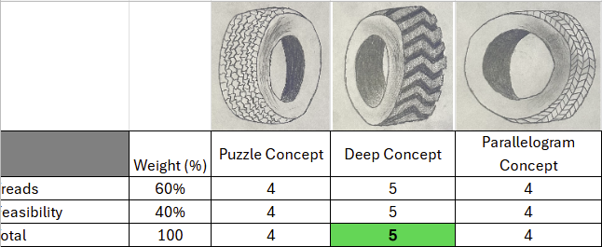

## Aluminum Bumper

For the aluminum bumper geometry subsystem, the team decided to judge the concepts based on weight distribution, volume, and feasibility, as indicated in (Table 8). The weight distribution section was judged on how much the bumper would affect the center of mass for the vehicle, which was the same for all three concepts. The volume section was judged based on how little volume it took up. The third and final was feasibility, this was judged on how easily this would be to manufacture. Feasibility was weighted the highest, so the team decided to proceed with concept number three.

Table 8: Concept Selection Matrix for Bumper Geometry Subsystem

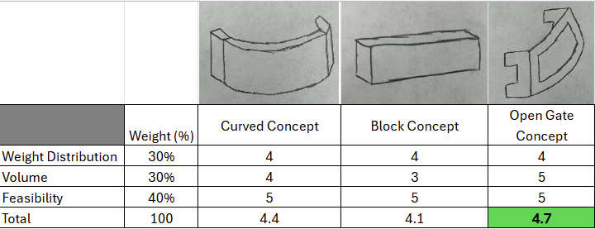

## Trailer Hitch

For the trailer hitch geometry subsystem, the team judged the hitch geometries based on feasibility, simplicity, and strength, as indicated in (Table 9). The feasibility section was scored on how easy it would be to manufacture. Connectivity is how well each hitch connects the bumper and trailer. Strength was scored based on how well each hitch would handle vibrations and stresses caused by the load on the trailer. Since strength was the most important feature of the design, the team decided to proceed with concept two due to its greater strength.

Table 9: Concept Selection Matrix for Trailer Hitch Geometry Subsystem

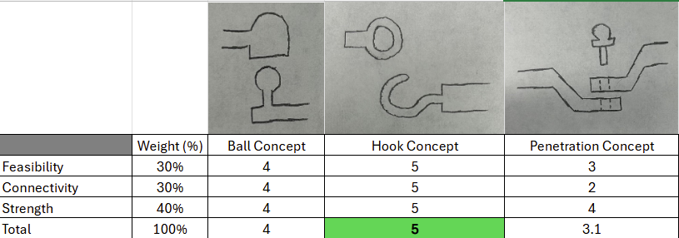

## Trailer

For the trailer geometry subsystem, the team decided to judge the hitch geometry based on stability, feasibility, capacity, and strength, as indicated in (Table 10). Stability was judged on how stable the designated load would be when moving and vibrating. Feasibility was judged on the ease of manufacturing the trailer. Capacity was judged by how large a load it could carry, and strength was judged on how much weight the trailer could withstand, which will also be highly reliant on the material chosen. Since capacity was the greatest factor in the design, the team decided to proceed with concept one.

Table 10: Concept Selection Matrix for Trailer Geometry Subsystem

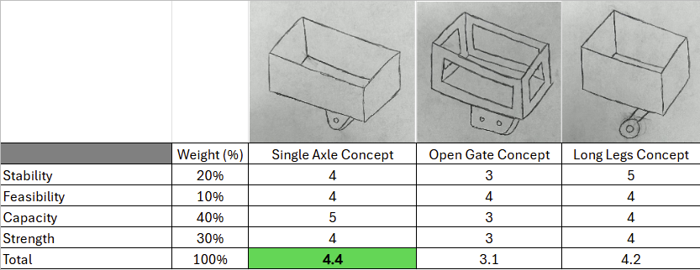

For the trailer material subsystem, the team decided to judge the trailer material on durability, weight, price, and ease of production, as indicated in (Table 11). The durability was scored based on the material’s resistance to scratches, deformation, and cracking. The weight category was scored based on the material’s weight. The price category was scored based on ease of production, or how easily the material is to change into its final desired shape. The team decided to move forward with aluminum because of its good balance of all factors.

Table 11: Concept Selection Matrix for Trailer Material Subsystem

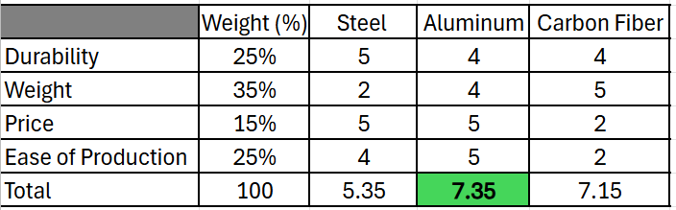

# Detailed Design Discussion (Design Iteration 1)

This section outlines the process of designing the prototype for each subsystem for design iteration one. This section also includes the bill of materials for the first design iteration and the testing and validation of the initial prototype from each subsystem.

## Polymer Body

The body concept chosen for the car aims to optimize both the towing and racing abilities of the truck. With a spoiler to reduce drag and lift, the team designed this body concept to have the appearance of a race car, with the necessary aerodynamic properties to excel at racing. The rough dimensions for the body were taken using digital calipers and rough sketches were drawn on paper before transferring them into CAD. For the first design iteration, the body panels of the truck were cut using the laser cutter and glued together with hot glue. The body was drawn in CAD, and additional part files were drawn for the top and side panels of the car. The body panel files were saved as a DXF file and then transferred to the laser table for cutting. The engineering drawings for the first iteration are shown in (Figure 9).

After the files were transferred, the team placed a sheet of cardboard on the laser table and cut out the top and side panels of the body. Since the manufacturing methods available for design iteration 1 did not allow the team to express the full detail for the body concept, the first design iteration was used to ensure that the dimensions of the body fit the car without impeding the wheels of the car, and that the wheel wells fit the dimensions of the chassis. The shell is shown in (Figure 10).

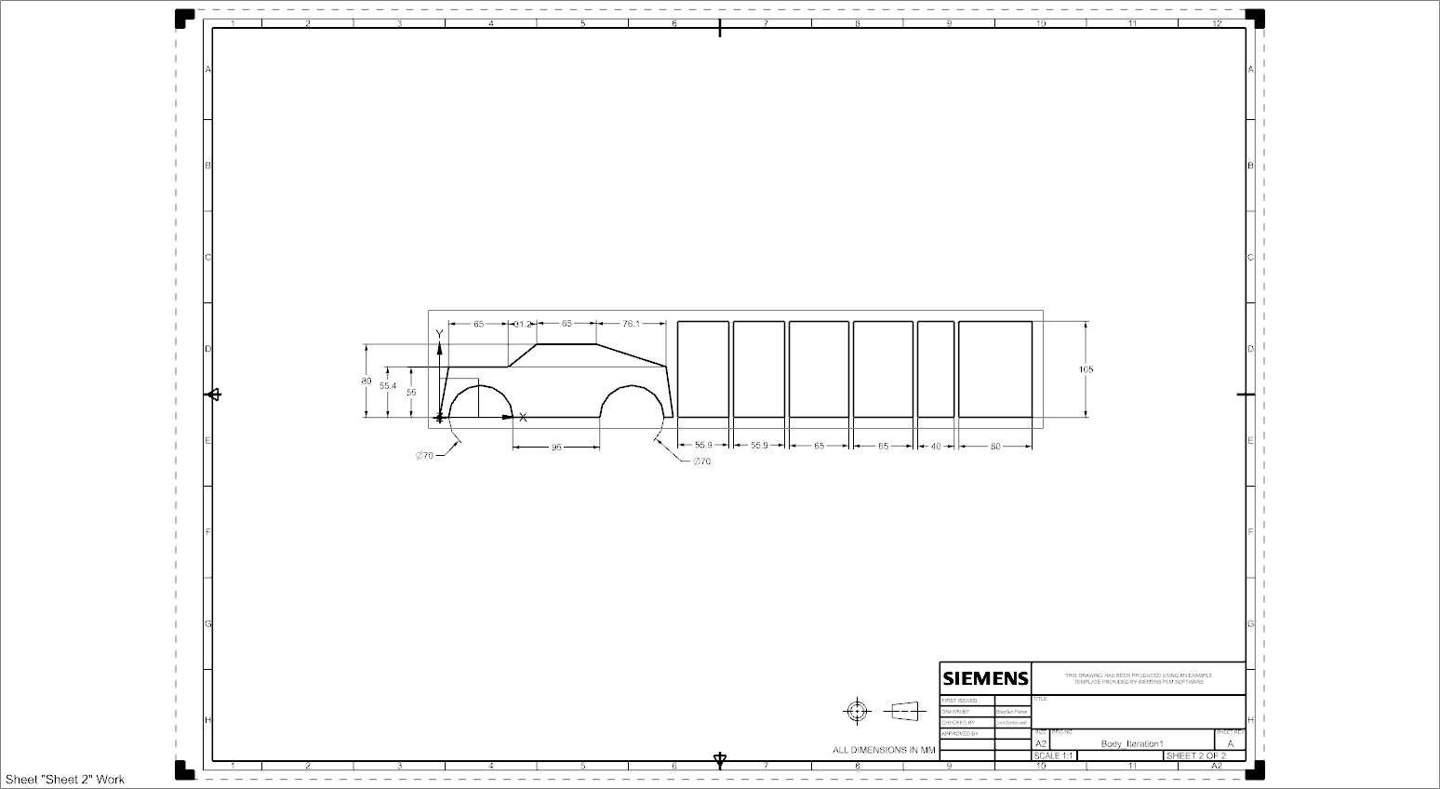

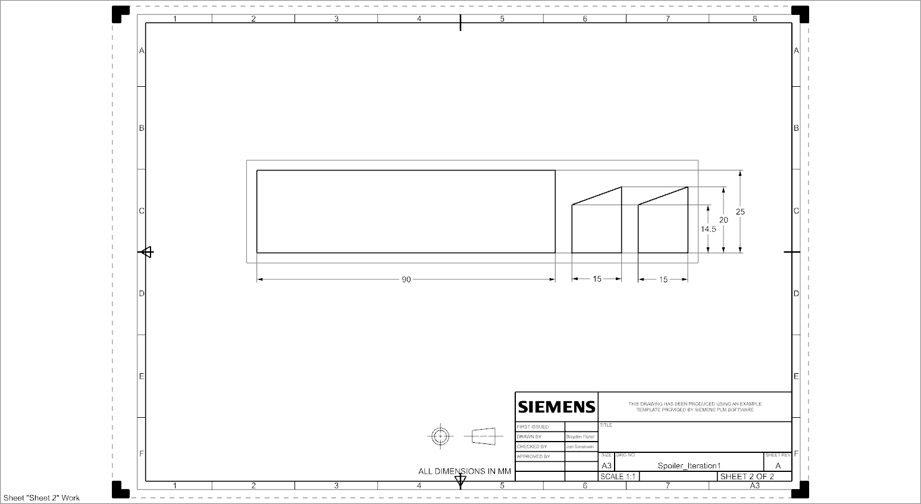

Figure 9: Engineering Drawings for Body Components

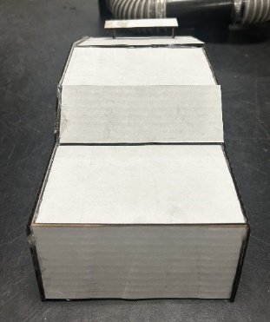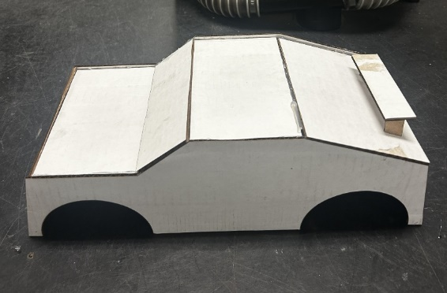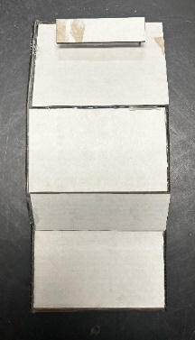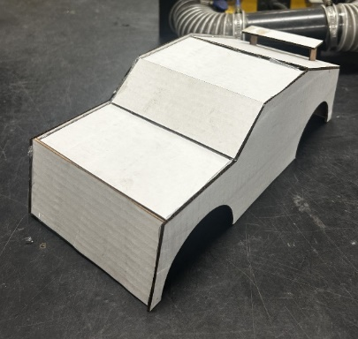

Figure 10: Body Prototype 1

## Tires

The first iteration of the tire, shown in (Figure 12), was chosen because of its tread patterns for their designated job. While one was chosen for racing and the other for towing, both would have the same fitting on the truck, and so only one prototype was manufactured to ensure the correct fit with the axle of the truck. The tires were drawn in CAD using dimensions obtained using calipers. The engineering drawings for the tire are shown in (Figure 11). Those CAD files were converted to DXF files and sent to the laser table for cutting. The goal of the first iteration was to confirm that the axle fit snugly into the tire and that the hexagon cutout on the axle fit into the new tire design to ensure the new tire fit well and did not slip. Given the manufacturing processes available for design iteration 1, the team did not feel it necessary to create a 3-D tire in order to save on material costs. With the dimensions for the axle and hexagon cutout confirmed, future iterations will include treads made from rubber and a 3-D printed rim.

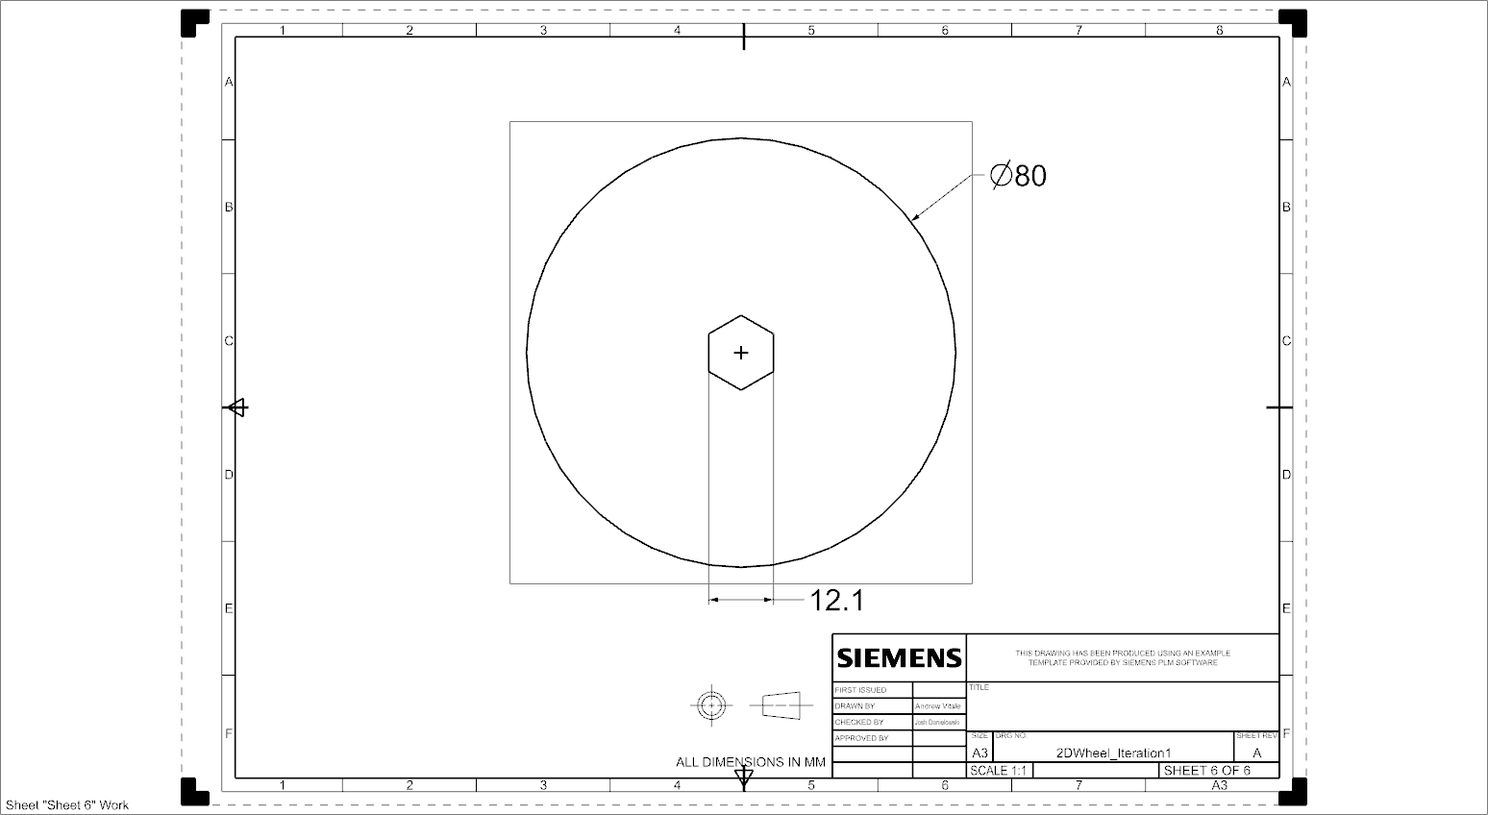

Figure 11: Engineering Drawing for Wheel

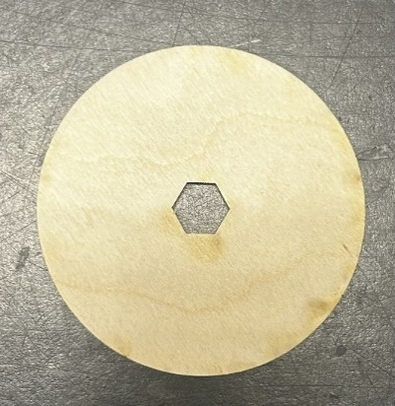

Figure 12: Wheel Prototype 1

## Trine “Power T”

The Trine “T”, shown in (Figure 14), was laser cut using cardboard for design iteration 1 to ensure dimensions would fit on the roof of the body. Since the component is purely cosmetic, the goal of the first design iteration was to assess the dimensions. The dimensions were taken using a ruler and drawn in CAD. The CAD file was then saved as a DXF file and transferred to the laser table for cutting. The engineering drawings for the Power T are shown in (Figure 13). The final iteration will be cast from aluminum, ensuring that the final design adds a bit of weight to allow better traction from the tires, but not so heavy that it weighs down the truck.

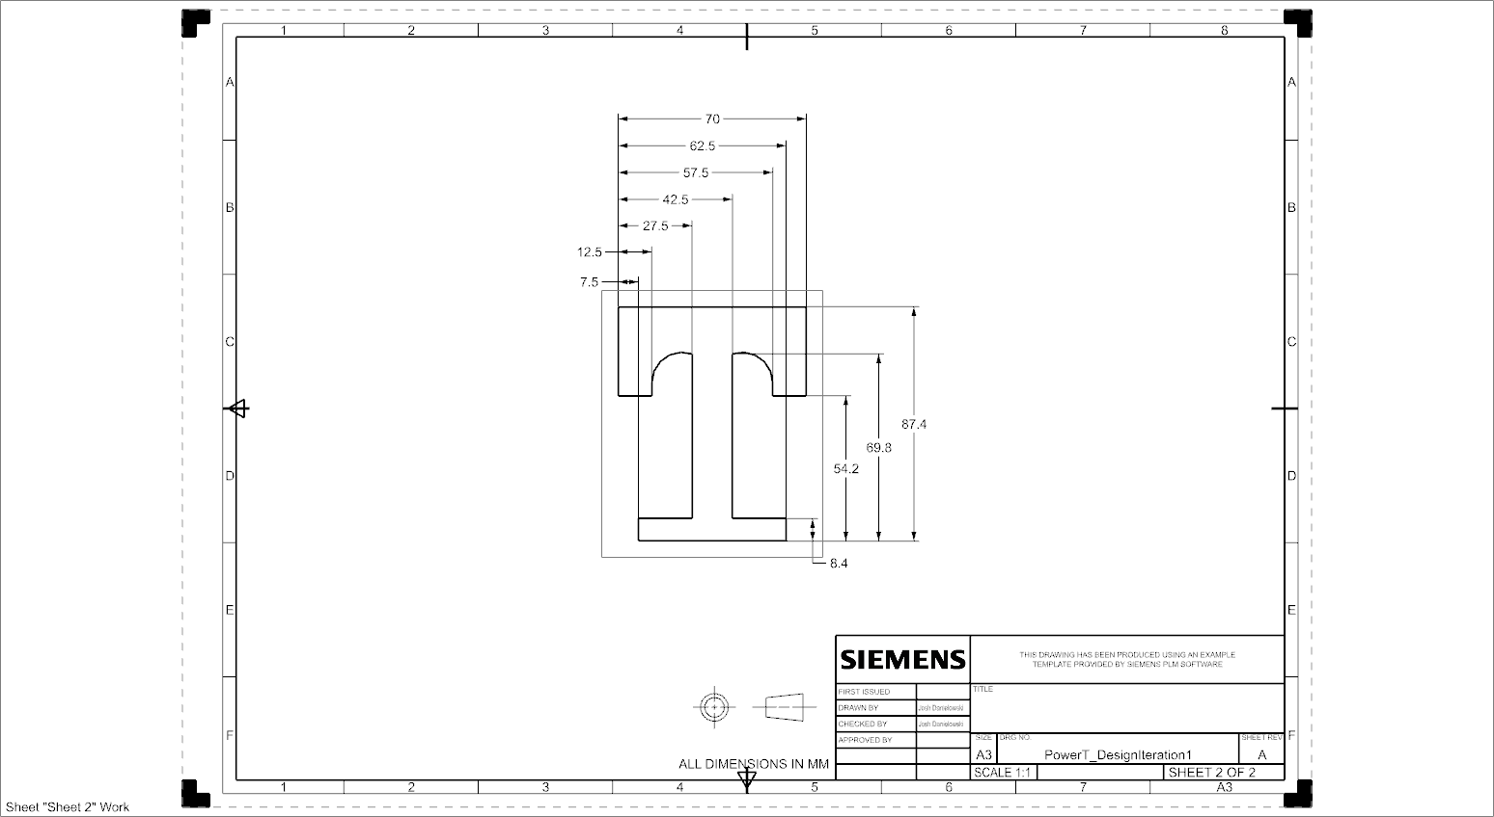

Figure 13: Engineering Drawing for Power T

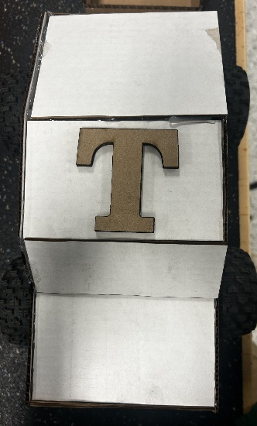

Figure 14: Power T Prototype 1

## Bumper

The design for the bumper, shown in Figure 16, was chosen due to its similar qualities to a standard bumper and lesser mass. The design is a simple rounded bumper with a rectangular cutout and a further attachment at the bottom, which will allow it to be attached to the RC truck the same way the original bumper was. The dimensions of an ideal bumper were taken using calipers and were transferred onto rough sketches, which allowed the bumper to be easily drawn in CAD. For the first design iteration, due to the limitation that only cardboard is allowed, the team simplified the design to make it easily made in 2D. This iteration of the bumper consists of a flat rectangular base and the same rectangular cutout in the center of the base. The rectangular piece used to attach the bumper to the RC truck is the same. The CAD files were then saved as DXF files and transferred to the laser table for cutting. These engineering drawings are shown in (Figure 15). The bumper was cut into two separate parts, the bottom, which will attach to the truck, and the vertical piece that will protect the chassis of the truck. The final design for the bumper will be made from cast aluminum, which will add a bit of weight to the rear of the truck and support the weight of the trailer and road, but not so much as to weigh the truck down.

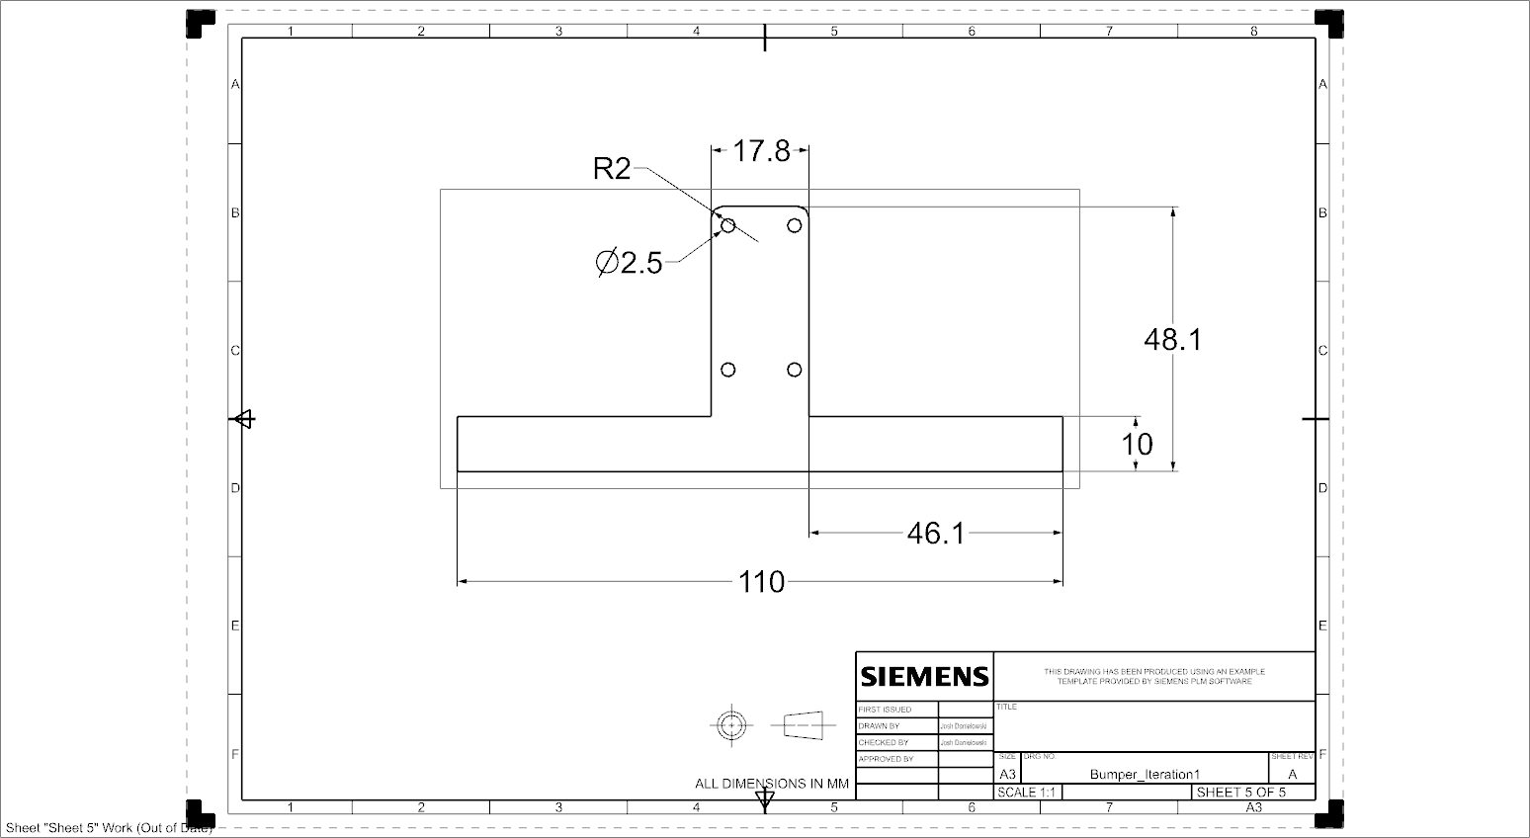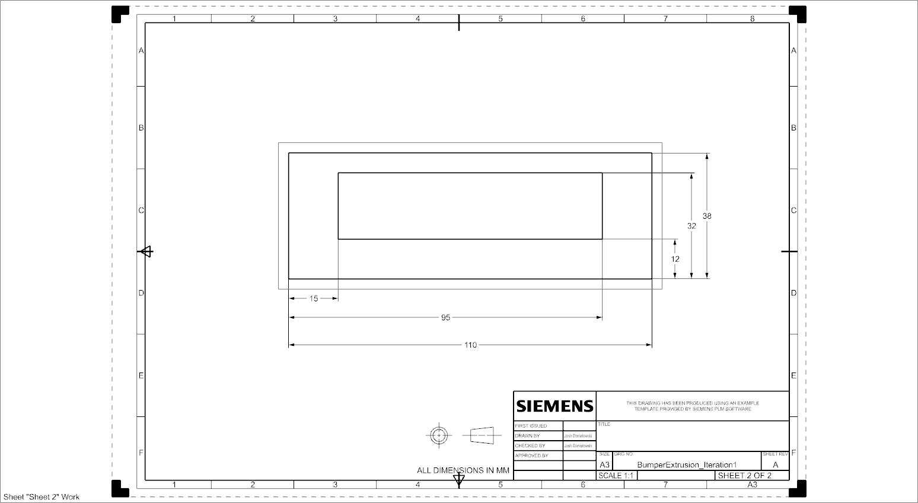

Figure 15: Engineering Drawings for Bumper Components

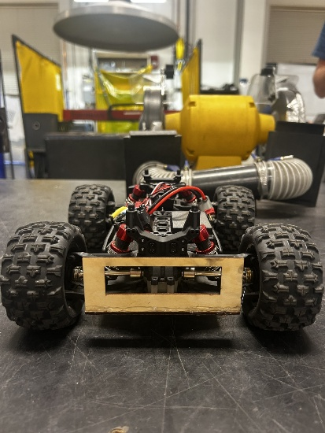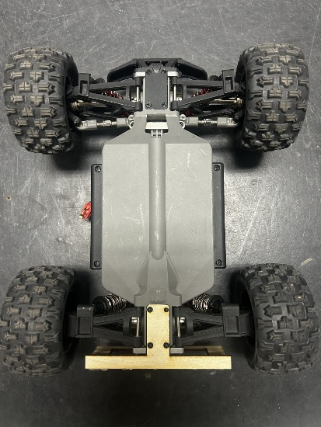

Figure 16: Bumper Prototype 1

## Trailer

The design for the trailer, shown in (Figure 18), was chosen due to its ability to support the designated weight and to easily attach to the trailer. The dimensions of the trailer were taken with respect to the truck itself, using a slightly smaller width and length than the truck chassis. These dimensions were taken using a ruler and transferred onto rough sketches, which were then transformed into CAD parts. Similarly, the hook was drawn in two dimensions with respect to the dimensions of the loop that will be attached to the bumper. These measurements were taken using calipers, which were transferred onto rough sketches and then drawn in CAD. The CAD files were saved as DXF files and transferred to the laser table for manufacturing. These engineering drawings are shown in (Figure 17). Due to the manufacturing processes available for the first iteration, the five sides of the trailer were each drawn as separate rectangles and cut from the same piece of cardboard. The pieces were then assembled using tape and hot glue to achieve the final geometry of the trailer. The final iteration will be made from cast aluminum to both support the weight of the load and to meet the stress requirement set by the team.

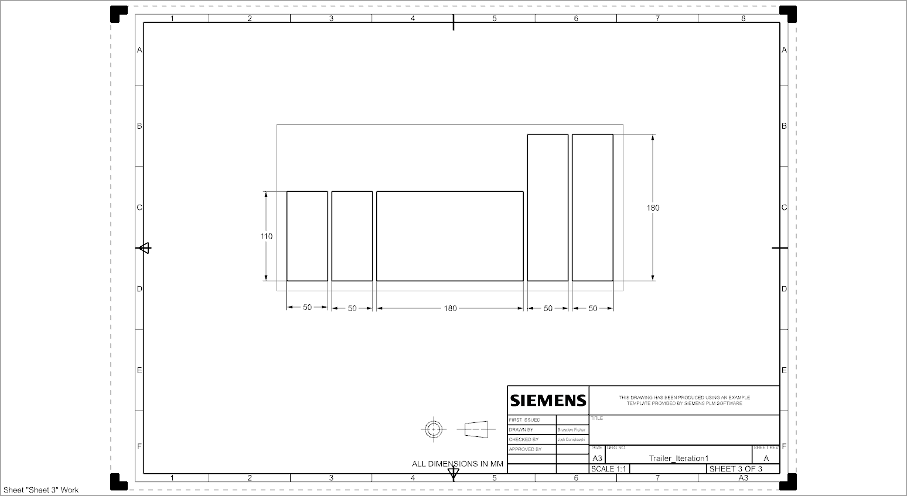



Figure 17: Engineering Drawing for Trailer Components

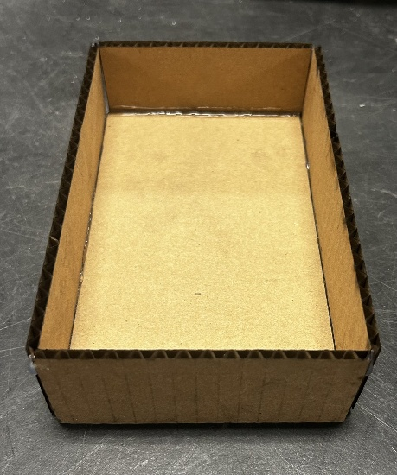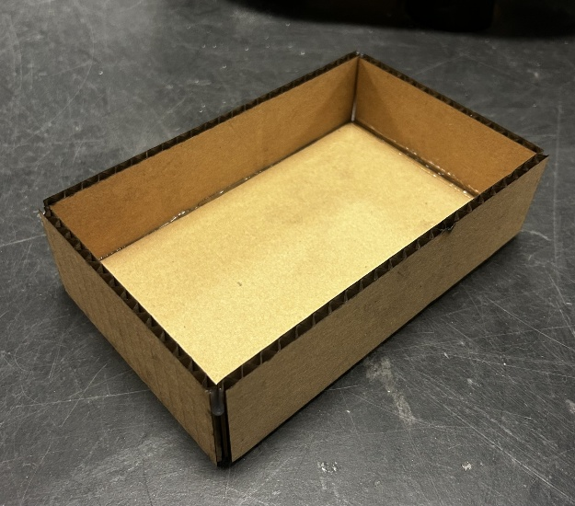

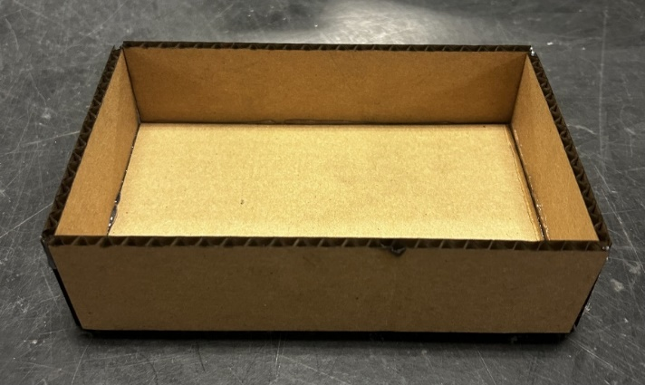

Figure 18: Trailer Prototype 1

## Hitch

The hitch, shown in (Figure 20), was chosen due to its secure latching design that would ensure the trailer would stay securely connected to the truck. The design utilizes a hook and loop mechanism to allow the trailer to be securely attached to the rear bumper of the truck. The measurements for the hitch mechanisms were found with respect to the body, bumper, and trailer dimensions and were taken using calipers. The dimensions were recorded on paper in the form of rough sketches, then transferred to CAD software. The engineering drawings for the hitch are shown in (Figure 19). The CAD files were then exported as DXF files and transferred to the laser table for cutting. The hitch was cut from basswood and used primarily to test the fitment of the pieces together. In future iterations, the loop will be connected to the rear bumper made of aluminum, and the hook will be a part of the trailer, also made of aluminum.

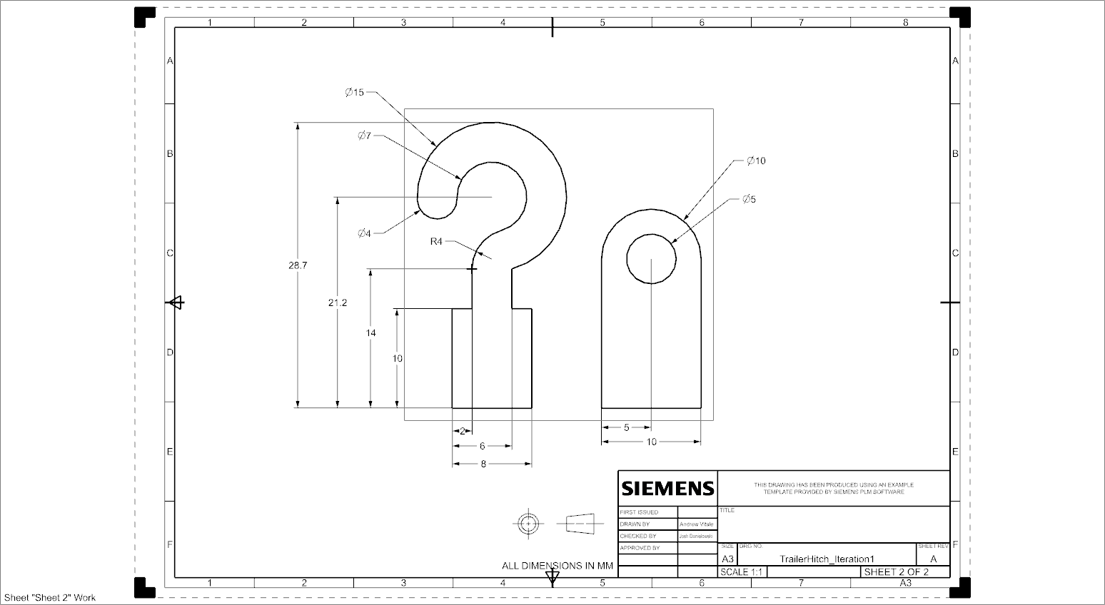

Figure 19: Engineering Drawing for Hitch

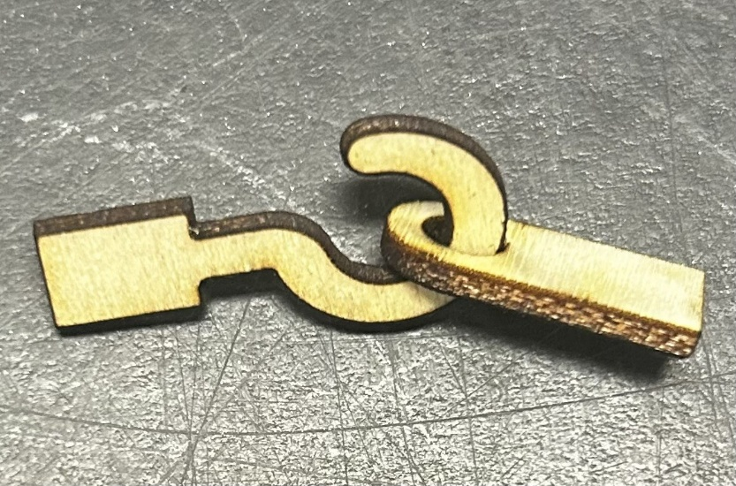

Figure 20: Hitch Prototype 1

## Bill of Materials

The bill of materials for design iteration one, shown in (Table 12), lists the different components used to construct the team’s first prototype. The team decided to use a mix of cardboard and basswood sheets to construct the first prototype, as those were the easiest to fit together using two-dimensional shapes cut from the laser cutter to build the three-dimensional geometries that represent the concepts generated by the team. The size for each component was determined using the sum of the areas of each two-dimensional shape. These areas were calculated using the frame dimensions determined by the laser cutter, so the scrap material is included in our calculations for cost, since those scrap pieces are no longer useful for manufacturing other parts. The cost per square millimeter was calculated by dividing the total area of the product per pack of material by the total cost of the pack of material, including a 6% sales tax. The materials used for design iteration one were meant to test the size and fit of parts to the truck chassis and will not be used in future iterations. Since all of the materials and the RC truck were provided to the team, the total cost for the first prototype was $0.

Table 12: Bill of Materials for Prototype 1

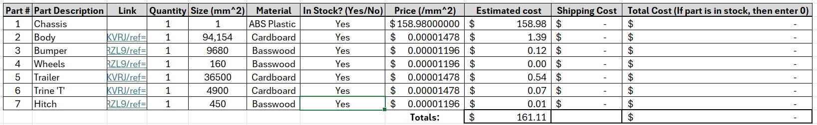

## Manufacturing and Assembly Plan

For each subsystem: polymer body, tires, Trine “T”, bumper, trailer, and hitch, a manufacturing plan was created. This was done by creating flowcharts which organize the tasks necessary in chronological order and serve as a tool to follow the team’s progress. Various shapes were used throughout the flowcharts, which represent distinct steps in the manufacturing process. The shape’s function and description are found below in (Table 13).

Table 13: Legend for Manufacturing Flowcharts

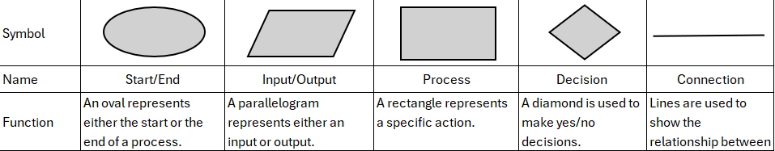

### Polymer Body

The manufacturing plan for the polymer body is displayed in (Figure 21). Due to the limitations of the first design iteration, the team simplified the CAD for the polymer body into several 2D geometries. The team created a side profile for the body, which was laser-cut twice along with six rectangles of specific dimensions to form the top of the body and connect the two side profiles. The team cut two identical trapezoids and a rectangle, which were assembled to replicate a spoiler. All these pieces were glued together and placed on the RC truck to verify the correct dimensions. After analyzing the complete cardboard body, the team concluded that the next design iteration would need to be thinner and slightly shorter, with the wheel wells being smaller. These issues will be addressed in design iteration two.

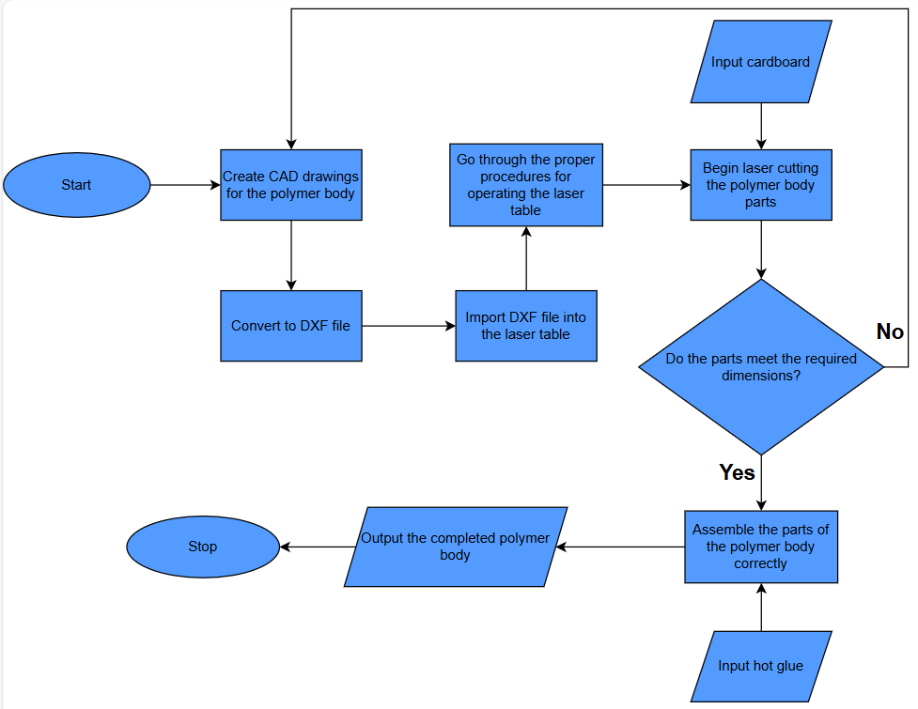

Figure 21: Manufacturing Flow Chart for Body

### Tires

The manufacturing plan for the tires is shown in (Figure 22). To test the fitment of the tire to the axle, the team produced a single tire part. This was done by making a simple tire-shaped CAD drawing and laser cutting it out of basswood. This part was placed on the axle of the RC truck and its diameter was compared to the existing tires. After analyzing the fit, the team concluded that the part meets the dimensional requirements and fits well on the existing chassis.

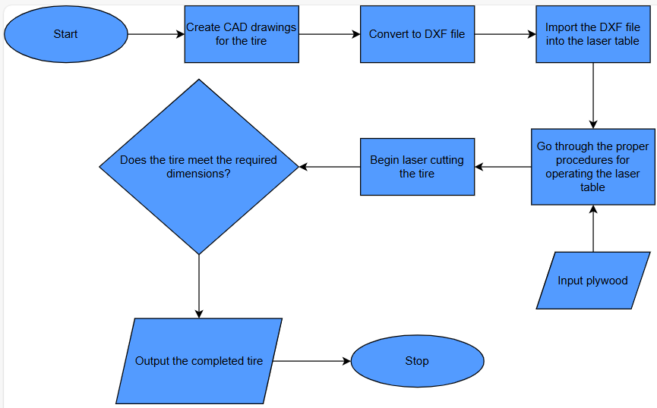

Figure 22: Manufacturing Flow Chart for Tire

### Trine “Power T”

The manufacturing plan for the Trine “Power T”, which will be used to display school pride, is shown in (Figure 23). First, the logo was drawn in CAD and cut out of cardboard using the laser cutter. The dimensions of the Trine “Power T” allow for it to be easily attached to the top of the polymer body, without affecting the RC truck’s performance. After placing the finished part on the roof, the team concluded that the dimensions were sufficient.

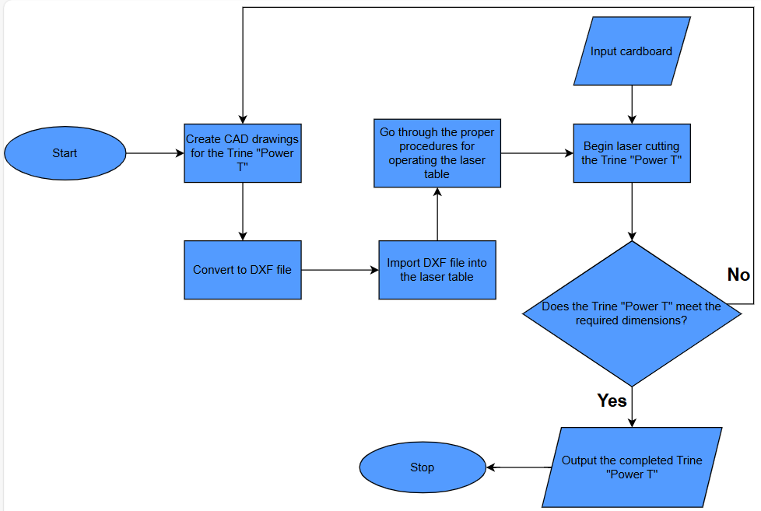

Figure 23: Manufacturing Flow Chart for Power T

### Bumper

The manufacturing plan for the bumper is displayed in (Figure 24). First, the bumper was drawn in CAD and then laser-cut out of basswood. This iteration of the bumper was designed to verify the dimensions of a bumper that can be successfully screwed into the rear of the RC truck in the same manner as the original part. It consists of a base with four holes, which allows for the bumper to be easily attached to the RC truck, and a rectangular section with another rectangle cut out of it, which makes up the actual bumper. This design choice reduces the bumper's mass while ensuring successful attachment and proper dimensional accuracy. After assembling the part, the team concluded that it meets the given requirements.

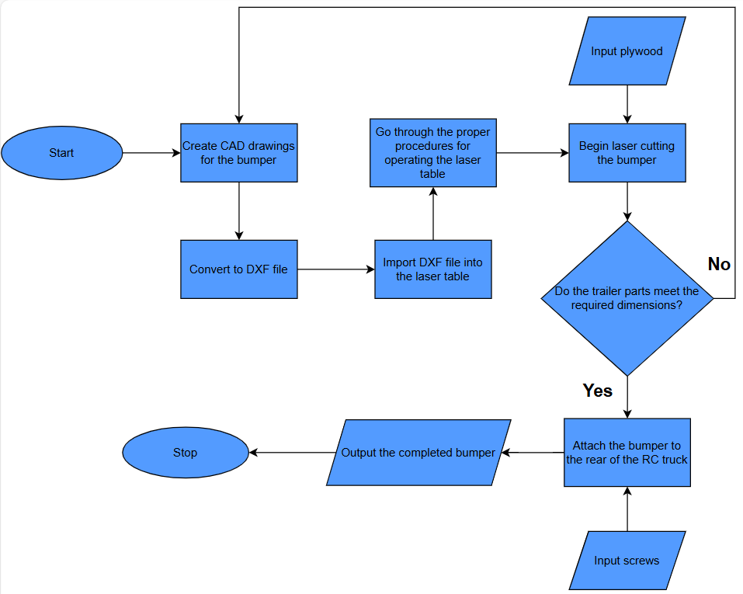

Figure 24: Manufacturing Flow Chart for Bumper

### Trailer

The manufacturing plan for the trailer is displayed in (Figure 25). Similar to bumper, the trailer was drawn in CAD and laser-cut out of cardboard. Due to the constraints of using only the laser table for the first design iteration, the team created CAD drawings of rectangles with the specified dimensions, which were then cut and then glued together. This provided a strong baseline for the dimensions of the trailer, which this iteration is focused on nailing. After analysis of the trailer, it was determined that the dimensions of an ideal trailer were successfully replicated.

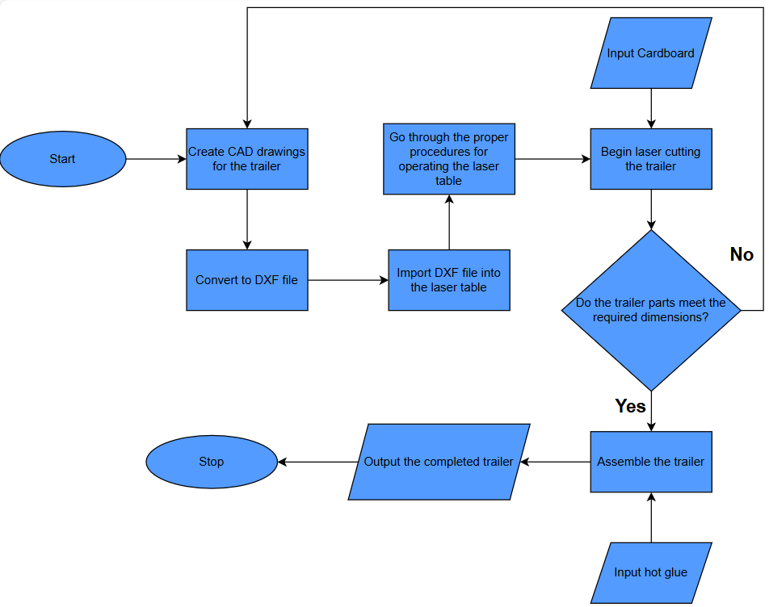

Figure 25: Manufacturing Flow Chart for Trailer

### Hitch

The manufacturing plan for the hitch is displayed in (Figure 26). The limitations presented for the first design iteration forced the team to take a new approach to the hitch. These constraints made it difficult to produce the two sections of the hitch already attached to the bumper and trailer. As a solution, the team produced the hitch as a separate 2D model. This allowed for an accurate assessment of the dimensions of the hitch while still adhering to the limitations of the first iteration. The team determined that the hitch produced met the dimensional requirements.

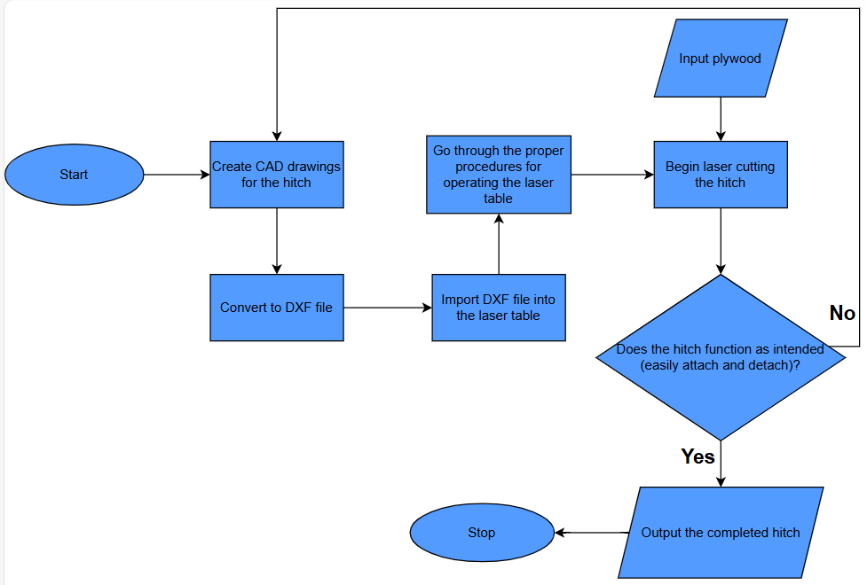

Figure 26: Manufacturing Flow Chart for Hitch

## Testing and Validation

For this design iteration, the team chose six criteria: body dimensions, tire outer diameter and connection, Hitch connection, Trine pride, bumper width, and trailer dimensions. (Table 14) lists the team’s requirements, reasonings, expected and actual outcomes, and a pass or fail rating based on the actual outcome. The body of the car was slightly larger than expected given our measurements, with the wheel wells not centered on the wheels. The cardboard body was loosely fitted to the chassis of the RC car to test fitment and clearance.

The tires were made from basswood, and the outer diameter was made to be roughly the same size as the actual tires on the RC car and to verify the mounting holes would fit the axle. After comparing the tire to the existing RC truck tire, the team concluded that the tire diameter was sufficient. In addition, when the tire was placed on the axle, the team concluded that the dimensions of the hexagon cutout for the axle were correct, and that the wheel would fit well on the axle without slipping.

The hitch connection was also made from basswood, and the dimensions were developed by the team with a thickness that would support the weight of the load while ensuring that the trailer stayed connected to the truck. The first iteration was to test the dimensions of the connection, and after producing the part and assessing the fit, the team decided to move forward with those dimensions for future design iterations.

The Power T was cut out of a piece of cardboard and mounted to the top of the car body. After comparing the dimensions to that of the roof of the body, the team concluded that it was a good fit for the roof of the car, and that the team will proceed with those dimensions for design iteration two.

The bumper was made from cardstock first, to test if the mounting holes lined up and the tolerances were correct. The bumper was then made from basswood and glued together to make sure the bumper did not interfere with the wheels or axles. The trailer was laser cut from five pieces of cardboard and glued together with hot glue. This was to test the overall size of the trailer and the bed area. After testing, the team concluded that both the bumper and trailer met the expected outcome and would move forward with those dimensions for future design iterations.

Table 14: Testing and Validation for Prototype 1

|  |  |  |  |  |
| --- | --- | --- | --- | --- |
| **Requirement** | **Reason** | **Expected Outcome** | **Actual Outcome** | **Pass/Fail** |
| Body Dimensions | Must fit the RC truck which had an original shell with the dimensions 24 x 11 x 8 cm. | 240 x 110 x 80 mm | 255 x 110 x 80 mm | Fail |
| Tire Outer Diameter/Hexagon Connection | Must have dimensions similar to the truck's original tires to properly fit existing chassis | do = 80-90 mm/w =12 mm | 88 mm/12.1 mm | Pass |
| Hitch Connection | To ensure that the hook fits the loop connection point on the bumper. | Hook secure in loop, fit easily | Yes | Pass |
| Trine Pride | To proudly represent the school of our team members. | Appearance of Trine "Power T" | Yes | Pass |
| Bumper Width | To ensure the bumper fits onto the RC truck properly. | 90 mm | 90 mm | Pass |
| Trailer Dimensions | So that the trailer is proportional to the RC truck and can handle the designated load. | At least 140 x 80 x 40 mm | 180 x 100 x 50 mm | Pass |

# Design Summary (Design Iteration 2)

For the second iteration of the team’s redesign of the RC truck, the focus was on the functionality of the final product. With the fitment of the mating parts determined in design iteration 1, it was time to create a three-dimensional prototype to assess functionality. The team made several changes based on the initial testing and the feedback from the critical design presentation, along with some changes based on conversations with Joe. The dimensions of the body were reduced to accommodate the bumper and allow for full functionality of the tires. The trailer and bumper dimensions were unchanged, but the hitch connection was combined with both subsystems, simplifying the manufacturing process. In addition, the headlights and taillights were included in this iteration, where the team aimed to integrate the lights into the body.

# Concept Generation (Design Iteration 2)

## Polymer Body

One of the main points of emphasis from the team’s critical design review was the size and fit of the body. The first iteration of the body was both too wide and too long, interfering with the tires and the bumper. With these considerations in mind, the team looked to improve with the second iteration, ensuring that the dimensions of the body were compatible with the other parts and the chassis. The team also decided to combine the headlights and taillights with the body by cutting holes into the body. The third iteration will include clear plastic vac-formed headlights that will be attached to the polymer body. The body will still be vac-formed and will have cutouts for the head and taillights.

## Tires

With the important dimensions for the tire confirmed through the first round of testing, the team decided to proceed with the initial design chosen for design iteration one. The second iteration would produce a three-dimensional tire resembling the concept chosen for design iteration one.

## Trine “Power T”

The team was content with the outcome of the Power T design and its proportions compared to the body. The team decided to eliminate the Power T from the second iteration to save on materials. The final iteration Power T will be made from aluminum using lost foam casting.

## Bumper

The team was thrilled with the design and fit of the bumper met the dimensional requirements for iteration 1 and did not need any major changes. The team decided to move forward with the same concept for design iteration two.

## Trailer

The team was pleased with the shape and size of the trailer, but after considering the design and availability of materials, the decision was made to use 18-gauge steel instead of aluminum for the final iteration due to its higher yield strength and resistance to bending. With speed not being a factor during the towing demonstration, the additional weight of the material should not prevent the trailer from performing its designed task.

## Headlights and Taillights

For the second design iteration, the team decided to proceed with the same designs chosen in iteration one, which would be 3D printed to eventually be used to vacuum form the final iteration prototype. The team determined that the head and taillights would be formed from clear plastic and affixed to the body to enclose the LED lights, giving the shape of the lights shown in iteration one.

# Concept Selection (Design Iteration 2)

Following the critical design review presentation, the team decided to adjust some of the selection criteria used for the concept selection during design iteration one. The team added additional criteria to several of the selection matrices such as weight distribution for the body, tread depth and traction for the tires, and volume for the trailer. This also ensured that each matrix had at least three criteria. The team maintained most of its selections from iteration one but did adjust a few of the selections based on new criteria and findings from iteration one.

## Polymer Body

The team decided to proceed with the chosen body design and material, which proved to be the most effective given the new criteria, as seen in Table 15. It was determined that, although the truck would not encounter speeds at which aerodynamics would be a factor, the downforce created by the spoiler concept would still give it an edge in the racing portion of the final demonstration. Racing and towing were unaltered, but the weight distribution category was added, along with the appearance category. Ultimately, the team decided to proceed with the spoiler concept.

Table 15: Concept Selection Matrix for Body Geometry Subsystem

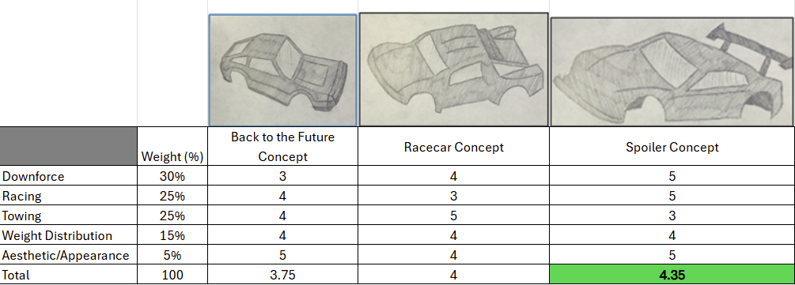

For the body material selection matrix shown in Table 16, the team revisited the selection criteria and decided to rename some of the criteria to more accurately convey the conversations had when selecting these concepts for the second iteration. The weights did not change; however, the “Price” category was changed to “Cost” to include not only the material price but all of the costs associated with production, including both primary and secondary manufacturing processes. In addition, the “Ease of Production” section was changed to “Machining Required”. The team decided to move forward with polycarbonate as the material for design iteration two.

Table 16: Concept Selection Matrix for Body Material Subsystem

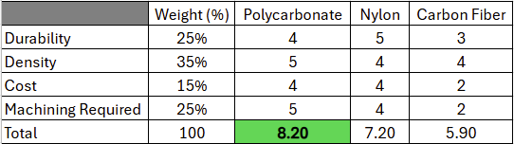

## Tires

The selection matrices for the tires shown in Tables 17 and 18 were altered to account for the time required to manufacture the tires. In addition, the “Treads” criteria were split into two separate criteria, those being “Tread Depth” and “Traction”, as the team wants to ensure that the truck will be able to handle the bonus course, which is said to include ramps and different obstacles. After reviewing the selection criteria, the team decided to proceed with the Spiderweb Concept for the racing applications and the Deep Concept for towing applications.

Table 17: Concept Selection Matrix for Racing Tire Subsystem

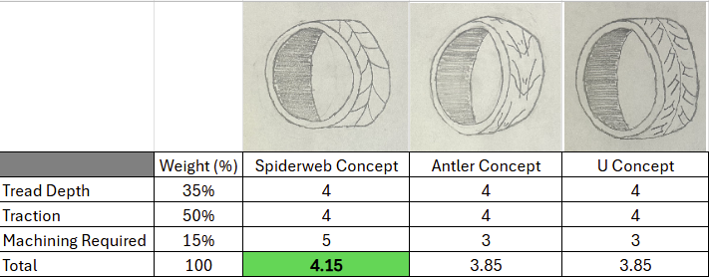

Table 18: Concept Selection Matrix for Towing Tire Subsystem

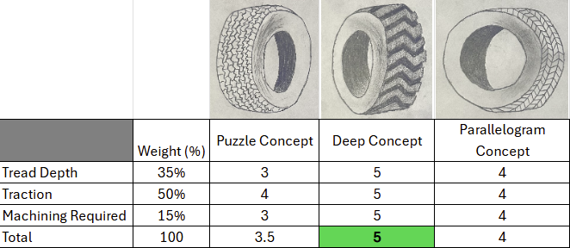

## Bumper

The selection matrix for the bumper shown in Table 19 was altered slightly, replacing “Feasibility” with “Body Compatibility” in response to the testing of the first design iteration. It became clear to the team that the compatibility of the bumper to work with the body attached was an overlooked design criterion, so the team strongly considered the compatibility of the bumper with the body for iteration two. The team ultimately decided to proceed with the Open Gate Concept for design iteration two.

Table 19: Concept Selection Matrix for Bumper Geometry Subsystem

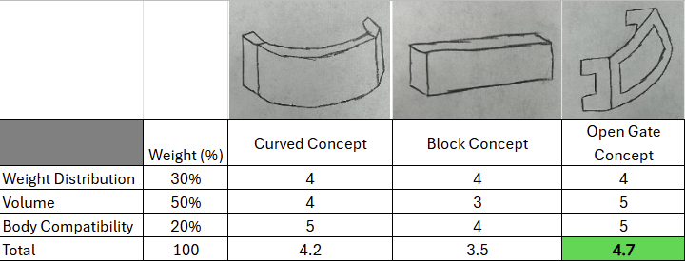

## Trailer

For the trailer geometry and material selection matrices shown in Table 20, the team adjusted the selection criteria to include volume, as the main function of the trailer will be to hold weights during the towing tests. After reviewing the new criteria, the team decided to proceed with the Single Axle Concept for the trailer geometry. However, after considering the properties of the materials proposed for the trailer, the team reevaluated the selection criteria and found that steel would better suit the function of the trailer, as shown in Table 21. The final iteration prototype will be cut using the plasma cutter and bent to form the final geometry. The mounts for the axle will be welded to the bottom, and the hitch to the front of the trailer.

Table 20: Concept Selection Matrix for Trailer Geometry Subsystem

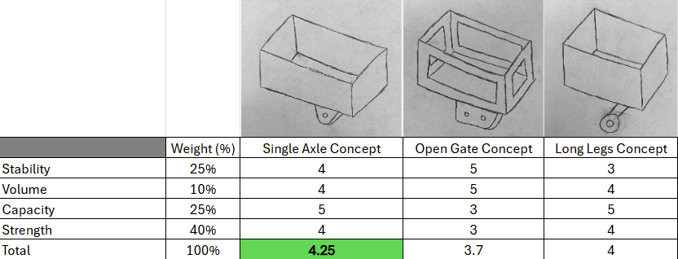

Table 21: Concept Selection Matrix for Trailer Material

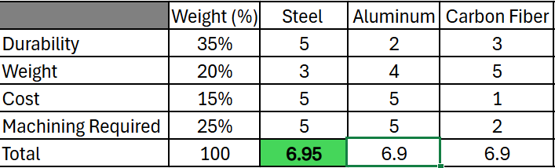

## Hitch

The hitch selection matrix, shown in Table 22, was changed slightly for iteration two. Based on feedback from the critical design review presentation, the team decided to replace the “Feasibility” criteria with “Connectivity”, which will have a greater impact on the performance of the trailer for the final demonstration. After reconsidering the selection criteria, the team decided to move forward with the hook concept for design iteration two, which will be included as a part of the bumper and trailer for future iterations.

Table 22: Concept Selection Matrix for the Trailer Hitch

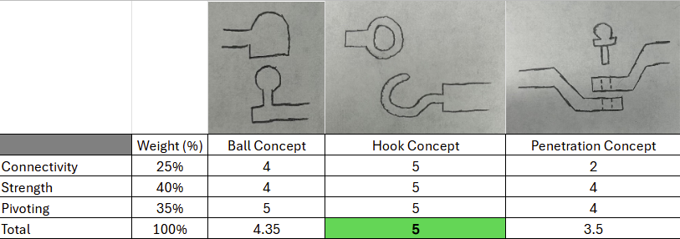

# Detailed Design Discussion (Design Iteration 2)

Following the changes to the concept generation and selection for the second iteration, the engineering drawings for the three-dimensional components were created for iteration two. The dimensions of the body were altered and redrawn, still in two-dimensional form. These updates are detailed below.

## Polymer Body

For design iteration two, the team revisited the measurements taken during iteration one and adjusted them to ensure the functionality of both the chassis and the trailer hitch, which were hindered by the body during iteration one. For the second iteration, new measurements were taken, and the dimensions were used to draw the body in two-dimensional panels. This iteration also included four small holes on the top pieces of the body to allow it to be easily mounted onto the chassis. The engineering drawings for the second iteration of the body are shown in Figure 27. The tolerances for the laser cutter were ±0.05 mm. The team again decided to laser cut cardboard and glue the pieces together to form the final geometry, shown in Figure 28.

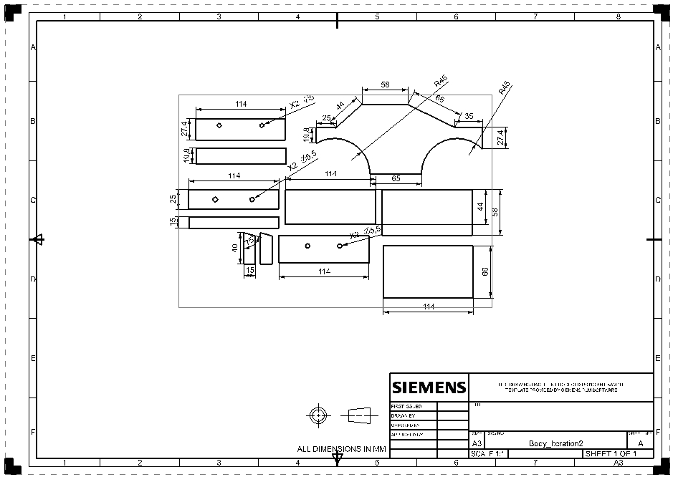

Figure 27: Engineering Drawing for Body Components

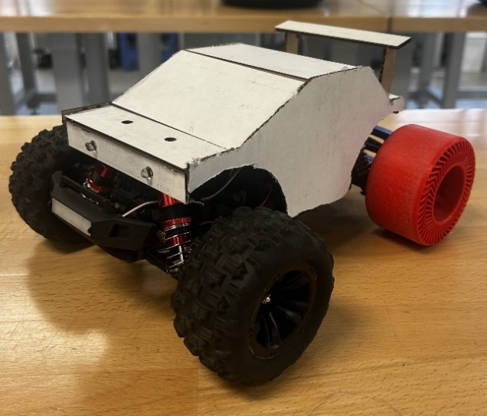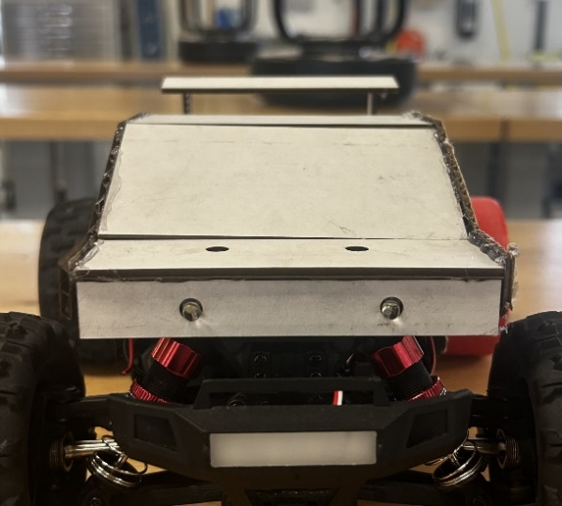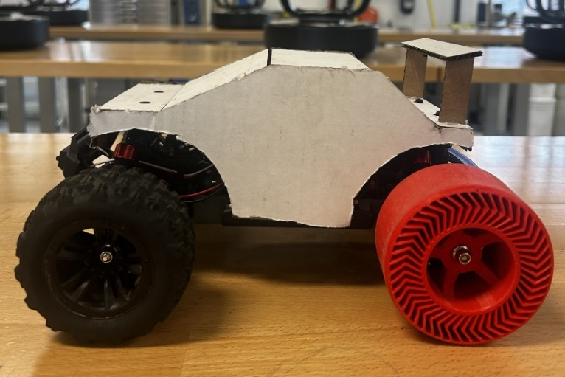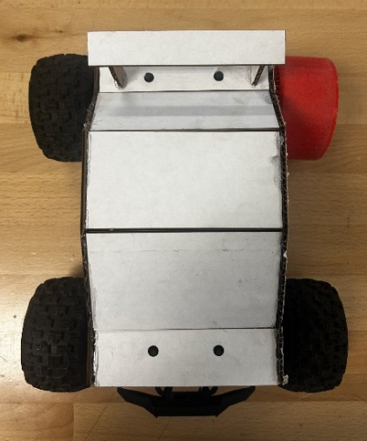

Figure 28: Body Prototype 2

## Tires

The tires for iteration two, shown in Figure 30, are far more sophisticated than the first iteration tires. The goal of the previous iteration was to identify the correct dimensions for the tire and test the fitment of the tire to the axle. After confirming that the dimensions for key mating components were correct, the team used those dimensions and extruded them out to the correct width. For the second iteration, the team focused more on the width and function of the tire. The tire was drawn in CAD, and the engineering drawing is shown in Figure 29. The team manufactured the tire using the 3D printer, and the tire was printed using PLA. For the final iteration, the team has discussed using TPU instead of PLA because of its more rubber-like texture, as the PLA will not have sufficient traction.

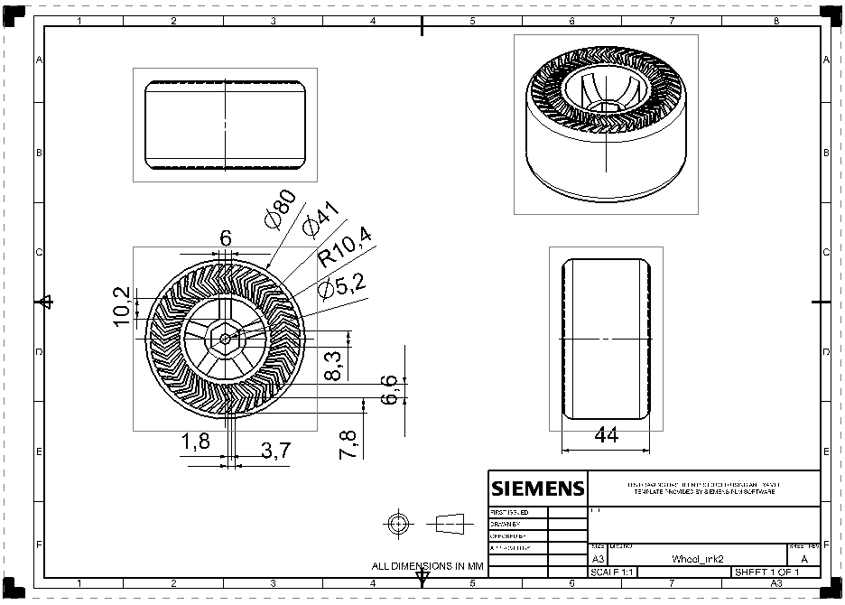

Figure 29: Engineering Drawing for the Tire

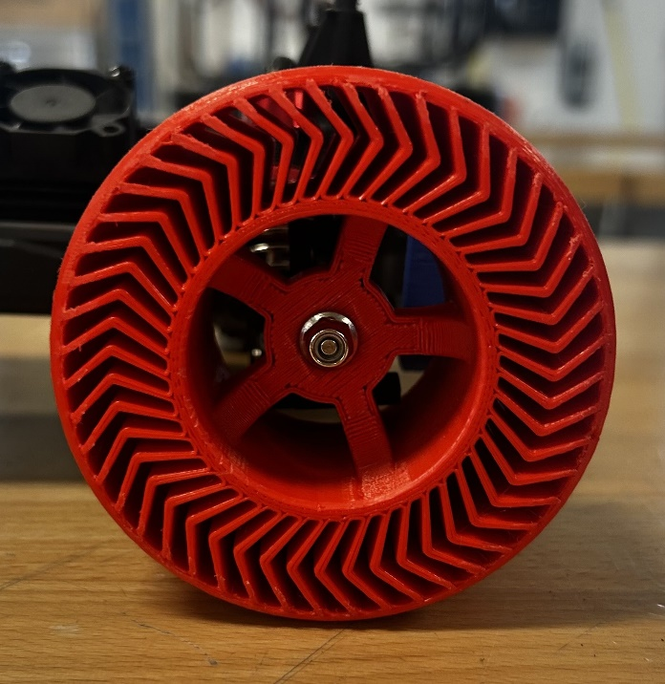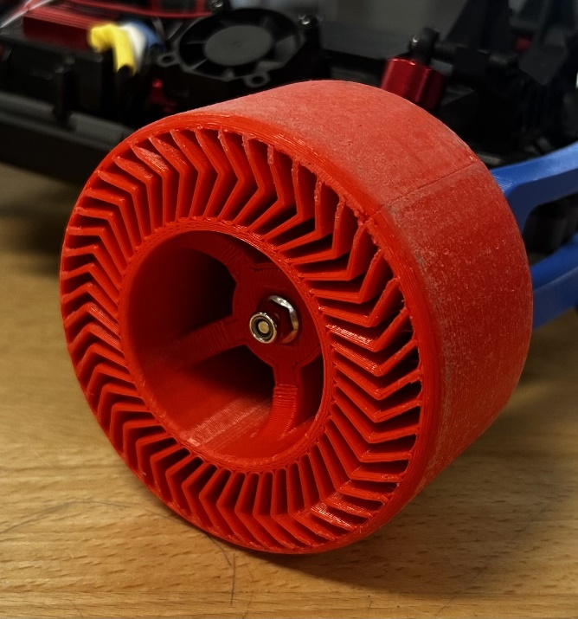

Figure 30: Tire Prototype 2

## Bumper with Hitch

The bumper for iteration 2, shown in Figure 32, is the three-dimensional version of the prototype produced in iteration 1. The design features a curved bumper and includes the hoop end of the hitch, a shape that the team could not produce in the first iteration. This choice was made because the first iteration successfully identified the necessary dimensions for the bumper, so the team was free to focus the second iteration on the functionality of the bumper and hitch together. This geometry will be 3D printed for this iteration and converted to a match plate to be cast from aluminum for the final iteration to save on materials. The engineering drawings for this iteration of the bumper are shown in Figure 31.

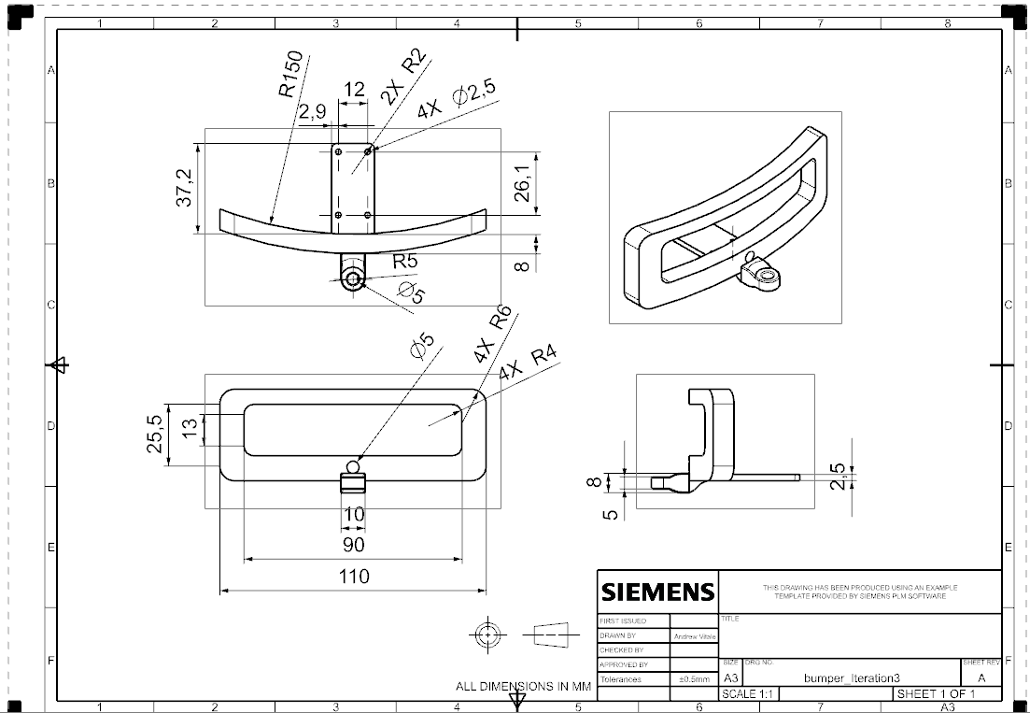

Figure 31: Engineering Drawing for the Bumper with Hitch

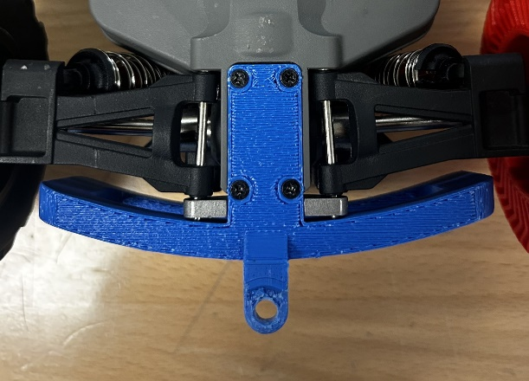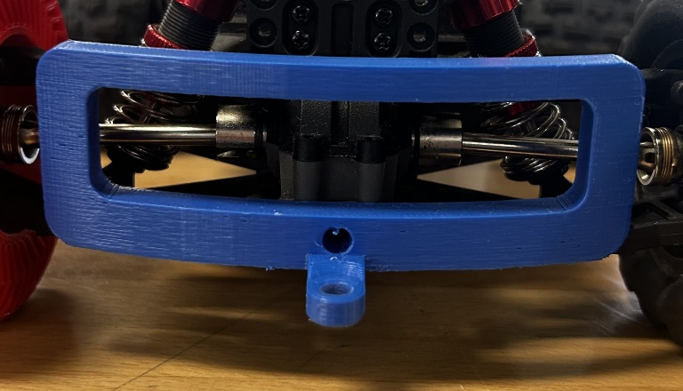

Figure 32: Bumper Prototype 2

## Trailer with Hitch

The second iteration of the trailer, shown in Figure 34, takes the concept generated during the first iteration and brings it to life, combining the chosen design with the dimensions used to produce the simplified first prototype. This iteration, which combined the hitch subsystem with both the bumper and trailer, also includes the hook used to attach the trailer to the truck. The engineering drawings showing the dimensions used to print the second iteration of the trailer are shown in Figure 33.

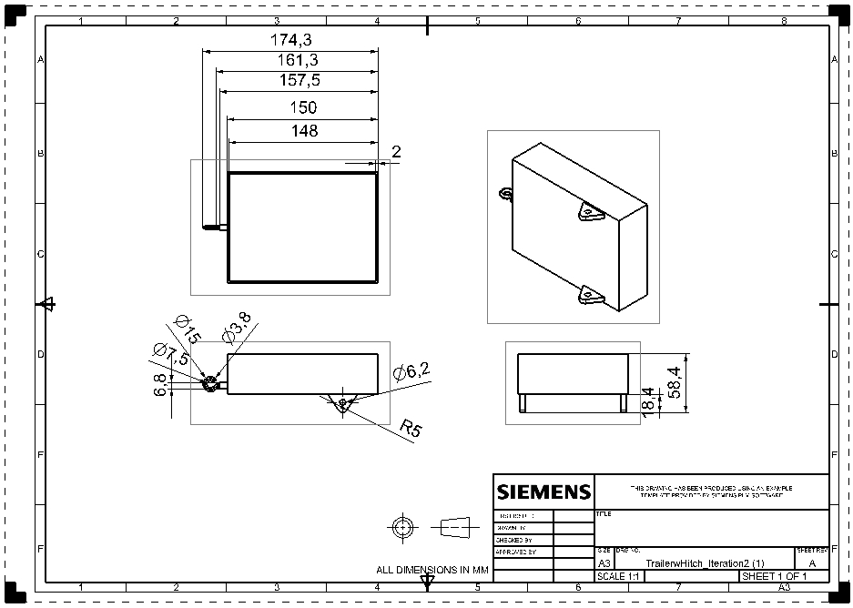

Figure 33: Engineering Drawing for the Trailer with Hitch

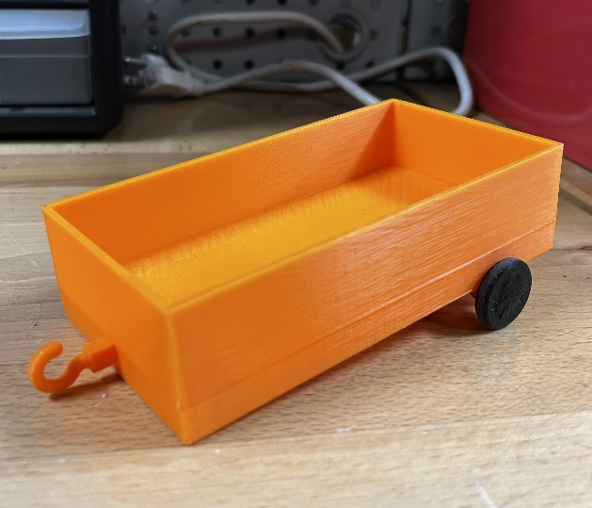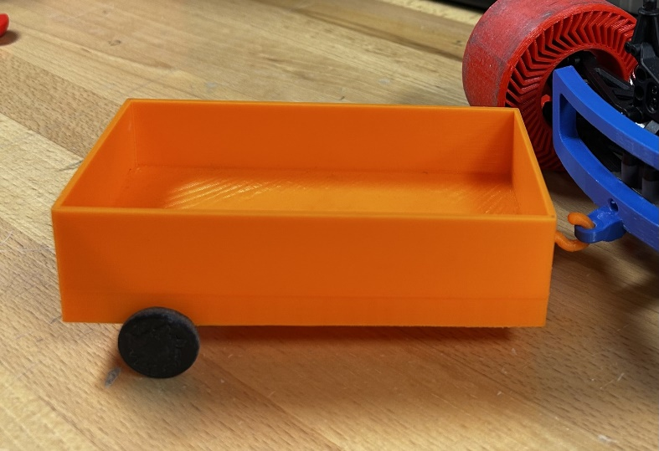

Figure 34: Trailer Prototype 2

## Head and Tail Lights

The headlights and taillights are shown in Figure 36. The headlights and taillights themselves will be housed inside the body as LED lights, and the designs shown will be attached to the body over the LED lights to act as head and taillight covers. The headlight covers are dome-shaped, while the taillight covers are rectangular. These designs were drawn in CAD as three-dimensional geometries to be printed and attached to the body to show where the final iteration will sit to enclose the LED lights. The engineering drawings for the head and taillights, shown in Figure 35, show the dimensions of the 3D printed parts that will be used to vac-form clear thermoplastic around those shapes to achieve the final geometry of the lights.

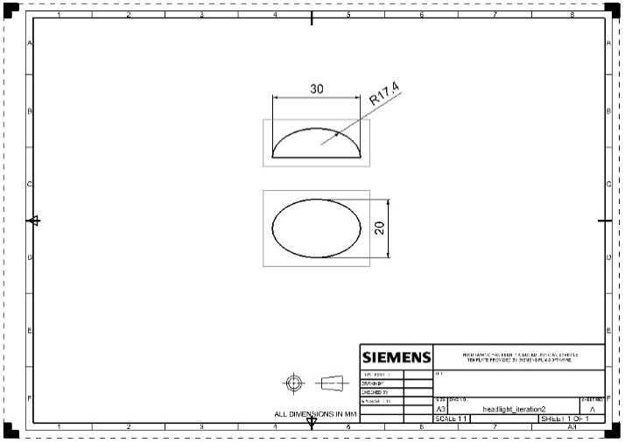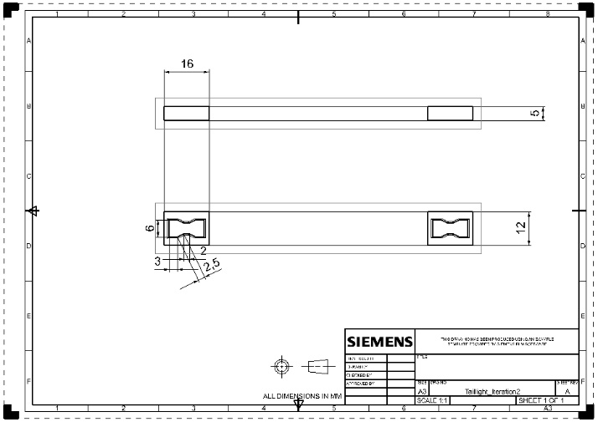

Figure 35: Engineering Drawings for the Head and Tail Lights

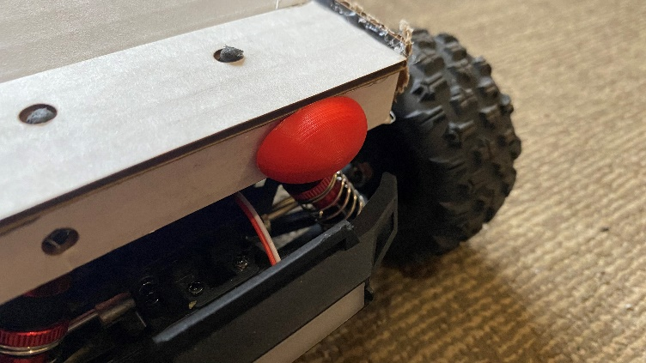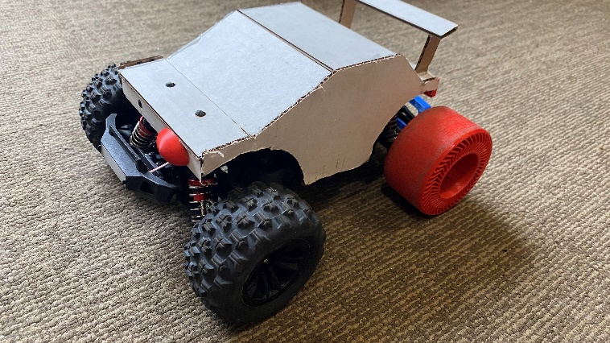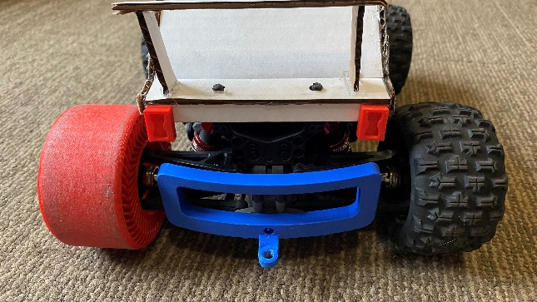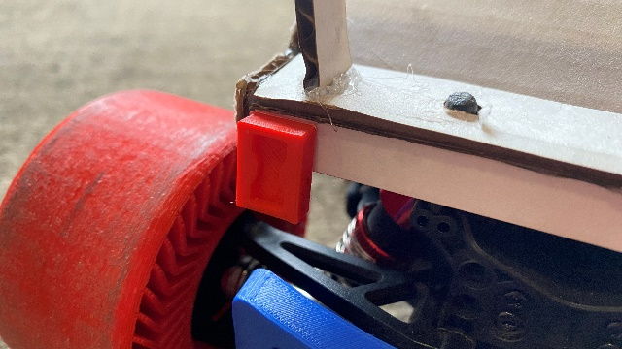

Figure 36: Head and Tail Lights Prototype 1

## Bill of Materials

The bill of materials for design iteration two, shown in Table 23, lists the different components used to construct the team’s second prototype. For the second iteration, the team decided to construct the body using cardboard and the rest of the components using PLA. The size of the body was determined using the sum of the areas of each two-dimensional shape. These areas were calculated using the frame dimensions determined by the laser cutter, so the scrap material is included in our calculations for cost since those scrap pieces are no longer useful for manufacturing other parts. The cost per square millimeter was calculated by dividing the total area of the product per pack of material by the total cost of the pack of material, including a 6% sales tax. The size of the printed parts is the weight in ounces of material used during the print. The cost per gram for the PLA was calculated by dividing the total cost (including tax) of a 1-kilogram roll of PLA by 1000, which was then multiplied by the weight in grams of the printed part. The materials used for design iteration two-body will not be used in future iterations. However, the team intends to use some of the materials used to construct the 3D printed components to construct design iteration 3, particularly the parts that will be vac-formed and cast. Since all of the materials and the RC truck were provided to the team, the total cost for the second prototype was $0.

Table 23: Bill of Materials for Prototype 2

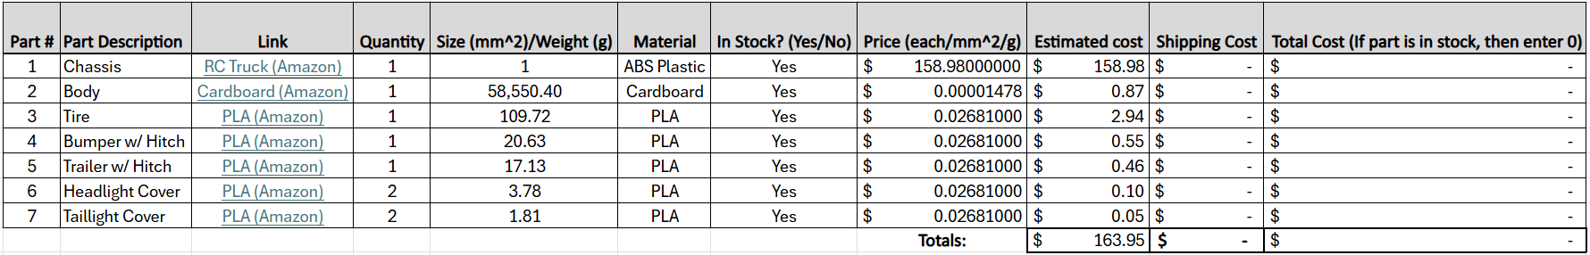

## Manufacturing and Assembly Plan

For this iteration, the team was allowed to use either the laser cutter or the 3D printer. The team produced the body from laser-cut cardboard and used 3D printers to produce the rest of the subsystems. The team did not manufacture a Power T for design iteration two, as it was an unnecessary use of materials.

### Polymer Body

The manufacturing plan for the second iteration of the polymer body is displayed in Figure 37. Similar to design iteration one, the body was drawn in two-dimensional sections in CAD using dimensions taken with digital calipers. The file was then exported as a DXF file and sent to the laser cutter. The side profile was cut twice, and the rectangular panels necessary to construct the full body were cut from the same sheet of cardboard, along with the parts for the spoiler. These pieces were hot glued together, and the complete body subsystem was placed on the RC truck to check its dimensions.

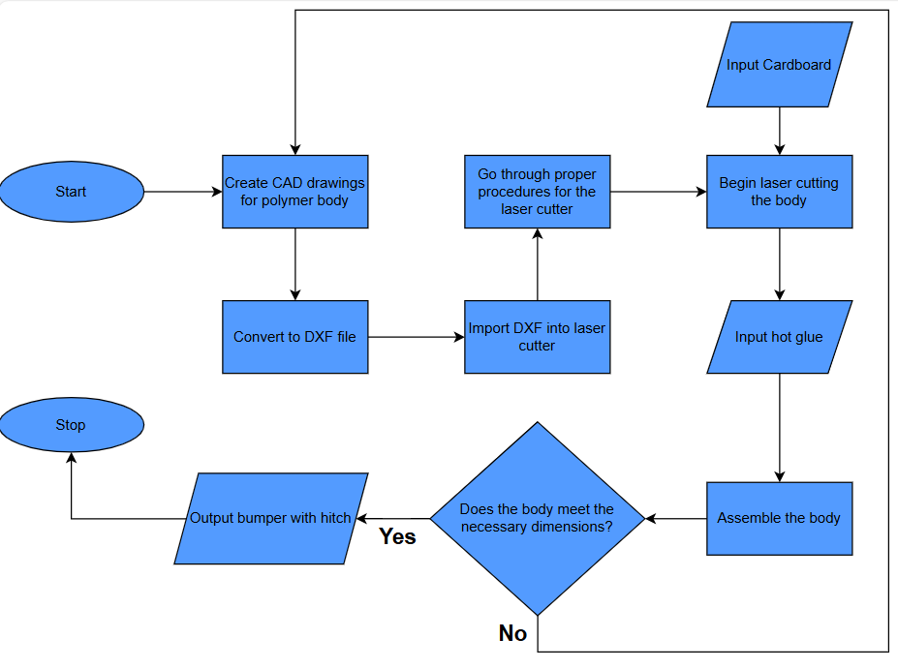

Figure 37: Manufacturing Flow Chart for the Body

### Tires

The manufacturing plan for the second iteration of the tires is shown in Figure 38. Using the key dimensions confirmed in design iteration one, the tire was drawn in CAD, with a far more detailed pattern on its rim and equivalent width to that of the original RC truck tires. The CAD file was exported as an STL file and then sent to the 3D printer using the Prusa Slicer software. The part was 3D printed out of PLA and tested on the RC truck, along with three of the original tires to avoid wasting material printing 4 tires.

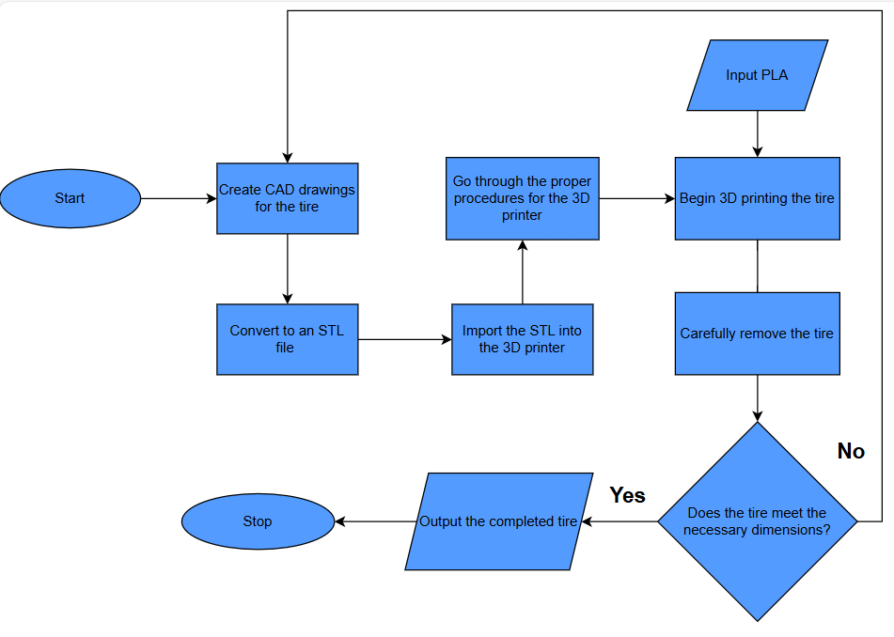

Figure 38: Manufacturing Flow Chart for the Tires

### Bumper with Hitch

The manufacturing plan for the second iteration of the bumper is displayed in Figure 39. The bumper and hitch were drawn in CAD as one part using dimensions taken with digital calipers. The file was then exported as an STL file and sent to the 3D printer using the Prusa Slicer software. After producing the part, it was attached to the chassis using the factory hardware.

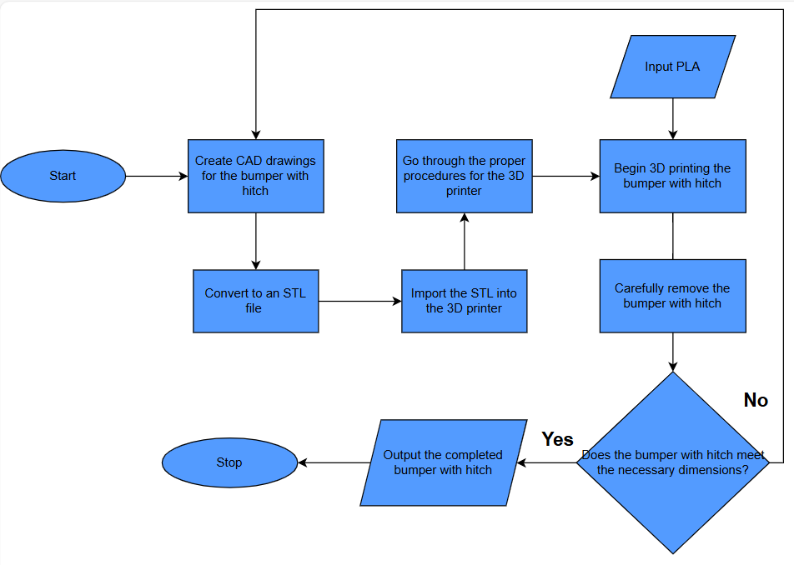

Figure 39: Manufacturing Flow Chart for the Bumper

### Trailer with Hitch

The manufacturing plan for the second iteration of the trailer is displayed in Figure 40. The trailer with the hook end of the hitch attached, along with the axle and wheels, was drawn in CAD. The file was then exported as an STL file and sent to the 3D printer using the Prusa Slicer software. The part was 3D printed using PLA. The wheels and axle were then attached to the trailer bed, and the hook was used to attach the hitch to the bumper.

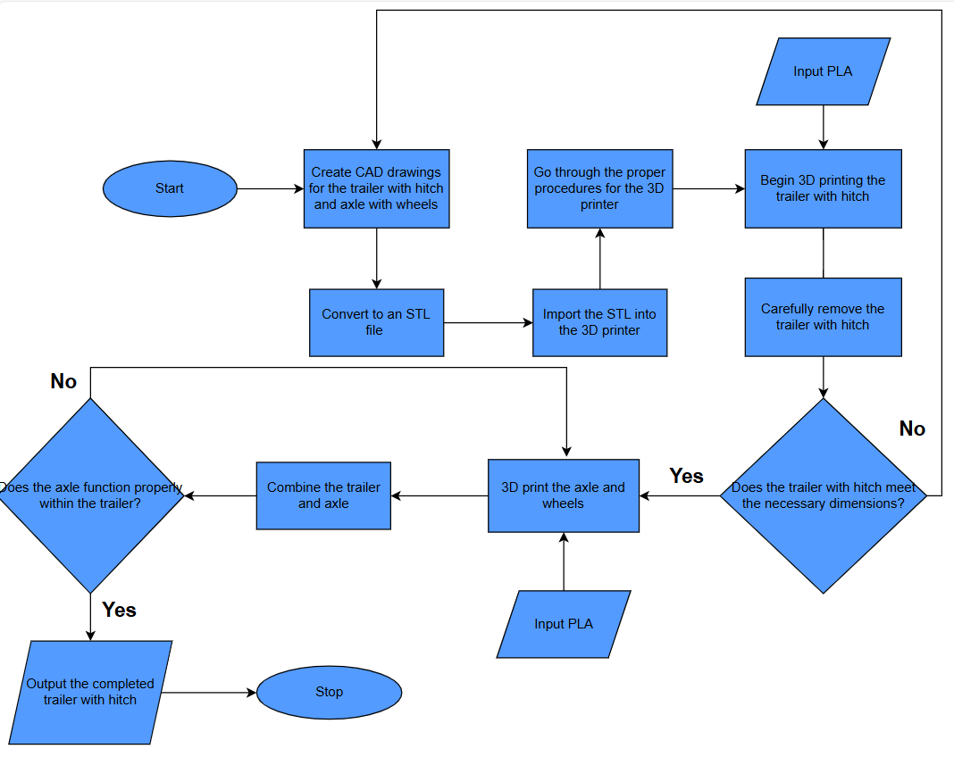

Figure 40: Manufacturing Flow Chart for the Trailer

### Headlights and Taillights

The manufacturing plan for the headlights and taillights can be seen in Figure 41. The head and taillight covers were drawn in CAD using dimensions relative to those taken of the body where the covers would be mounted. The files were exported as STL files and sent to the Prusa Slicer software for printing. The covers were 3D printed and taped to the body. This was done rather than permanently attaching them to the body, as the 3D printed covers will be used to vac-form the headlight and taillight covers in the final iteration.

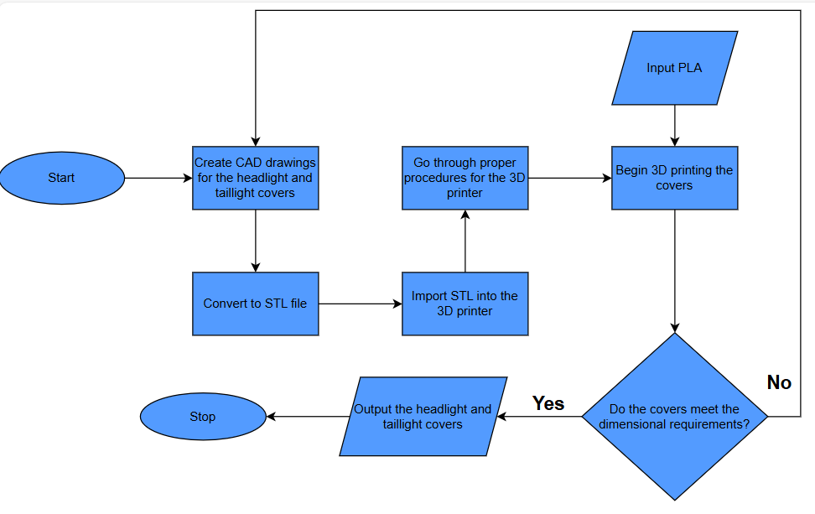

Figure 41: Manufacturing Flow Chart for the Head and Taillights

## Testing and Validation

For the testing and validation of the second design iteration shown in Table 24, the team retested the body dimensions and tested the functionality of the tire, bumper, and trailer. The team also tested the integration of the head and taillights with the body. After testing the dimensions of the body, the team found that it fit the chassis much better than the original iteration. This iteration also included holes for the existing mounting nubs that allowed the factory body to attach to the chassis. The holes placed in the iteration two body aligned well with the nubs on the chassis, and those dimensions will be used for the final iteration to mount the body. The one adjustment that will be made is the height of the front and back panels, which need to be extended further to accommodate the head and taillight covers to be mounted to the body. After testing, the team will move forward with these dimensions and construct a three-dimensional model to vacuum form the final body.

The team did not have the desired material (TPU) available for the second iteration of the tires, so this iteration of the tire was 3D printed using PLA. Because of the low coefficient of friction of the PLA, the team was not concerned with the traction of the material. Instead, the focus was on the functionality of the tire when used in conjunction with the factory tires. After testing the truck with the new tire, the team concluded that the tire functioned well, aside from some slipping due to the lack of treads and the use of PLA, which will be addressed in the final iteration.

The team first ensured that the bumper attached to the truck using the mounting screws included with the chassis. After sanding the mounting plate end of the bumper that connected to the chassis, the bumper was mounted to the truck. The testing of the bumper and trailer consisted of driving the truck with the bumper and trailer attached. The completed trailer with the hitch was successfully attached to the bumper and stayed attached throughout testing. After successful testing, the team is prepared to move forward with these designs and dimensions for the final iteration of the bumper and trailer, made from aluminum and steel, respectively.

For the head and taillights, the team was focused on compatibility with the body since these parts would be vacuum formed and attached to the main body for the final iteration. After producing the covers and positioning them on the body in the correct spots, the team decided that their size was appropriate, but the body would need to be altered to accommodate their geometry. However, the team decided to proceed with the vacuum forming process using the 3D models produced during this iteration and alter the body instead of altering the dimensions of the head and taillight models.

Table 24: Testing and Validation for Prototype 2

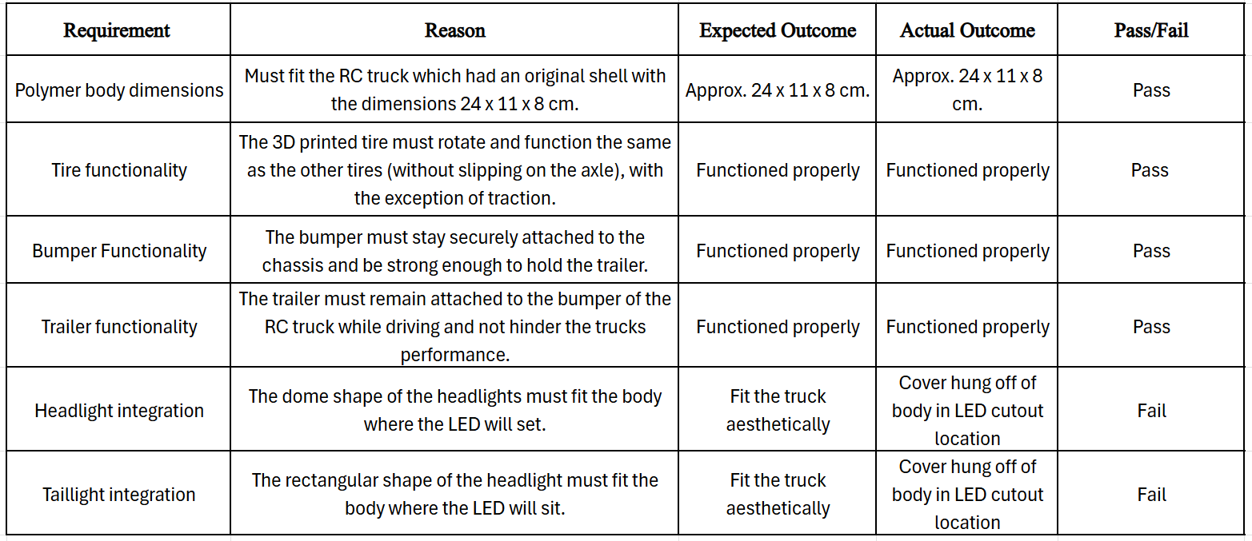

# Design Summary (Design Iteration 3)

The final design iteration of the new and improved RC truck took the team’s findings from the first two iterations and optimized them to produce a final iteration to achieve both the customer and team-determined requirements. The team had all manufacturing processes available for this iteration, and the team used many of those processes to produce their final iteration. The dimensions of the body were reproduced in a smooth three-dimensional geometry while extending the sides to allow the head and taillights to fit on the body. The trailer and bumper were both reproduced using steel and aluminum, respectively, with the trailer hitch integrated into the design of both parts. The initial dimensions of the Power T were used to create an aluminum iteration that will be attached to the body using an undermount. Finally, the head and taillights were manufactured using the 3D printed models from design iteration two.

# Concept Generation (Design Iteration 3)

Following the testing and validation of the second design iteration, the team has decided to move forward with the same concepts for the final iteration. No new concepts were selected, and thus there were no new selection matrices for this iteration.

# Detailed Design Discussion (Design Iteration 3)

## Polymer Body

For the final iteration of the body, shown in Figure [], the team used the dimensions determined in iteration two and transformed those into the model that resembled the concept chosen during the first design iteration. In addition to the holes for mounting the body to the chassis and those for the lights, pinholes were included in the CAD drawing, which enabled the team to use the model to vacuum form the body once printed from PLA. The engineering drawings for the mold used to create the body, shown in Figure 42, detail the exact dimensions used for the final iteration.

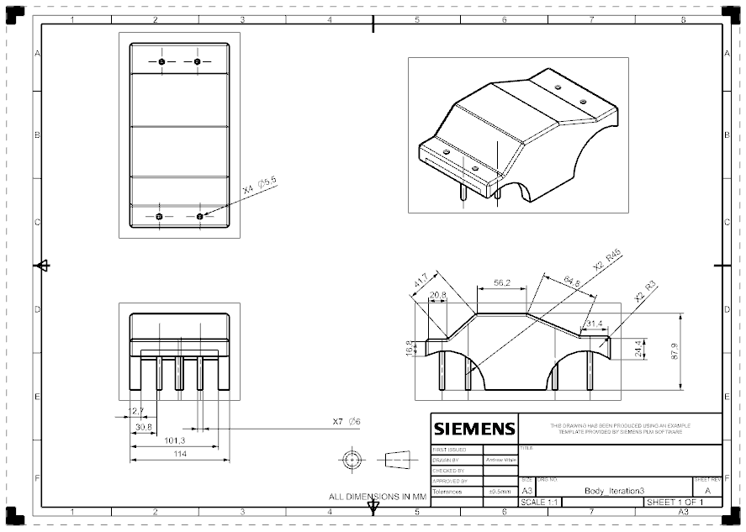

Figure 42: Engineering Drawing for Body Mold

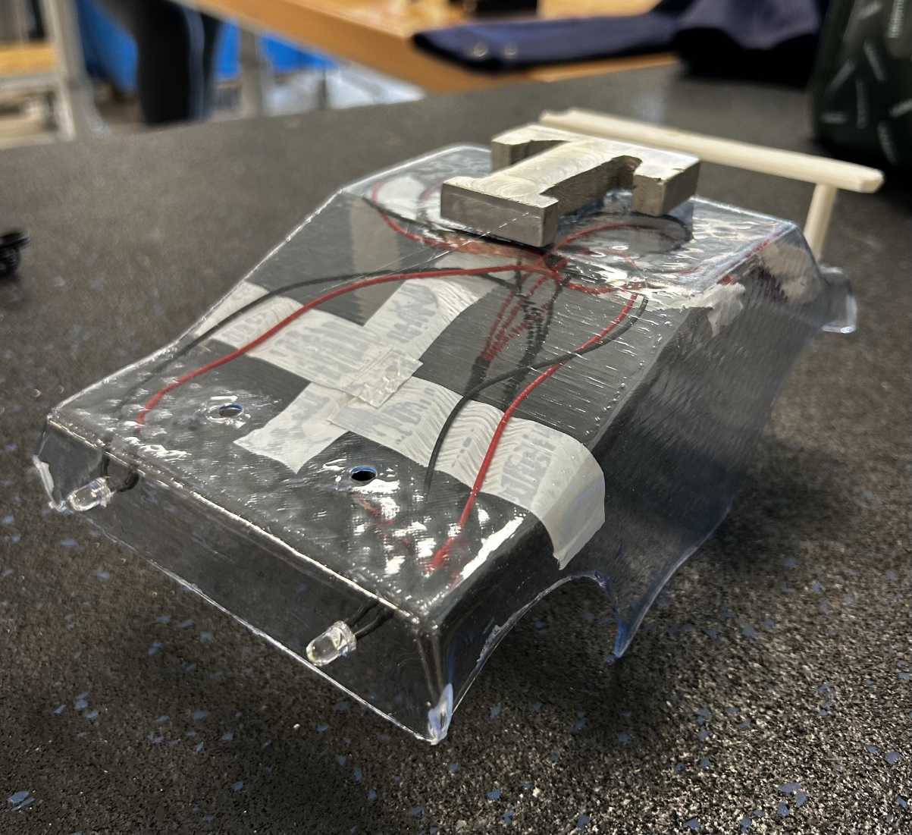

Figure 43: Body Final Prototype

## Head and Taillights

The head and taillights for the final iteration, shown in Figure 44, consist of two separate parts. The team used printed prototypes from design iteration two to vacuum-form two headlight covers and two taillight covers, which would be made from clear plastic and attached to the final body. Underneath these covers, the team would use existing holes in the body to insert LED lights, which were hardwired to the battery from the chassis. The engineering drawings for the models used to vacuum-form the headlight covers can be found in design iteration two. Note that the vacuum forming of the headlight covers failed, so those were not included in the final design.

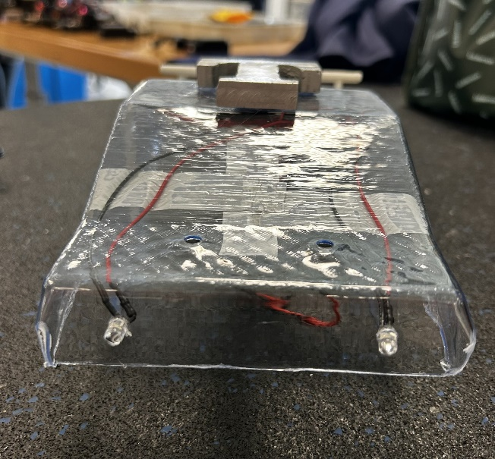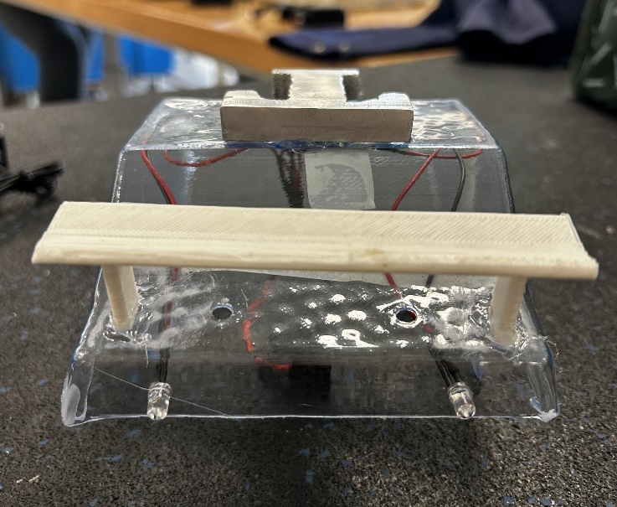

Figure 44: Head and Tail Lights

## Tires

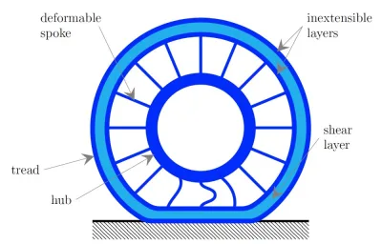The racing and towing tires for the final iteration, shown in Figures [] and [] respectively, feature a single-print TPU design. The team chose TPU due to its higher coefficient of friction (Braileanu et al., 2023) and its tendency to deform when compared to PLA. The rim and the tire are made of one CAD file, with inspiration for their design drawn from some “airless” tires that companies have attempted to produce for consumer automobiles. After a conversation with Joe and considering the dynamics of the design of the rims, the team drew two separate tires for each set, with two tires printed for each set. This is because when the tires are in use, the arrows that support the rims will act as shock absorbers. However, if the arrows are pointed in the wrong direction, they will cave in on themselves instead of acting as a spring. Figure 45 illustrates this idea, showing how the spokes of the tire deform when the vehicle is in motion. The engineering drawings for the tires are shown in Figures 46 and 47.

Figure 45: Illustration of a non-pneumatic tire structure showing the shear layer. (Image Credit: University of Illinois)

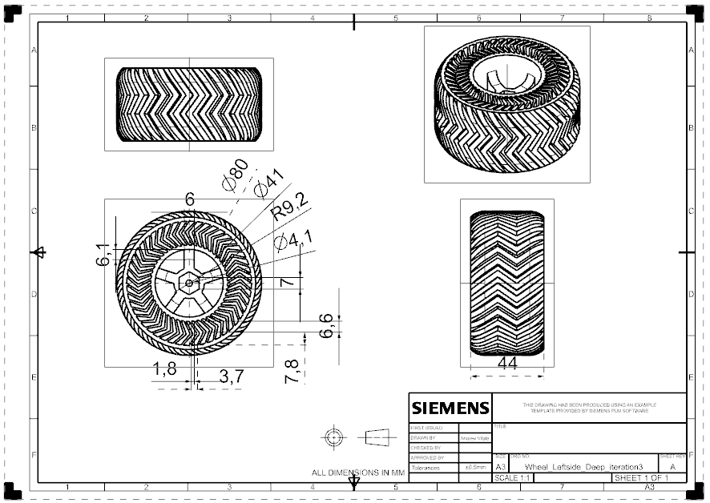

Figure 46: Engineering Drawing for the Towing Tires

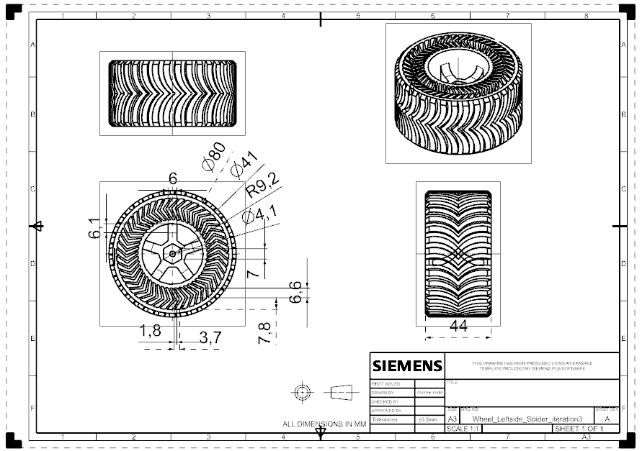

Figure 47: Engineering Drawing for the Racing Tires

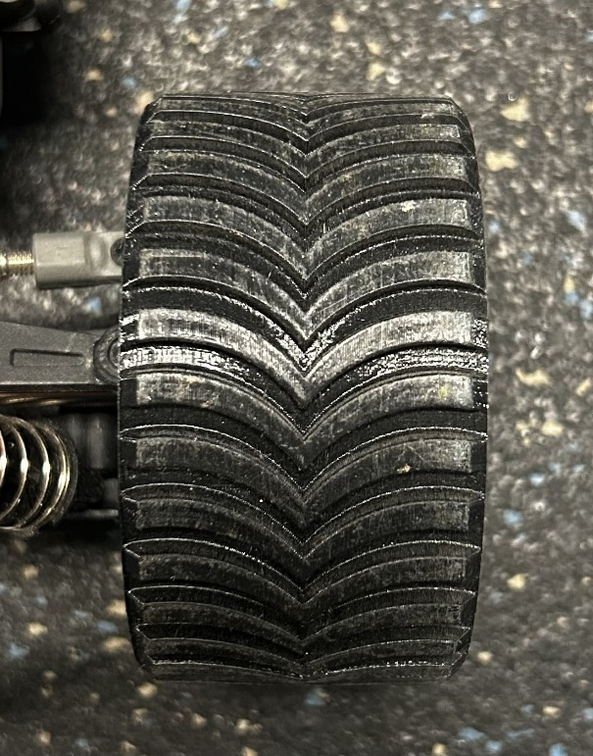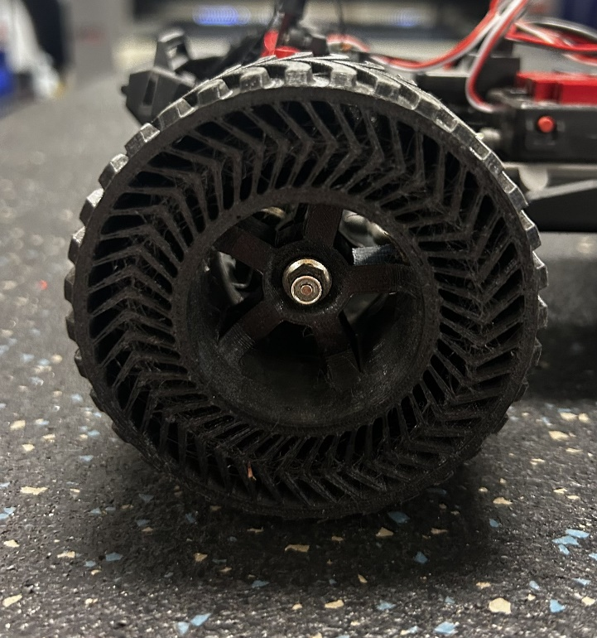

Figure 48: Racing Tires Final Prototype

## Trine “Power T”

The final iteration of the Power T, shown in Figure 49, features a cast aluminum version that was produced during the team’s casting proficiency tool training. The shape was printed on paper and affixed to a block of foam, so the dimensions were roughly the same as in the first iteration, but not exact. Note that there is no engineering drawing for this iteration.

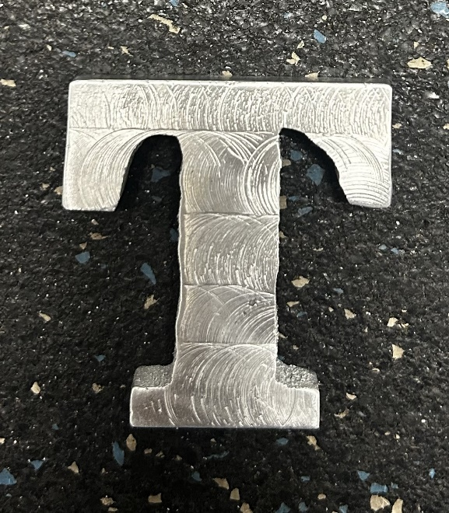

Figure 49: Power T Final Prototype

## Bumper with Hitch

For the final iteration of the bumper, shown in Figure 50, the team decided that it would be more time-consuming to produce the bumper using a match plate, and instead opted to recreate the bumper using foam cut with a foam cutter and then using that model to lost foam cast the aluminum bumper instead of sand casting. The engineering drawings used to produce both the foam model and the final aluminum bumper can be found in previous iterations. 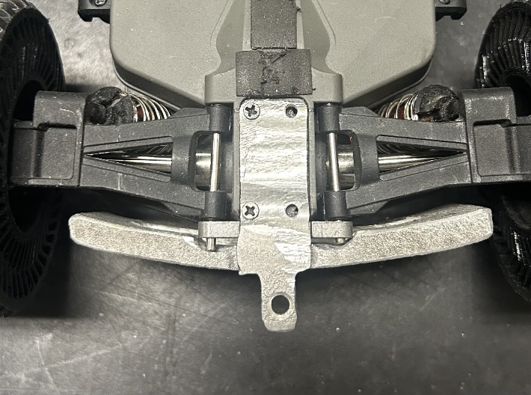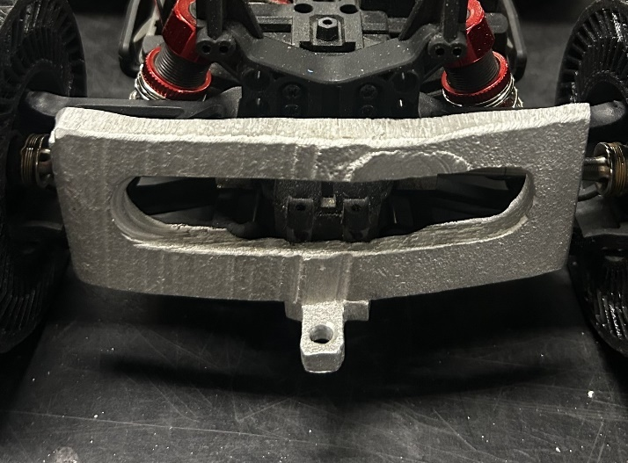

Figure 50: Aluminum Bumper Final Prototype

## Trailer with Hitch

The trailer with a hitch for the final iteration is shown in Figure 55. The team decided to use their new knowledge of bending to produce the final trailer bed geometry. The bed of the trailer was drawn in CAD in a two-dimensional view, with fillets at the tops of the trailer and holes at the corners to prevent the metal from pinching when bent. The radii of both the fillets and holes followed the rule of thumb, with those radii being equal to the thickness of the steel, around 1.27 mm. The team used a piece of aluminum stock to make the axle, and bearings with a bracket were used to seat the axle. The tires were designed in CAD and printed using the 3D printer. The engineering drawings for the trailer geometry, the hitch connection, the axle, and the tires are shown in Figures 51-54.

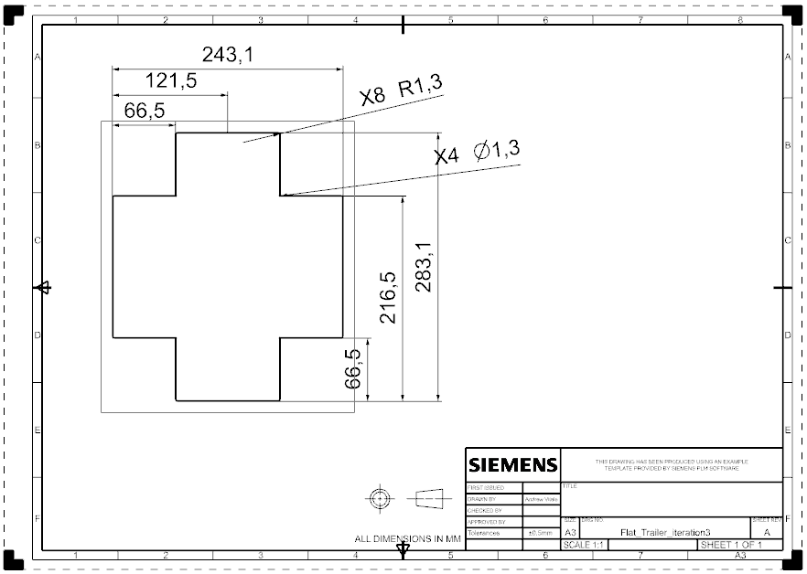

Figure 51: Engineering Drawing for the Flat Trailer Geometry

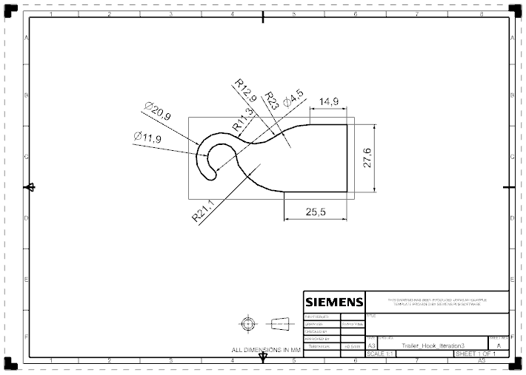

Figure 52: Engineering Drawing for the Hitch Connection

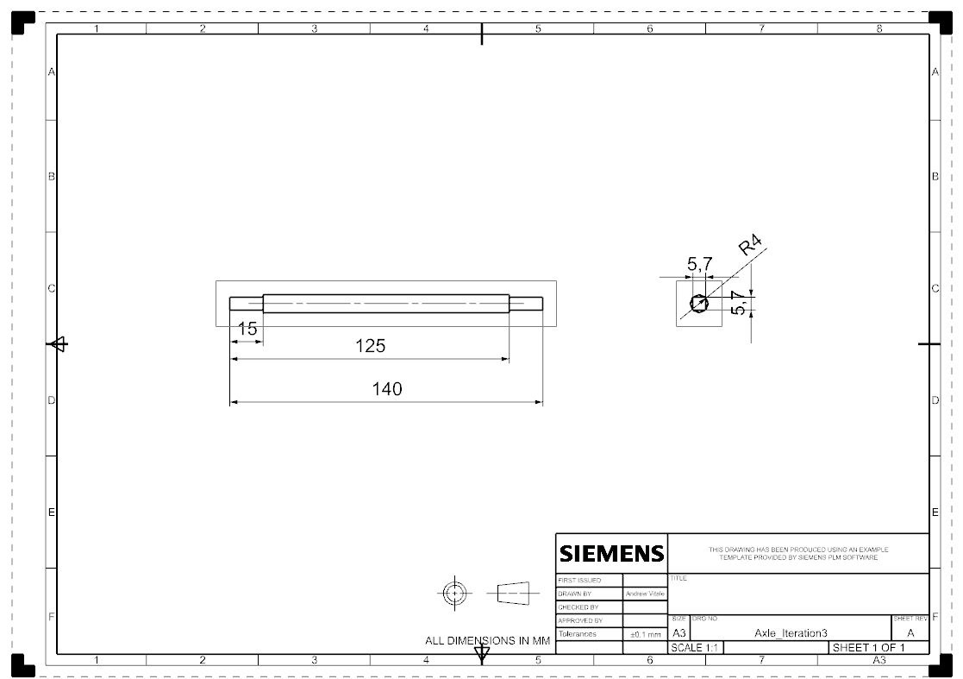

Figure 53: Engineering Drawing for the Axle

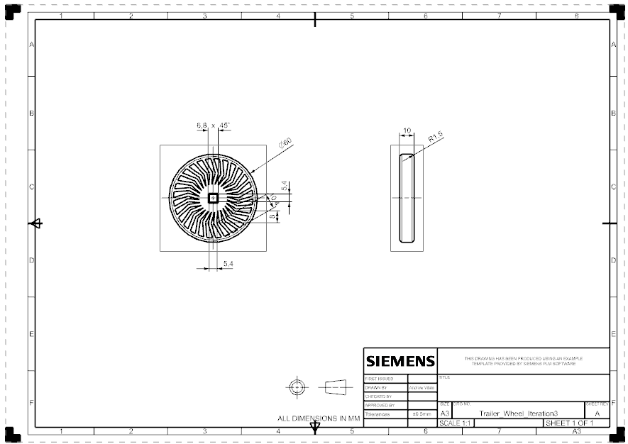

Figure 54: Engineering Drawing for the Trailer Tires

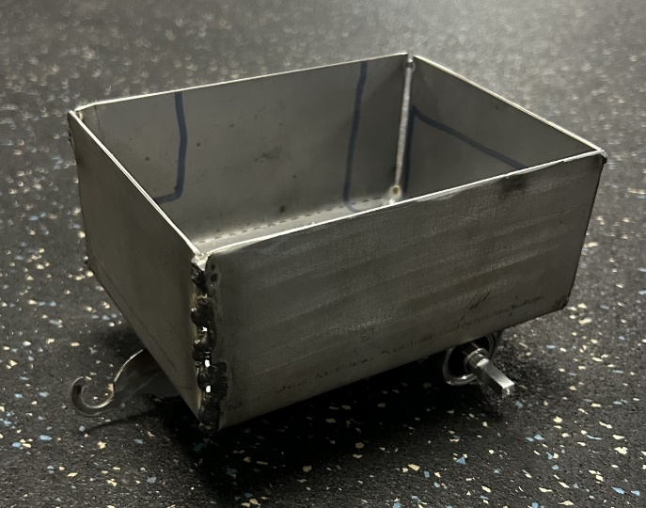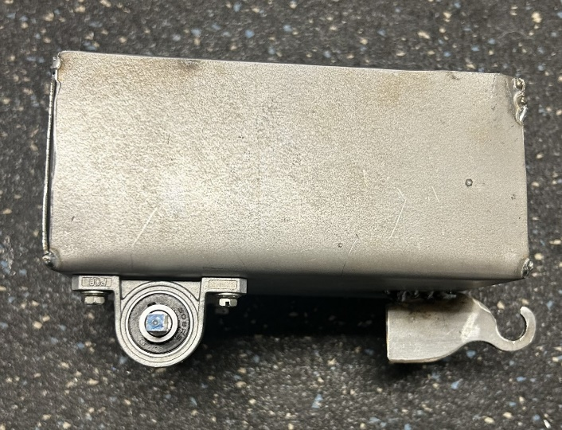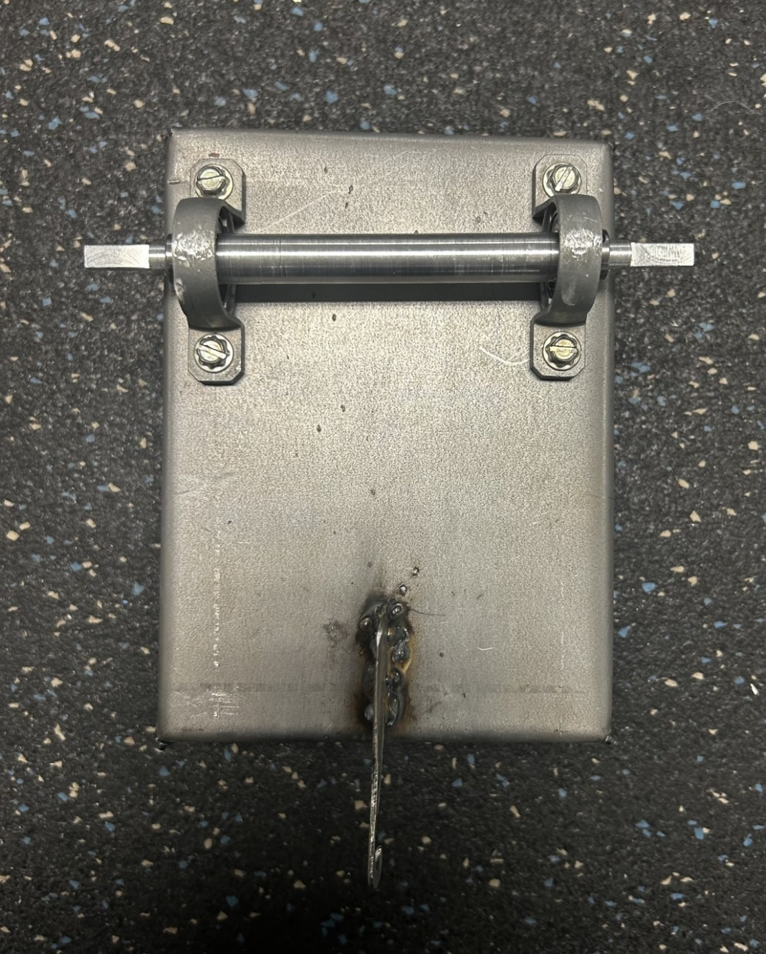

Figure 55: Isometric, Side, and Bottom Views of the Trailer Final Prototype

## Bill of Materials

The bill of materials for the final prototype, shown in Table 25, lists the different components used to construct the team’s third and final prototype. For the final iteration, the team used several plastics, polymers, and metals to manufacture and produce the final product. For the vacuum-formed body, the surface area of the sheet of plastic was used to calculate the cost. The cost per square millimeter was calculated by dividing the total area of the product per pack of material by the total cost of the pack of material, including a 6% sales tax. The size of the #D printed parts is the weight in ounces of material used during the print. The cost per gram for the PLA and TPU was calculated by dividing the total cost (including tax) of a 1-kilogram roll of filament by 1000, which was then multiplied by the weight in grams of the printed part. For the steel used to produce the trailer, a quote from Metal Super Markets for the size of the sheet metal used to produce the trailer geometry. The aluminum used during casting was priced using the average price for scrap aluminum per pound, and converted to a price per gram of aluminum. For all of the parts that did not require manufacturing, including lighting and bearings, a price per unit was derived from the price of a pack on Amazon. Since all the materials and the RC truck were provided to the team, the total cost for the final prototype was $0.

Table 25: Bill of Materials for the Final Prototype

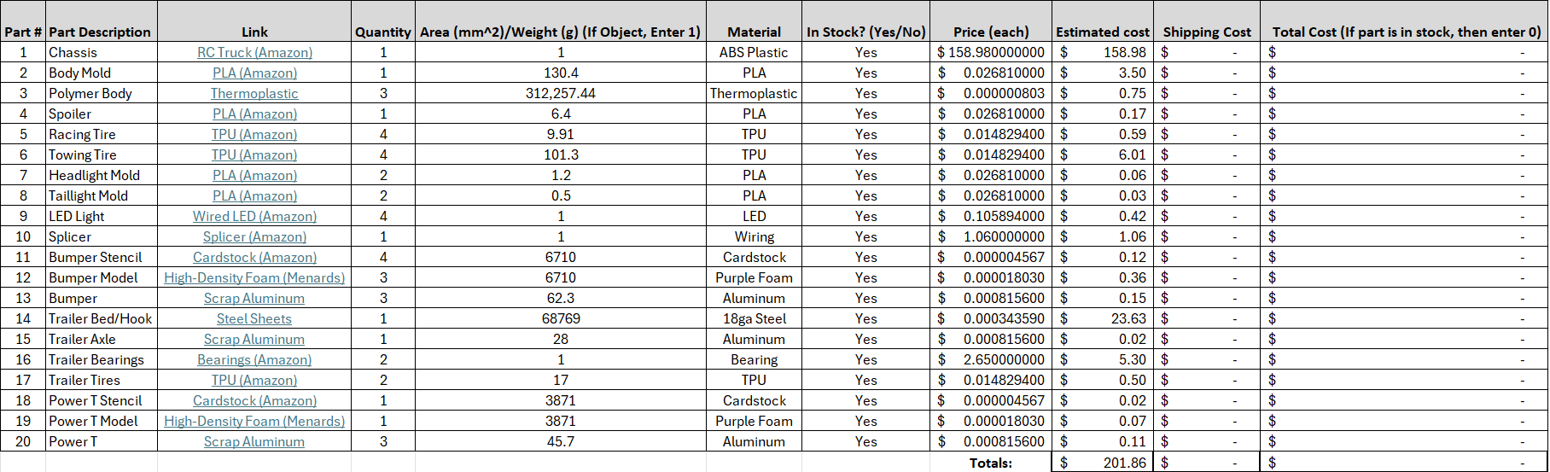

## Manufacturing and Assembly Plan

### Polymer Body

The manufacturing and assembly plan for the body is shown in Figure 56. The body and spoiler were first drawn in CAD using the dimensions confirmed during iteration two before being exported as STL files. The files were imported into the Prusa Slicer software, which were then sent to the 3D printer to be printed from PLA. Once the body mold was printed, it was then placed in the vacuum former along with the thermoplastic, and the body was molded. Once the thermoforming process was completed, the spoiler was attached to the rear of the body using hot glue. Figure 57 shows the mold used to vacuum form the final prototype, and Figure 58 shows part of the vacuum forming process.

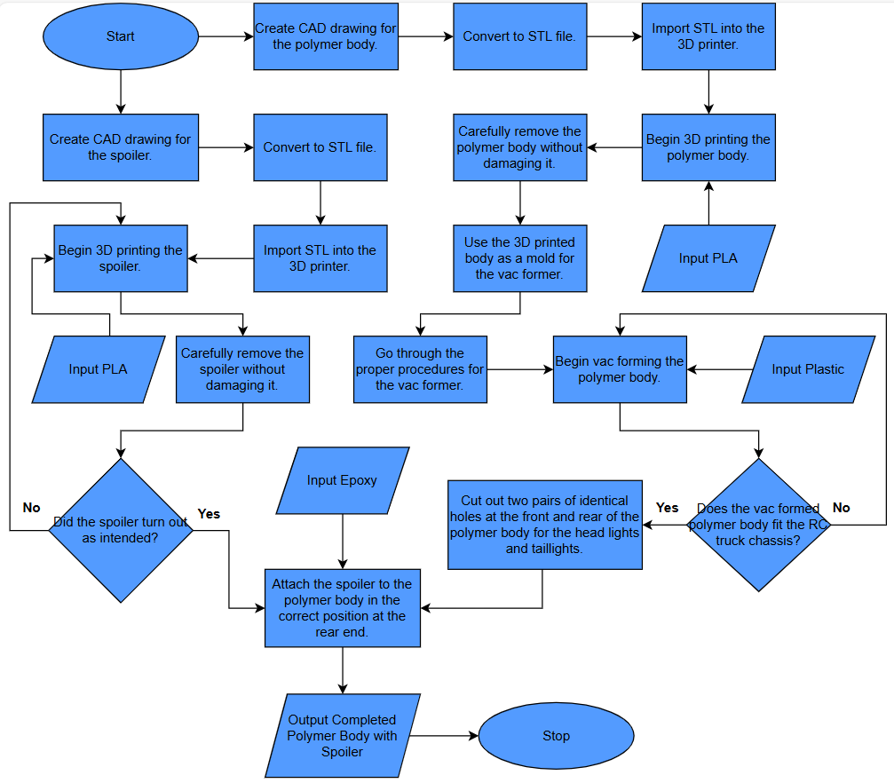

Figure 56: Manufacturing Flow Chart for the Body

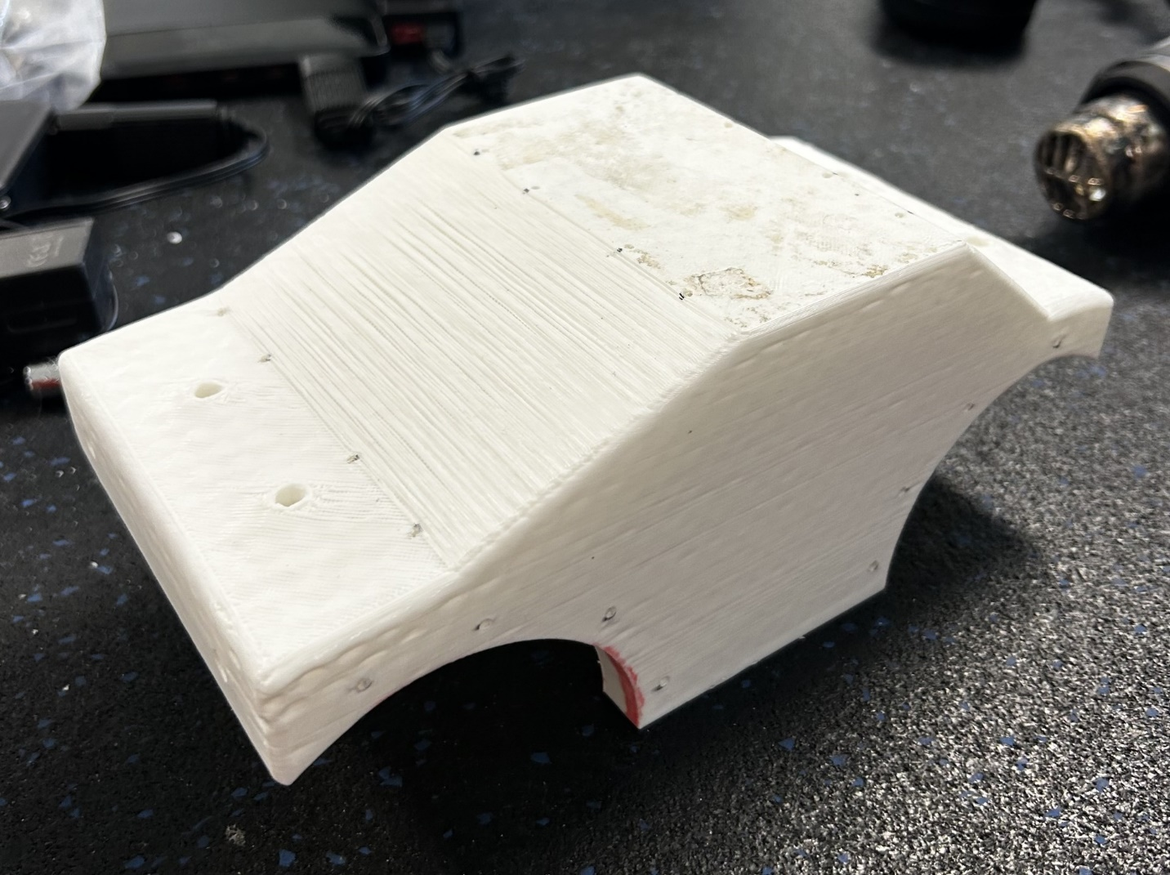

Figure 57: Mold for Vacuum Forming

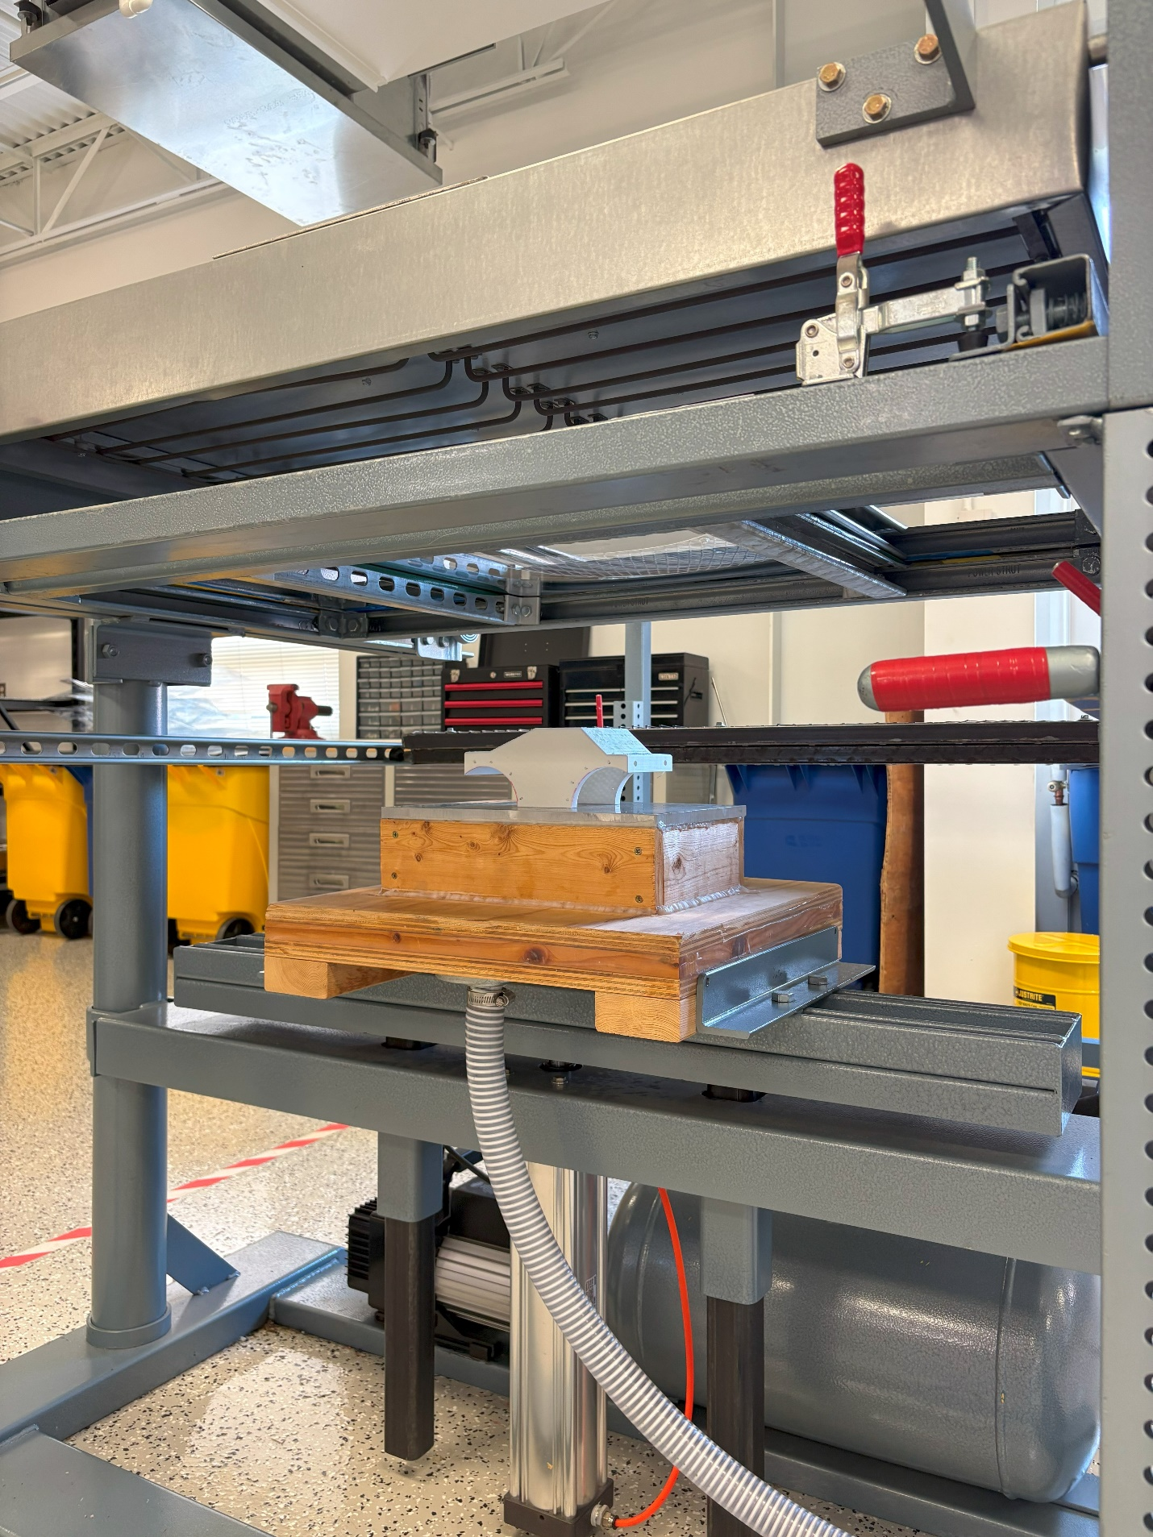

Figure 58: Vacuum Forming the Body

### Head and Taillights

The manufacturing and assembly plan for the head and taillights is shown in Figure 59. First, CAD drawings were created for the head and taillight covers using dimensions based on the holes cut from the polymer body. These files were converted to STL files and sent to the Prusa Slicer software to be 3D printed. The 3D-printed covers were then used as molds for the vacuum former, allowing the team to easily produce the desired dome shape out of clear plastic. Once manufactured successfully, the covers were attached to the polymer body using epoxy in the necessary positions to cover the lights when the polymer body is attached to the chassis. For the head and taillights, the team decided to connect LEDs to the RC truck and fix them under the covers. Note that the team ran short on time and was forced to omit the covers from the final iteration due to time constraints and the failure of the molds, shown in Figure 60.

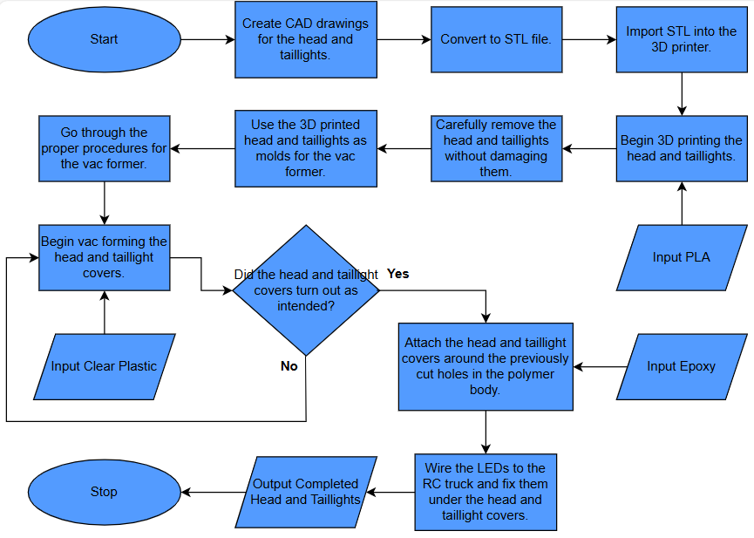

Figure 59: Manufacturing Flow Chart for the Head and Tail Lights

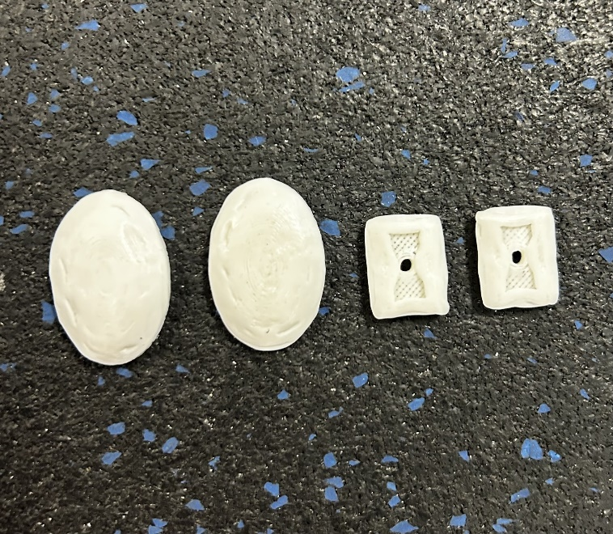

Figure 60: Failed Vacuum Forming Molds

### Tires

The manufacturing and assembly plan for the tires is shown in Figure 61. The tires for the chassis were first drawn in CAD using the dimensions obtained during iteration two and converted to STL files. The files were then imported into the Prusa Slicer software, where they were sent to the 3D printer to be printed from TPU. The printed tires were removed from the printer and placed on the axles of the truck, where they were attached using the included hardware from the truck. The trailer tires followed an almost identical process, but the were placed on the axle and attached to the axle using hot glue.

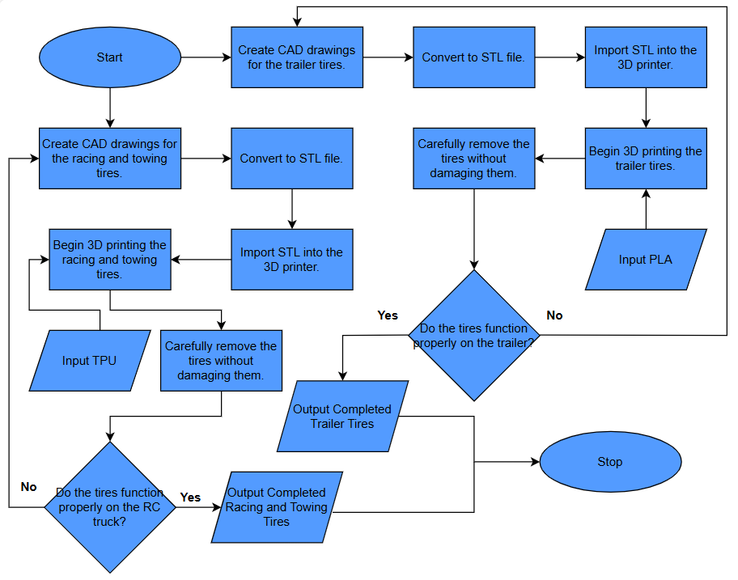

Figure 61: Manufacturing Flow Chart for the Tires

### Trine “Power T”

The manufacturing plan for the final iteration of the Trine “Power T” is shown in Figure 62. The CAD for the Trine “Power T” was provided by Trine University, which owns the rights to the logo. This file was printed off and taped to a piece of foam, which was cut with a hot wire foam cutter. The team decided to then cut the block further into four equal pieces to make the Trine “Power T” thinner and to allow a choice of the best one when casting was complete. These pieces of foam were then lost foam cast out of aluminum. Once the process was complete, the team chose to continue with the piece that turned out best. The piece was further machined with the mill (Figure 63), hand grinder, and sand blaster to get rid of any rough edges and imperfections. Once the part was completed, it was attached to the body using hot glue.

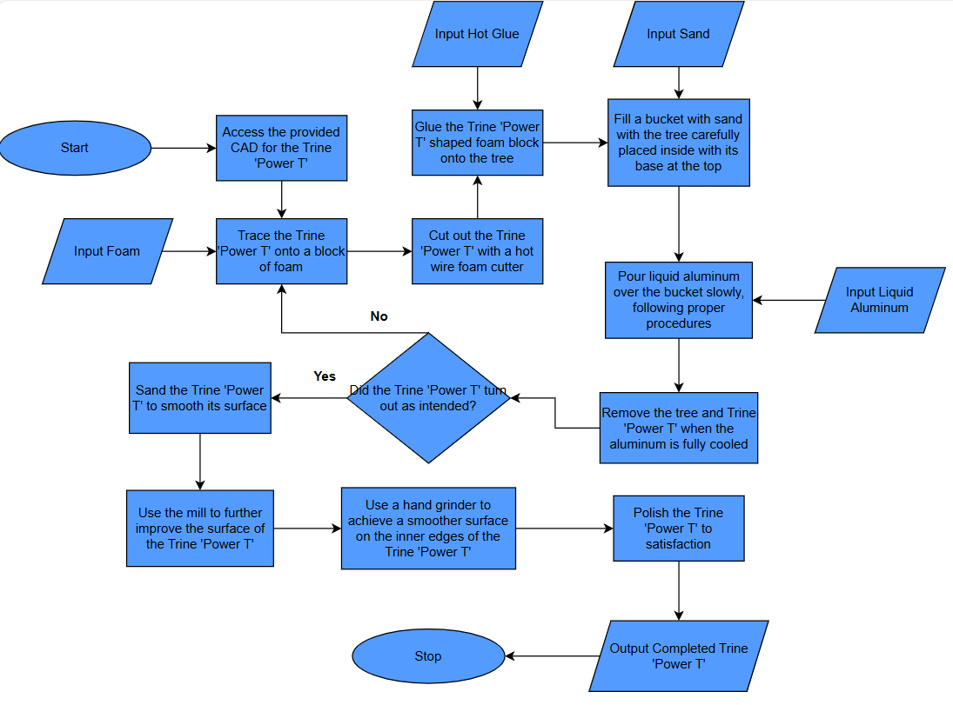

Figure 62: Manufacturing Flow Chart for the Power T

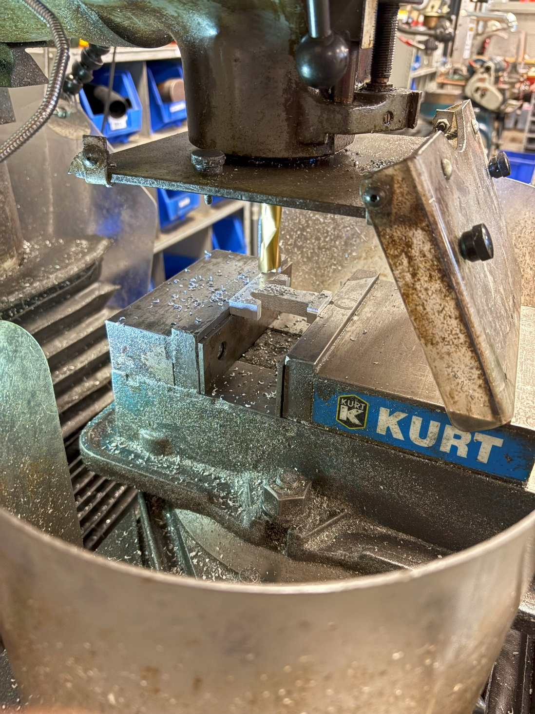

Figure 63: Milling Process on Power T

### Bumper with Hitch

The manufacturing and assembly plan for the bumper and hitch is shown in Figure 64. First, the bumper and hitch were drawn in CAD using the dimensions retained from iteration one. The team split the bumper into two parts, allowing for it to be easily displayed in 2D geometries. This allowed us to laser cut the two parts out of paper, which served as a template to be glued to a block of foam. After cutting out the necessary parts, the team glued together the two parts, creating four polystyrene cutouts of the bumper and hitch. These were attached to the tree and lost foam cast out of aluminum. After completing the castings, the team chose the best one to continue with the secondary manufacturing processes. The bumper was taken to the mill to refine the part to the dimensions determined in design iteration two. The part was then finished using the hand grinder, and holes were drilled to achieve the desired fitment on the truck.

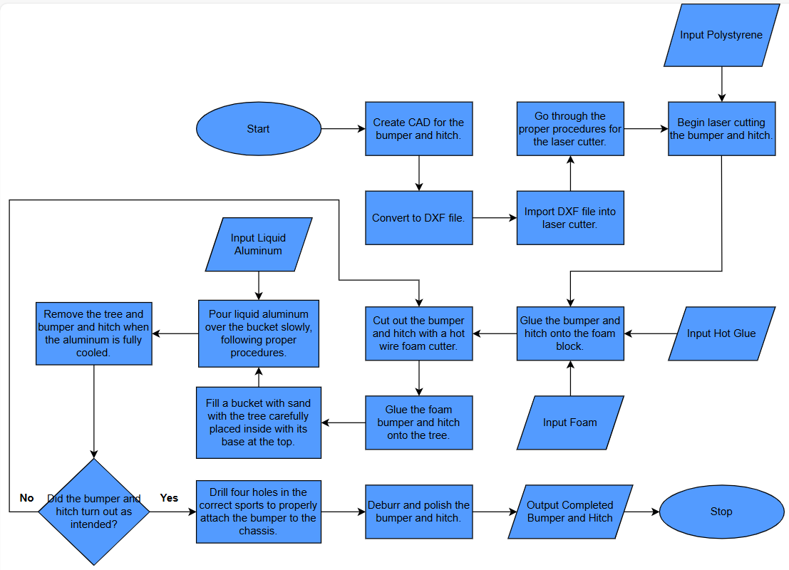

Figure 64: Manufacturing Flow Chart for the Bumper

### Trailer with Hitch

The manufacturing and assembly plan for the trailer is shown in Figure 65. The body of the trailer and the hook for the hitch were first drawn in CAD using the dimensions obtained during iteration one. The files were exported as a DXF file and sent to the plasma cutter for cutting. Once the parts were cut, the edges were finished using the hand grinder to remove any sharp edges. Once the part was finished, it was taken to the shear, break, and roll to bend the sides to the final geometry of the trailer body. After the bending operation was performed, the sides of the trailer were tack-welded together using the MIG welder, and the hook was welded onto the bottom of the trailer (Figure 66).

The axle for the trailer was drawn in CAD using dimensions derived from both the trailer and the bearings selected to seat the axle. The engineering drawing produced from the CAD file was used during a turning operation (Figure 67) on the lathe to produce the final geometry of the axle. Once the axle was completed, the bearings were attached to each side using set screws. Holes were drilled in the bottom of the trailer body, and 4 small nuts and bolts were used to attach the bearings to the trailer. The TPU wheels were then seated on the axle and secured using hot glue.

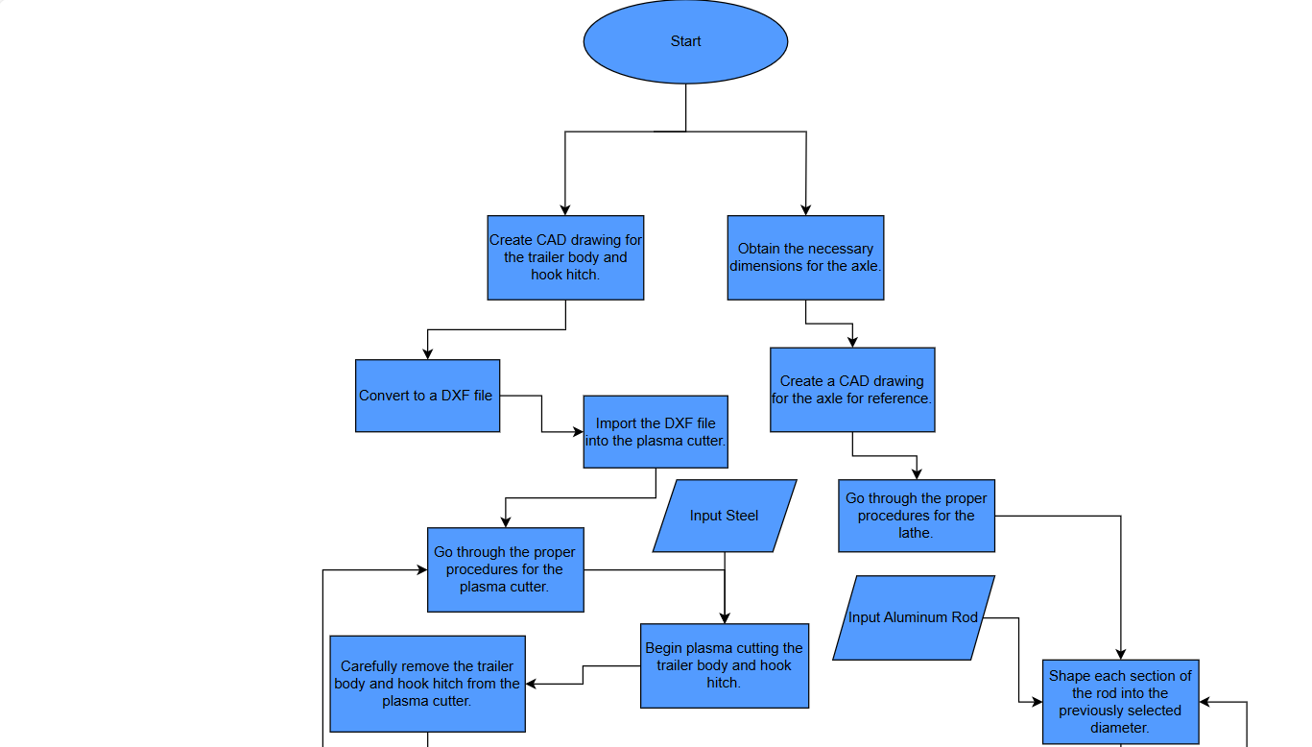

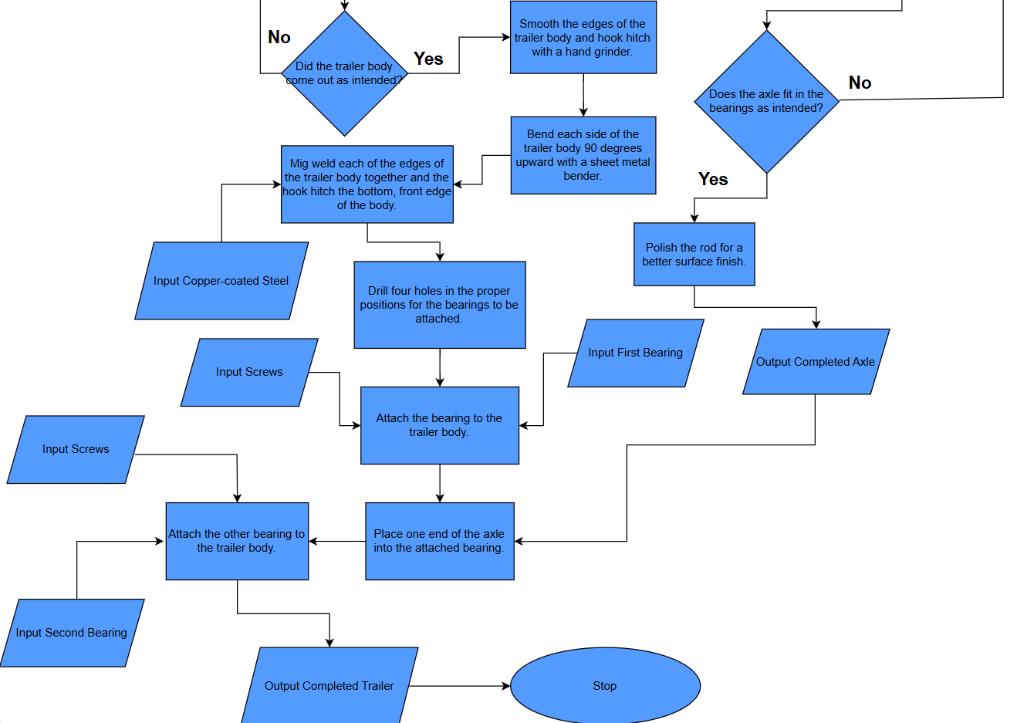

Figure 65: Manufacturing Flow Chart for the Trailer

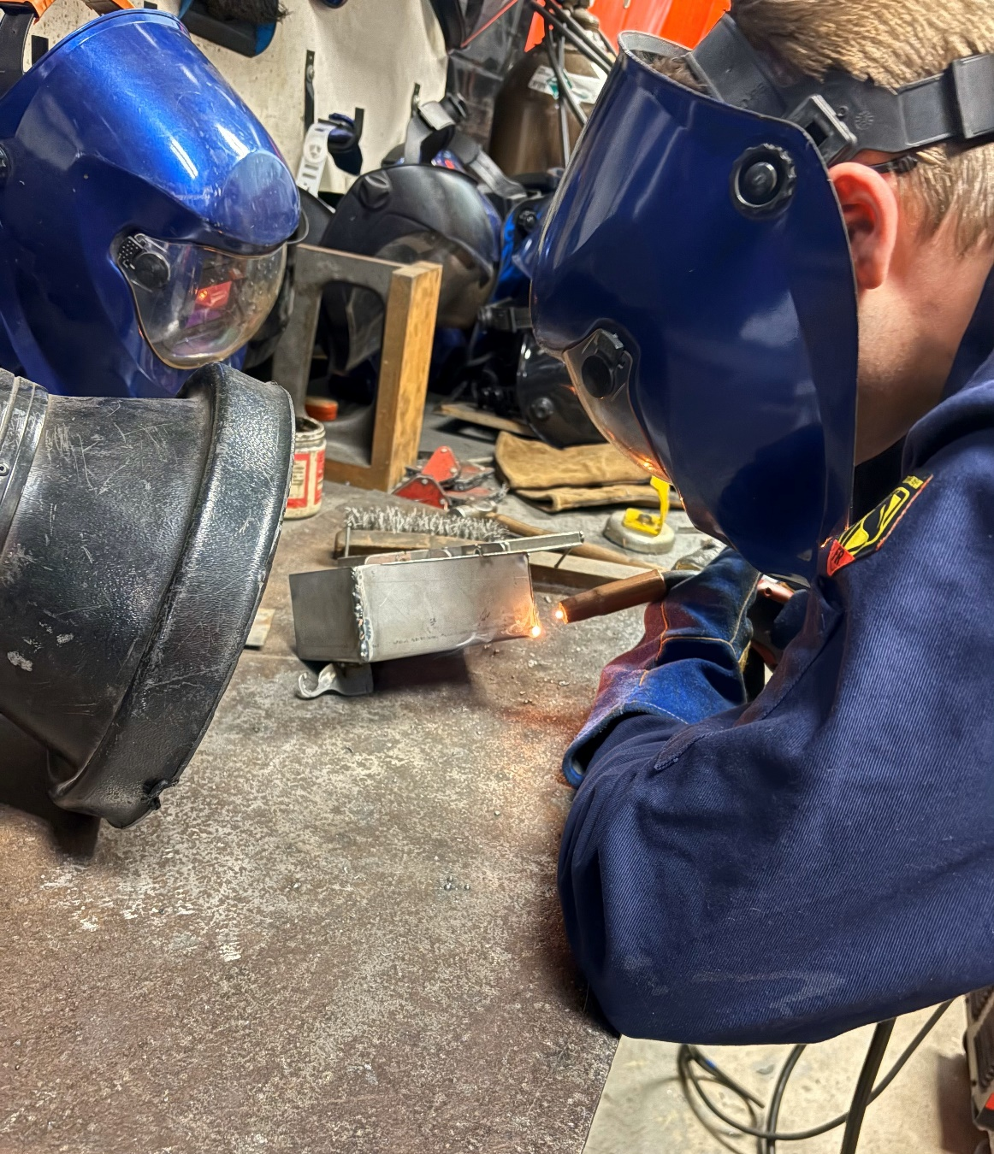

Figure 66: Welding the Trailer Components

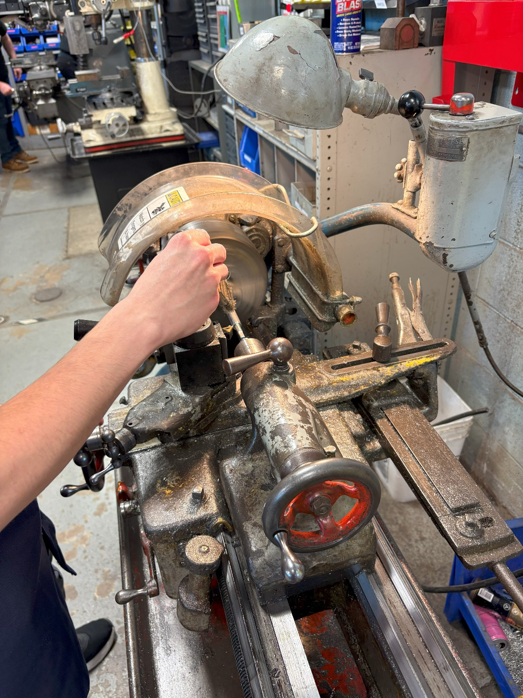

Figure 67: Turning Operation on the Axle

## Testing and Validation

Table 26 summarizes the testing and validation of the final prototype. The vacuum-formed body, though it did not turn out perfectly, was able to integrate easily with the chassis and the headlights. The holes drilled to mount the body on the chassis were slightly off, so only one set of the pins was able to be used to secure the body. The Power T turned out well and certainly displayed school spirit without hindering the performance of the truck. Both the racing and towing tires were sufficient; however, the traction on the brick floor of the foundry was far better than the slick floor, and that proved challenging during the towing portion of the demonstration. The bumper held up well with the 10lb weight inside the trailer, but the trailer hook experienced significant plastic deformation during testing with higher weights. However, it did stand up throughout the demonstration without part failure. Finally, the head and tail lights functioned as intended, using the function button on the RC remote to turn the lights on and off.

Table 26: Testing and Validation for the Final Prototype

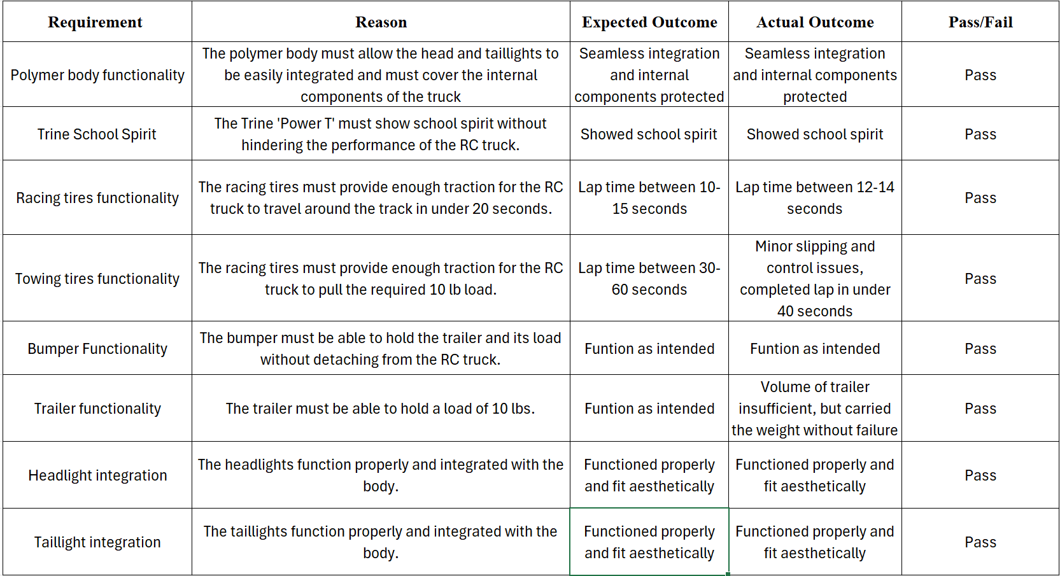

# Conclusion

This team was overall content with the performance of the final prototype during the demonstration, but there were several takeaways that the team will consider for future projects and in the future as engineers. The team encountered several issues throughout the project, including delays in the printing of parts, failure of molds during vacuum forming, parts breaking during milling operations, and designs that needed to be changed. The team’s largest issue during the project was timelines, and with CAD files being such a large portion of the design process, those files should have been prioritized in the Gantt chart to ensure they were ready, particularly for printing 3D models. In addition, the team needed to perform multiple vacuum forming operations on the body, and after several operations, the mold began to show signs of deforming. Having a geometry that was closer to the original concept chosen, with fewer corners and sharp edges, would have made the vacuum forming process easier. In addition, having internal deadlines set further in advance would have relieved stress on the team and allowed the final prototype to have all of the components that the team had conceptualized during preliminary phases.

The team was forced to get creative with early prototypes, using two-dimensional geometries to create three-dimensional parts and finding use for those early iterations. As the second iteration rolled around, the team had more tools at their disposal to produce the geometries that they had conceptualized, and even more so for the final iteration. The biggest takeaway from the project was to be eager to learn all of the manufacturing processes covered in the course. The team could have produced all of their parts using 3D printers, but instead accepted the challenge of learning new processes to produce the final prototype. Being excited to get hands-on and pour aluminum or create a trailer by bending and welding sheet metal proved to be rewarding to the team for the final demonstration, as the results were overwhelmingly positive.

The team did encounter some design flaws during the final iteration and would look to improve on those if there were future iterations. The most glaring flaw was the trailer and hitch design. Though the customer did not specify a volume that would need to be carried, the team could have designed a trailer with a higher volume capacity. In addition, the hook used for the hitch was not only difficult to connect, but also proved to be a weak point when towing the 10lb load. The team would look to reevaluate the design of the hitch and increase the volume capacity of the trailer. In addition, the bumper was a difficult part to create, since there was no simple way to produce the curved geometry using two-dimensional shapes. The milling process to refine the bumper took a significant amount of time, and if the team was able to train on the 5-axis mill, the final geometry would have likely been more dimensionally accurate if produced on that machine. Finally, the wheels did not provide as much traction as the team would have liked, and the team would have likely changed the composition of the tires to allow for more compression when driving to allow a larger surface area to contact the ground, increasing the traction of the tires.

Overall, the team was very satisfied with the performance of the final prototype, completing the fastest lap times in both the racing and towing times for the Wednesday lab section. As the second project course completed during the team’s time at Trine, this project was significantly more enjoyable, and the hands-on experience gained throughout the semester is invaluable. The team learned lessons in leadership, time management, and teamwork, and will look to carry those lessons into future group endeavors both at Trine and beyond.

# References

Braileanu, P. I., Calin, A., Tiberiu Gabriel Dobrescu, & Pascu, N.-E. (2023). Comparative Examination of Friction Between Additive Manufactured Plastics and Steel Surface. *Materiale Plastice*, *60*(3), 48–57. https://doi.org/10.37358/mp.23.3.5675

Jain, M., Kumar, D., Chaudhary, J., Kumar, S., Sharma, S., & Verma, A. S. (2023). Review on E-waste management and its impact on the environment and society. *Waste Management Bulletin*, *1*(3), 34–44. https://doi.org/10.1016/j.wmb.2023.06.004

Liu, A. F. (2005). Mechanical Properties Data for Selected Aluminum Alloys. *Mechanics and Mechanisms of Fracture: An Introduction*. https://doi.org/10.1361/memf2005p397

Research and Markets. (2024, October). *Remote Control Toy Car Market Size, Share & Forecast to 2030*. Researchandmarkets.com. https://www.researchandmarkets.com/report/remote-control-car?srsltid=AfmBOorspPPrs02NN1OJe69PnbJXkOD7tWMMbDkqbp_mCr7CasW37FTq

# Appendix A: Gantt Chart

A Gantt Chart was created to track the team’s progress and assign tasks, along with setting internal deadlines to ensure the team met the major milestones and final report deadlines. The grey blocks represent completed tasks, and these screenshots of the Gantt chart were taken at the conclusion of the project. Figures 68-71 show the four major milestones of the project: (68) Milestone 1, (69) Milestone 2, (70) Milestone 3, and (71) Final Report.

Figure 68 shows the tasks assigned to complete the first milestone of the project. These included setting up the report document and creating a preliminary Gantt chart, along with generating and selecting initial concepts for the subsystems.

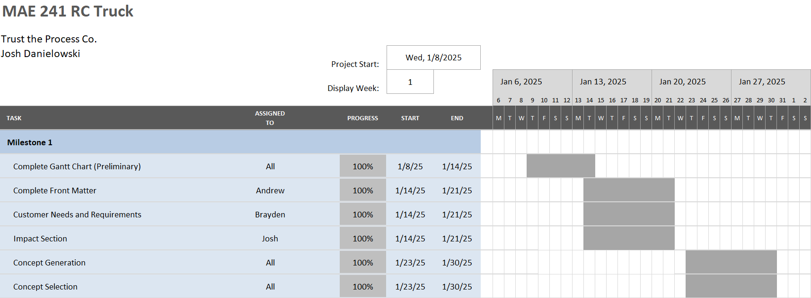

Figure 68: Milestone 1 Gantt Chart

Figure 69 shows the tasks assigned to complete the second milestone of the project. These included updating the Gantt chart and report based on the graded milestone 1, along with the design, manufacturing, and testing of the first prototype. This milestone also included a bill of materials, which was completed following the manufacturing of the first prototype.

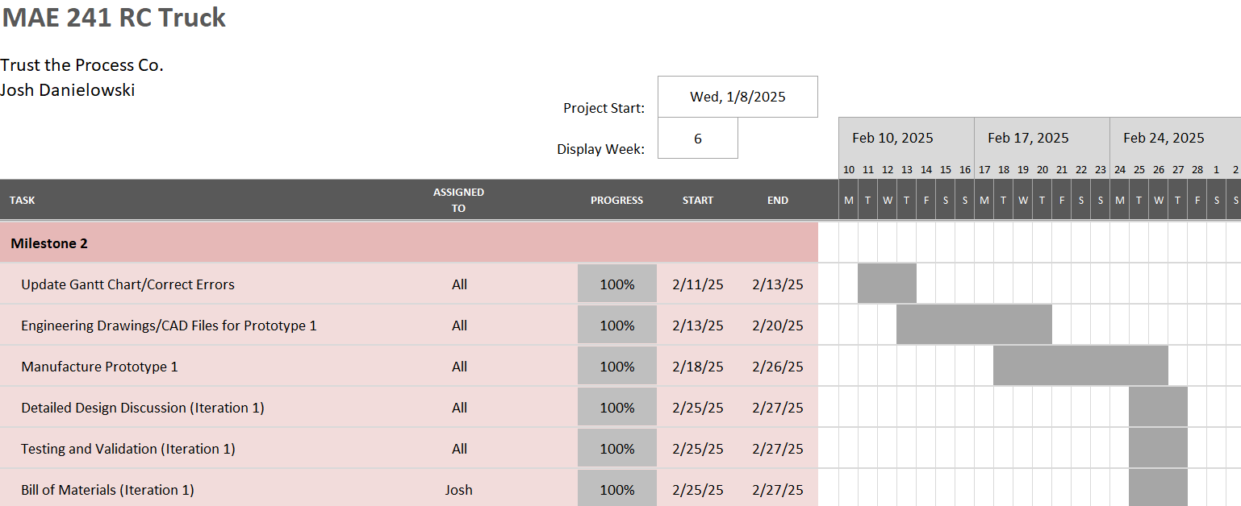

Figure 69: Milestone 2 Gantt Chart

Figure 70 shows the tasks assigned to complete the third milestone of the project. This milestone included the critical design review presentation and the beginning of the tool training included in the course. In addition, this portion of the project included the full second iteration of the design, from concept generation to testing and validation of the second prototype.

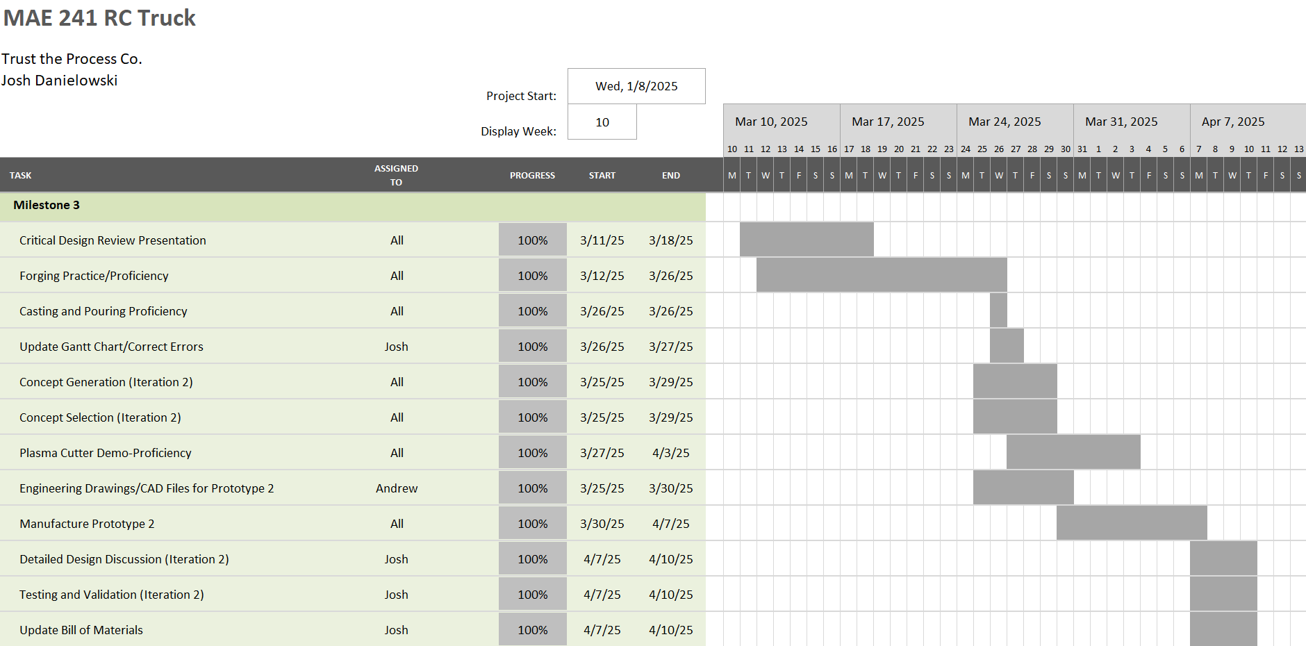

Figure 70: Milestone 3 Gantt Chart

Figure 71 shows the tasks assigned for the final report and conclusion of the project. This final phase of the project included the rest of the tool training and the final design iteration of the project. It included finalizing the Gantt chart, bill of materials, and the addition of the abstract, conclusion, and relevant appendices to the final report.

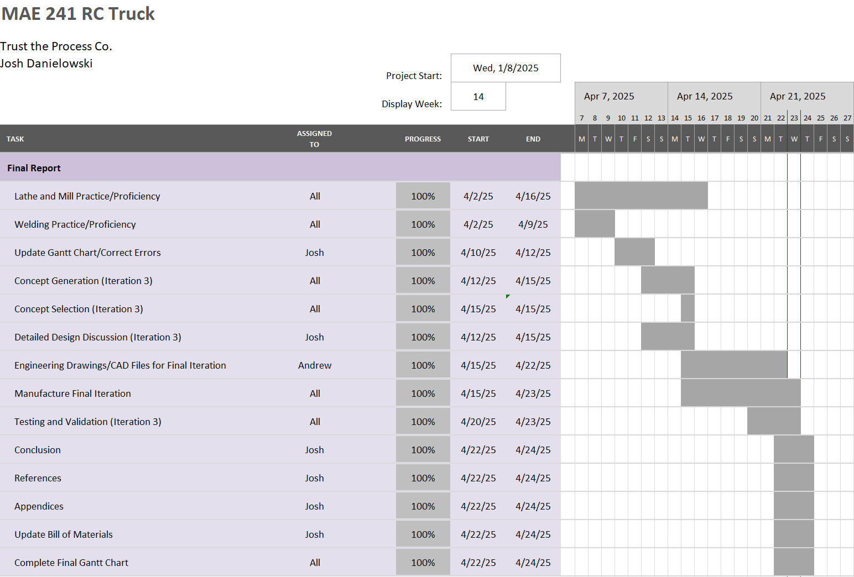

Figure 71: Final Report Gantt Chart